THE FREE LIBRARY OF NEW HOPE SOLEBURY
Board of Trustees Meeting Minutes – Draft Copy
April 18, 2018

In attendance: Beth Houlton, President; Carol Taylor, Vice-President; Ron Cronise, Treasurer; Polly Wood, Secretary, Larry Davis, Liz Jordan, Connie Hillman, Kay Reiss, Doug Brindley
Also in attendance: Pamm Kerr

I. CALL TO ORDER – Beth Houlton

A. The meeting was called to order by Beth at 5:29
B. MOTION by Ron, to accept the February Meeting Minutes. SECONDED by Larry, APPROVED by all.

II. FINANCE REPORT – Ron Cronise
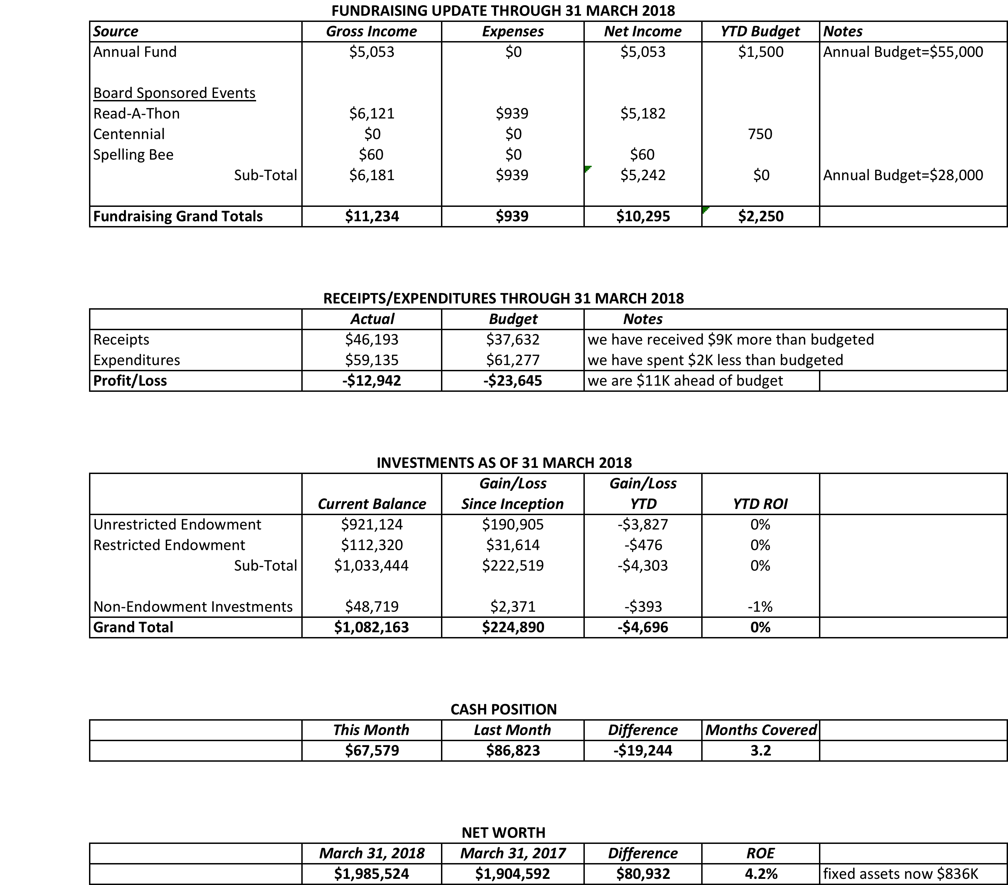

Ron made presentations to New Hope and Solebury regarding the library’s funding. Connie accompanied him. The presentations took about an hour and Ron gave a summary of all the things the library does beyond lending books. Connie compiled a list of all the services the library has to offer and also showed the statistics for these programs and services. Ron explained the library’s funding formula from the state and where our funds come from. We continue to be the poorest funded library in the county while also having the highest household income level. Ron asked both the borough and the township for additional funding. Ron is supposed to go back to speak to the full borough council in early May at their working session. Solebury’s follow up is TBD.

III. DIRECTOR’S REPORT – Connie Hillman
- Annual Report has been submitted

- Keystone Grant: There is another round of Keystone Grants opening up. These are grants to be used for capital improvements and are matching grants (we pay half, the state pays half). Connie would like to use this to replace the shelving in the children’s department. She has spoken to the FOL about it and they are willing to fund our half (about $9,000). The applications are due June 15. With the board’s permission, she would like to proceed. If we get accepted, we wouldn’t find out until the end of the year. The board agreed this was a great idea and as the FOL will cover the library’s half of the funding, we are in full support.

- Website: Is now live and looks great. Eric and Connie went through training with Kim and they are starting to work with it independently.

- Building :

  - Vic Lance did the spring cleanup and mulching of the gardens.

  - Thank you to Paul Spencer for repairing the chairs. Paul noticed that for some of these chairs, it is actually a second repair, so the chairs may need to be replaced in the future.

- Summer Reading: Connie is meeting with the Huxleys next week to discuss our summer reading schedule. Patricia intends to hand out reading logs and program registration information at the June 3 birthday party. We’re hoping for another great summer.

- Birthday Week: The library turned 100 years old on April 2. Visiting patrons really enjoyed the display of the library’s history. We had two school groups who had tours from Margaret Ely, the first librarian, a magic show and a concert from the New Hope-Solebury-Lambertville Community Choir. We also had cupcakes all week.

IV. WEBSITE LAUNCH

V. BUILDING/PROPERTY

- Back hill gardening update – This will take place on Earth Day (weather permitting) – Saturday & possibly Sunday.
- Memorial planting – We would like to honor Doro Kerr in a way that would enhance the library with a planting of some sort. We do not have any firm plans at this point. Pamm noted that if this would present any budget issues, her mother would have preferred that we keep a balanced budget instead.

VI. DEVELOPMENT – Doug Brindley
Doug is reaching out to others who have done fundraising for libraries to get some ideas for how best to find/reach out to potential major donors. We need to train ourselves for a more sophisticated outreach.

- Centennial Fundraiser Follow Up – Liz/Ron
We have gotten some money donated in honor of the library’s birthday (unrelated to the mailing). The mailing went to about 48/49 names. This has not proven to be very successful.
- Spring Appeal – Liz
Liz showed a mock up of the mailing. It will go out to all of our mailing list. Because the 100th birthday is a one-time thing, we feel this is a good time to get the message out to all of our patrons. We will also send the mailing out to some households in Lumberville and Carversville to try to reach a broader audience. The mailing will be May 1.
- Spelling Bee – Polly
We now have another $1,000 sponsor – Penn Community Bank. Trinity Day School will most likely buy an inside cover in the program. Alison Kingsley spoke about the library and all of its programs at last night’s borough council meeting and I spoke about the Bee. Carol has submitted an application to the Wawa Foundation for a donation.
D. Elin Hildebrand – author event – Carol
Carol has arranged for Elin to come speak June 26. She is reaching out to local venues to see where we could host.

VII. MARKETING – Liz Jordan
Liz handed out a brand standards guide. It is also available on Dropbox. It is very important that we use it properly especially if we are working on a project or with a designer. It has our colors, voice, tone and manner. Consistency is very important. We are all brand ambassadors.

VIII. CENTENNIAL – Polly Wood

- June Community Party – June 3. 2:00-5:00

IX. GOVERNANCE – Kay

- Ninth Board Member
Ideally we would like to find someone with development experience, but we do still need someone. If anyone has suggestions, please let Kay know.

X. FRIENDS’ REPORT – Karl
The FOL has agreed to pay the $9,000 for the library match for the Keystone grant. This will be used for new shelving in the children’s library.

On May 2 from 6:00 -9:30 there will be A Taste of New Hope at the New Hope Winery. This is being hosted by the Greater New Hope Chamber and will include more than 10 baskets to be raffled off, the proceeds of which will go to the FOL. Tickets can be purchased in advance or at the door.

Respectfully submitted,
Polly Wood
Secretary

