THE FREE LIBRARY OF NEW HOPE SOLEBURY
Board of Trustees Meeting Minutes – DRAFT COPY
February 21, 2018

In attendance: Beth Houlton, President; Carol Taylor, Vice-President; Ron Cronise, Treasurer; Polly Wood, Secretary; Larry Davis, Liz Jordan, Connie Hillman, Doug Brindley
Also in attendance: Pamm Kerr, Karl Varnai

I. CALL TO ORDER – Beth Houlton

The Meeting was called to order by Beth at 5:35.
MOTION by Ron, to accept the January meeting minutes. SECONDED by Doug, APPROVED by all.

II. FINANCE REPORT – Ron Cronise
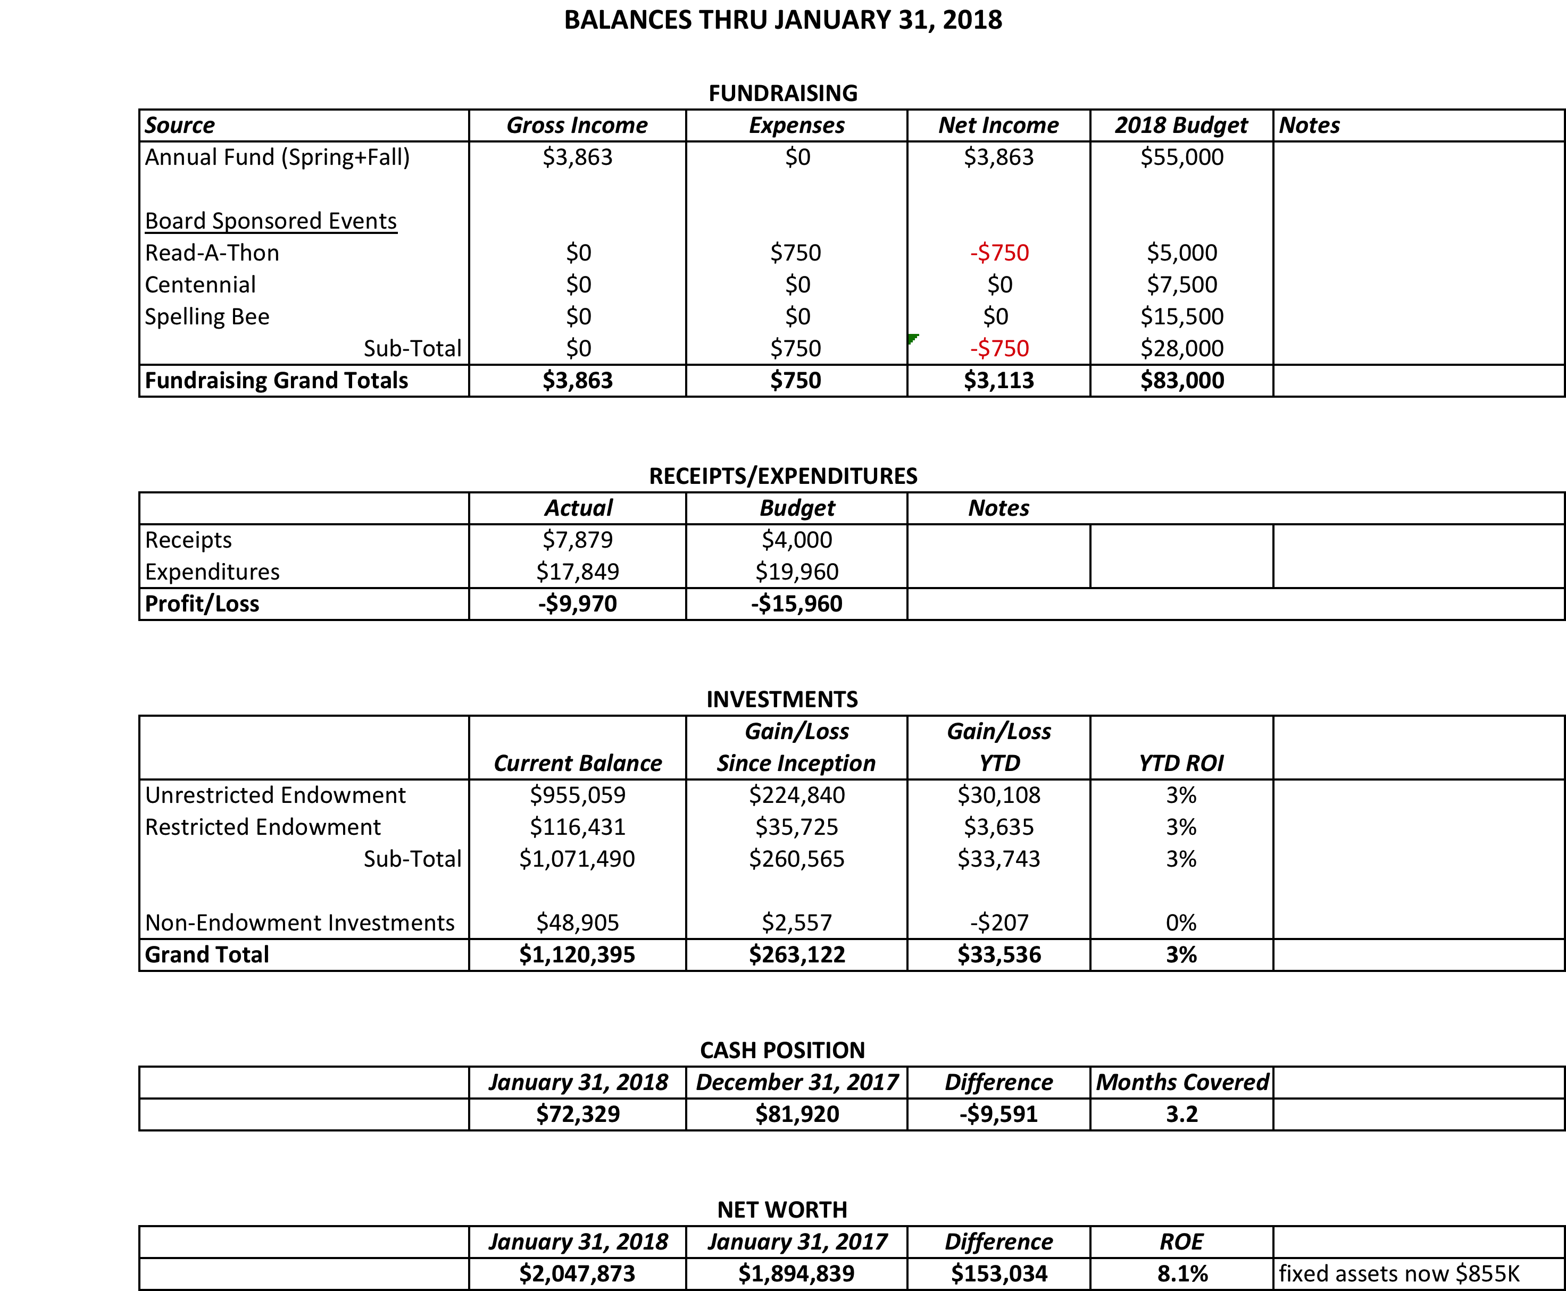

- Treasurer’s Report
Ron made a presentation to the shared services committee of New Hope. They were surprised and impressed with the number of programs and services we offer. He then showed them our financial situation. We are the poorest funded library in the county. Ron then called Helen Tai and suggested making the same presentation to Solebury. He will make the presentation to Solebury in March, although Helen will not be attending.

III. DIRECTOR’S REPORT – Connie Hillman
- PA Forward: We are golden! We have been awarded our gold star in the PA Forward initiative. At present we are one of 36 libraries in the state (out of 471) to have achieved this. We will get a formal certificate probably in March. This will make great publicity in conjunction with our 100th birthday.

- Website: Kim has been working on developing subpages for the site. She has added a widget that will allow our event calendar to produce a live feed on our home page. Overall it is looking very nice. On a side note, Jaime, our logo designer, has created a template for our e-mailing for use as an informational letter, a newsletter and an individual event advertisement to keep us consistent with our brand.

- Building issues:
  - Vic Lance corrected the flooding issues in the furnace room. Part of the issue was a drainpipe that had be accruing blockage for heaven knows how long. This drainpipe was not touched during our renovation. There was a “snake” four feet long of debris, dead leaves and twigs. In any event, everything seems to be fine now.
  - Bulbs in the hanging light fixtures on the first floor continue to blow out much sooner than anticipated. We have replaced 6 of them so far. Connie discovered that the bulbs which were placed in the fixtures at the time of renovation were not correct---they are not designed to be used in an enclosed globe, so that is why they are burning out. Connie made sure that the replacement bulbs that she ordered are compatible with our fixtures so hopefully this will eliminate the problem (after the final six blow out. . .).

- Summer Reading: Connie met with Darcy and Patricia to begin setting up programming for the summer. They are planning to increase our outreach to both New Hope and Solebury by setting up story times in area parks and conducting a story time as part of the Solebury summer camp. Both municipalities have been very positive about this proposal.

- Annual Report: Connie has started work on our annual report. The statistics have been input and she is waiting for the final profit and loss statement from our accountant to fill out the financial information, which according to Linda, won’t be until the end of the month. This will be a bit of a crunch since it is due March 2. However, we have our official statistics from the county. They look great. See below:

2017 2016

Total registered users 4,734* 3,814
Reference questions answered annually 6,760 5,460
Annual number of visits 36,830 31,000
Program attendance 4,086 3,012
Computer uses per year 3,627 2,814
Wireless uses per year 3,536 2,234
Circulation physical items 58,234 57,299
Circulation children’s items 19,392 17,362
E-circulation 8020 6210

The state is now counting the number of electronic items to which our patrons have access. Including physical and electronic collections and online databases, the people of New Hope and Solebury have access to 530,109 items FREE of charge.
*This number is significantly higher due to the change in criteria for counting cardholders. We are now counting by geocode rather than by the library at which the patron obtained his card. This gives a truer number of cardholders in our service area.
The statistics are due to the dedicated efforts of the entire staff, who have worked to keep the collection in good order, assist patrons with computer issues and the overall marketing of the library. The children’s circulation is the highest it has ever been in this library’s history thanks to Patricia’s hard work in the children’s department.

We are eligible for another keystone grant. Connie thinks shelving for the children’s department would be a good project. We would need to match half the amount needed. The project would cost about $18,000, so we would need to have $9,000. Ron thinks this might be tight for 2018 but 2019 might be a possibility. We have a few months to apply for the grant, as it is not online yet. We have 18 months to complete the project if they approve the grant. We do still have an open line of credit with the bank should we wish to take out a loan if needed. The shelves at this point are not in good shape.

IV. LOGO/WEBSITE PROGRESS – Beth/Carol

V. BUILDING/PROPERTY

A. Back hill gardening proposal
A group of people have offered to plant 500 daffodils on the back hill behind the library. They would clean up the area and plant the bulbs. Bucks Beautiful would donate the bulbs. New Hope’s junior council would work on this with Geri Delavich who put fourth the proposal. This would not cost us anything. They would clean up March 3 and plant on Earth Day (April 22) weekend. Our main question/concern is ongoing maintenance. They want to film the process and give a copy to the library and also present to Council. This seems to be a great project and a win for all concerned so Beth will give them the go ahead after clarifying a few points with Geri.

VI. DEVELOPMENT – Doug Brindley
The development committee met to discuss various methods of fundraising and how to achieve our final goal of fully funding the endowment. How can we accelerate our methods without compromising or inhibiting our regular fundraising? We need to develop a long-term approach to the appeal to help us get away from fundraising. We do not have specifics yet of how we can accomplish this goal. Can we identify potential individuals who might be interested in a major donation? Maybe this would be a more appealing pitch to some people and we should spend more time focusing on these potential donors.

- Read-A-Thon Results/Report – Beth
The Read-A-Thon netted $5,046 this year. This includes some corporate matching. Our overall donations are down despite the number of participants having gone up. We had hoped to raise $7,000. There are a number of reasons this may have happened but probably the biggest reason is that Beth and Ellen had been told, by the school several years ago, not to push this as a fundraiser. Despite the fundraising portion on the folder, people focused on the reading. Next year, Beth and Ellen plan to push the fundraising portion more as there are several other (non-local) organizations that do fundraising at the school.
- Centennial Fundraiser (Additional Appeal) – Liz
The mailing has gone out to 49 families.
C. Spelling Bee – Polly
Liz would like to create a specific spelling bee logo and will need funds to do this.
Carol passed out a list of potential sponsors/advertisers/donors. Every board member is asked to take at least five businesses to approach. Polly, Carol, Liz and Pamm will get a form out to everyone with pricing and information to use when approaching potential donors.
VII. MARKETING – Liz Jordan
Next month Liz will have the brand guidelines for everyone to start using. We also have the new stationary with the logo.

VIII. CENTENNIAL – Polly Wood

- June Community Party will be June 3. Karl Varnai’s band will be playing. We hope to have some food trucks as well as cake. There will also be a juggler/magician, face painting and perhaps some “living statues”. Both the FOL and the library will have information tables set up including information regarding the Bee.

IX. GOVERNANCE – Beth Houlton
We still have an open spot on the board – ideally someone with development experience. Please let Beth know if someone knows of a candidate.

X. FRIENDS’ REPORT – Karl Varnai
The FOL has some fundraising activities planned (book sale, raffle baskets, ten raffle baskets at the Taste of New Hope event) and they will be voting soon on the wish list items from Connie. Swarm has offered 10% off of a particular line (Out of Print Books) to anyone showing a library card.

Respectfully submitted,
Polly Wood
Secretary

