THE FREE LIBRARY OF NEW HOPE SOLEBURY
Board of Trustees Meeting Minutes – Draft Copy
May 16, 2018

In Attendance: Beth Houlton, President; Ron Cronise, Treasurer; Polly Wood, Secretary; Connie Hillman, Liz Jordan, Larry Davis

I. CALL TO ORDER – Beth Houlton
The meeting was called to order by Beth at 5:28.

MOTION by Ron, to accept the April Meeting Minutes. SECONDED by Larry, APPROVED by all.

II. FINANCE REPORT – Ron Cronise
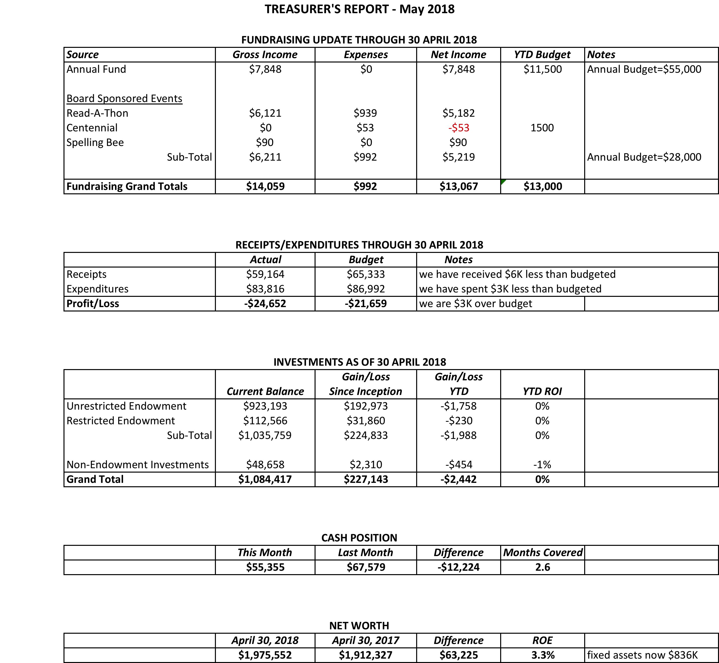

Ron has sent emails to New Hope and Solebury requesting our funds. Solebury will send a check mid to late June. New Hope has not yet responded. Ron handed out the end of year financials from the independent accountant for 2017.

III. DIRECTOR’S REPORT – Connie Hillman
- Keystone Grant: Connie started working on the Keystone grant for new shelving and contacted the state with a question regarding bidding. Her contact at the state said that shelving was considered furniture and therefore not normally covered under the grant criteria unless it would be an improvement to services or safety. Connie will have to frame this very carefully, but no guarantees.

- Building : The Friends of the Library have offered to cover the cost of the electrical work in the children’s department to install additional lighting. The cost is approximately $300.

- Summer Reading: The Huxleys have committed to another $5000 for our summer reading program with the check due to arrive mid-May. Summer reading program registration begins June 2. Science in the Summer registration begins May 18.

- District: The CPL directors met on April 19 to get more details for the gently used self-checkout machines offered by BCFL. While this is a nice addendum to our library, we have a problem as to where to put it. It was recommended that it be located near the checkout desk, since patrons with fines or expired cards will require staff assistance and we have no room or additional computer wiring in the lobby. We have until the end of December to decide. If we take the machine, we would assume the contract, which is $300/year.

- Staff Development: Eric and Connie will be attending a workshop on homeless patrons on May 18.

IV. BUILDING/PROPERTY

- Back hill gardening update – The hill has been cleared and the group will be back June 2 to do the planting.
- Memorial planting; Shelves in Lower Level

VI. DEVELOPMENT – Doug Brindley

- Spring Appeal – Liz
We sent to everyone on our list plus a few additional mailings. All in, each piece cost about $.80. The extras can be handed out at the party. A reminder email will go out in a couple of weeks.
- Elin Hildebrand Event Update
Board members are encouraged to talk up the event
- Spelling Bee – Polly
Polly updated the group on the current status of the raffle (now a raffle/drawing) and ad sales. We would like a few more overall sponsors and people are encouraged to find teams.

VII. MARKETING – Liz Jordan

VIII. CENTENNIAL – Polly Wood

- June Community Party
All board members are encouraged to attend and help with the event. Things are on track and hopefully the event will be a success!

IX. GOVERNANCE – Kay Reiss

- Ninth Board Member plus others
We have had numerous conversations regarding this position. Ideally, the candidate would have development experience and/or governance experience. The board is asked to approach friends or acquaintances who might be interested. At the end of the year, we will have two additional spots to fill.

X. FRIENDS’ REPORT – Karl Varnai
No report

Respectfully submitted,
Polly Wood
Secretary

