THE FREE LIBRARY OF NEW HOPE SOLEBURY
Board of Trustees Meeting Minutes – Draft Copy
June 20, 2018

In Attendance: Beth Houlton, President; Larry Davis, Liz Jordan, Kay Reiss, Connie Hillman, Doug Brindley
Also in Attendance: Karl Varnai

I. CALL TO ORDER – Beth Houlton

The meeting was called to order by Beth at 5:31

MOTION by Larry, to accept the May meeting minutes. SECONDED by Doug, APPROVED by all.

II. FINANCE REPORT – Larry Davis
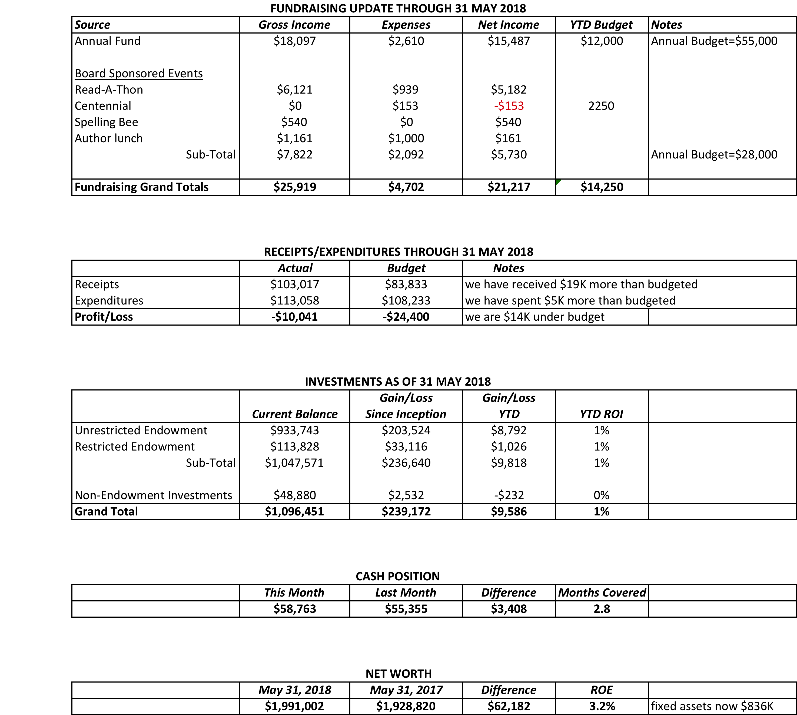

- Treasurer’s Report

III. DIRECTOR’S REPORT – Connie Hillman
- Keystone Grant: Connie has send in the grant and has verified that it was received by the State. Thanks to everyone who helped obtain the various pieces of information for her.

- Summer Reading: Summer Reading registration began Saturday June 2. The children’s and teen’s programs are filling up very nicely. The Explore! programs are nearly completely full. Darcy and Patricia will be going over to the LES and UES to promote the program to the kids. For the first time, we are able to take reading logs with us. Hopefully this will give us a great turnout.

- IU HOPE: Connie attended the end-of-the-year dinner for the IU HOPE students. These students are special needs and several of them volunteered weekly at the library this year as part of their curriculum. This is a great partnership with our schools and the teachers and students were very grateful for the opportunity.

- NHS Cares: Connie met with Zachery Mahon of NHS Cares and he feels that their mission of building a substance free community aligns with what the Library is doing.

- Museum Passes: We have added three new passes to our collection just in time for the summer: The Moravian Tileworks in Doylestown, The Independence Seaport Museum, and The Eastern State Penitentiary. We’re very excited to see how these circulate.

- Building:
  - Geri Delevich and her volunteers have cleaned up the slope behind the library and re-planting took place Saturday June 9.
  - Another element to our children’s garden is the addition of a solar fountain. This was purchased by Ricki Fisher and Andrea Weiner in memory of Lawrence Booth’s mother. It is entitled “Story Time” and very appropriate for a library garden.
  - Connie was contacted by Michael Cooper, the artist of Earth’s Piercing which is the sculpture on the front lawn. He wants to know if it is okay to put solar light on the sculpture so that people could see it at night. Connie contacted Carol Cruickshanks at New Hope Arts who is the coordinator of the outdoor sculpture project, since the piece was only supposed to be here until December, 2017. She said that 18 months is the rough timeframe for this, though sculptures can remain in place longer if mutually agreeable with the artist and the site. The Board agreed that we do want the sculpture to remain and we are fine with the lighting as long as the Boro has approved of Michael’s ideas for illumination and it is at Michael’s expense.
  - Jim Meskill our electrician will be coming out later this month to install the new lighting fixture in the children’s department. Thank you to the Friends of the Library for covering the cost.
  - There is indication in the Children’s area that some water has seeped into the wall and it probably came from an issue with a downspout. The landscaper has been notified and he will look at the situation and try to correct the issue.
- Strategic Plan: We are currently on schedule implementing our strategic plan. Upcoming items for the fall include:
  - 1000 Books Before Kindergarten Incentive: We will work on creating the structure of this initiative and marketing it in August/September to our area preschools and preschool families. Our goal is to have at least 20 children participating by the end of the year.
  - One Book; Two Towns: We will select a book and start developing the program in the fall in order to run the program over the winter months.

The community calendar is currently being handled by the new New Hope Borough website. Our participation in this is currently that of a contributor and it has a link on our website. Connie will find out if the site I just for New Hope or if Solebury organizations can also post and if Solebury residents can sign up for the list serve. For now, we have this initiative on hold.
We obtained our Gold Star in the PA Forward initiative this past winter.
Currently we have a volunteer staffed technical help desk on Saturdays over the summer. We have also established a Book-a-Librarian form on our website which allows our patrons to schedule one-on-one dedicated assistance in all matters of the library. This may be enough to satisfy our goal of establishing a help desk.
There are also strategic Plan items that are Board related and we need to put more specifics down for our goals.

IV. BUILDING/PROPERTY
The following items were discussed in Connie’s report.
- Sculpture discussion
- Back hill gardening update
- Keystone grant for lower level shelves

VI. DEVELOPMENT

- Spring Appeal Update – Liz.
- Elin Hildebrand Event Update – Connie
- Spelling Bee Progress

VII. MARKETING – Liz Jordan
UPDATE ON BRAND STANDARDS:
Our website, emails and e-newsletter are now all in the new brand look. The Brand Standards Guide is available for review and guidance on Dropbox.

100TH BIRTHDAY PARTY RECAP: Multiple emails (save the date, reminders and updates) were sent to patrons. Connie mounted a huge Facebook push for the event. We created and distributed 300 event bookmarks and 10 posters for the event. It was listed on the New Hope Borough and River Towns websites. Bucks County Herald ran our press release with a photo of Karl's band.

SPELLING BEE:
All forms have been created at no cost and are available on the website. The event is posted on the New Hope Borough website. Bee bookmarks were created (no cost) and will be distributed to interested patrons post-July 4.

VIII. CENTENNIAL

- June Community Party Follow Up – Beth

IX. GOVERNANCE – Kay Reiss

- We continue to seek new Board members. All Board members are asked to again reach out to people they know to make everyone aware of the openings.
- We are in the process of reviewing and updating policies. Connie is taking the lead on this.

X. A. Cintra Property: Beth (on behalf of the Library) and ReAlliance are finalizing an agreement that preserves the rights that were established in the original contract with Hillier. A motion by Larry, allowing Beth to sign this agreement was seconded by Liz and approved by all.

X. FRIENDS’ REPORT – Karl Varnai
Everyone thanked Karl for the music that he and his fellow musicians provided for the Centennial party. Karl reported that the raffle baskets have proven to be a good source of fund raising dollars for the Friends.

Respectfully submitted,
Kay Reiss

