THE FREE LIBRARY OF NEW HOPE SOLEBURY
Board of Trustees Meeting Minutes
July 18, 2018

In Attendance: Beth Houlton, President; Carol Taylor, Vice President; Ron Cronise, Treasurer; Larry Davis, Doug Brindley
Also in Attendance: Pamm Kerr, Joanne Reska

I. CALL TO ORDER – Beth Houlton
The meeting was called to order by Beth at 5:33
MOTION by Ron, to accept the June meeting minutes. SECONDED by Larry, APPROVED by all.

II. GOVERNANCE – Kay Reiss

- Proposal to Appoint Joanne Reszka to Open Board Seat
Joanne is being appointed to an open board seat that will go through December 2018. The board will then vote to renew her for up to two more 3-year terms thereafter should all be in favor of that.

- Board Member Search Continues
We will have two open board positions at the end of the year – Beth and Carol’s.

III. FINANCE REPORT – Ron Cronise
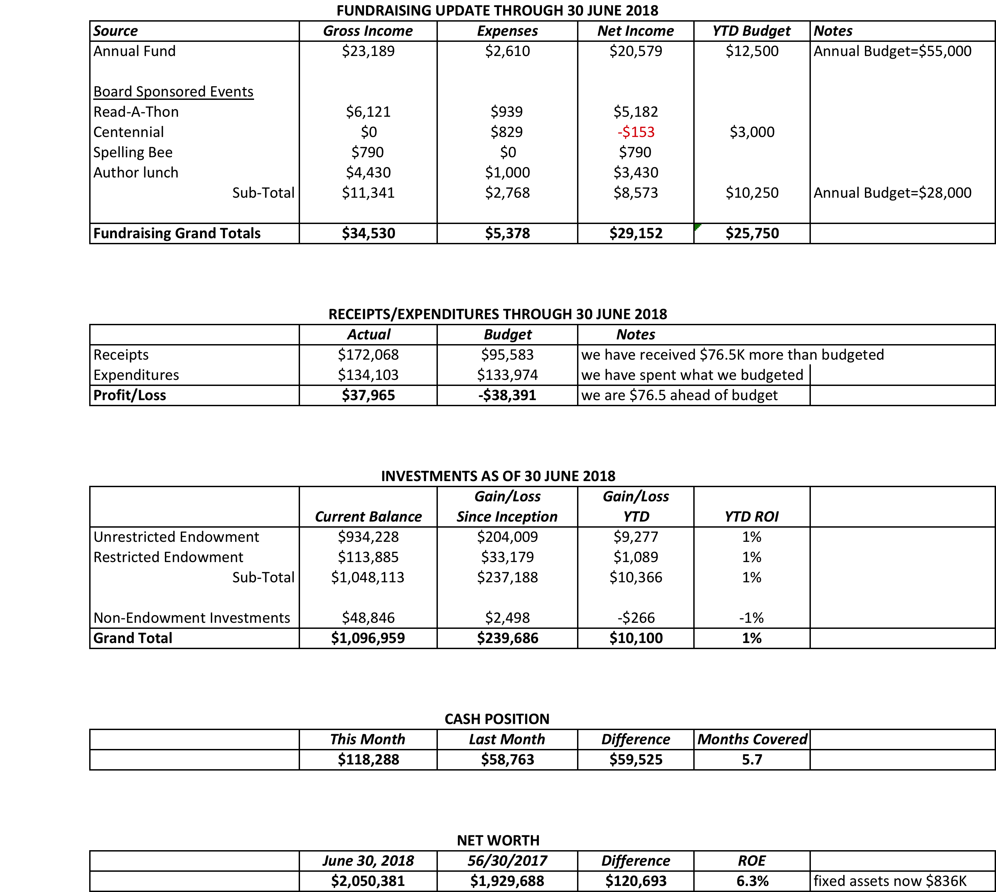

- Treasurer’s Report
- Spring Appeal Final Numbers

IV. DIRECTOR’S REPORT (Connie Hillman)
- IMLS Grant: At the beginning of July we applied for an IMLS (Institute of Museum and Library Services) grant to hold a coding club in our library. This is not a dollar amount, but rather the grant would allow for training and a computer coding program. We’ve asked the FOL for $2500 to purchase four laptops so that we can hold the program as well as other technical classes in the library. We will know by August whether or not we receive it.

- Summer Reading: The Summer Reading program is going very well. Registration for all of our programs is filled up. Patricia has been doing a great job keeping things fun and organized.

- IU HOPE: We are continuing to have volunteers from the New Hope-Solebury school district working at the library over the summer.

- Elin Hilderbrand: Our author visit went very well. We had 80 attendees. The day was beautiful and we got a lot of positive comments from attendees regarding the event. We started at 12 and ended at 2---as planned. Connie is still waiting to hear from Farley’s regarding our percentage of books sold at the event, but by the time all is said and done, Connie estimates we will have netted $2,600.

- Building:
  - The slope behind the library has been re-planted. Geri and some volunteers are taking turns watering it.
  - Sculptor Michael Cooper got the go-ahead to install solar lights to illuminate the sculpture on our front lawn.
  - Jim Meskill, our electrician, will be coming out on July 25 to install the new lighting fixture in the children’s department. Thank you to the Friends of the Library for covering the cost.

V. BUILDING/PROPERTY

VI. DEVELOPMENT

- Informal Poll for Increasing Endowment – Doug
Doug suggested that we might need another capital campaign in the future to enhance our endowment and become self-sufficient. Will discuss further at next development meeting.
- Elin Hildebrand Event Final Numbers – Carol
Net revenue approx. $2,600
- Spelling Bee Progress
Now up to ten pages of ads so need more ad space sponsors. Several raffle gifts collected and/or need to be collected.
Still need an MC for the event.
Next Bee meeting is August 22nd.

VII. MARKETING – (Liz Jordan – in absentia)
The marketing committee recently discussed what might be improved campaign elements for our fall and spring 2019 appeal

VIII. FRIENDS’ REPORT –
Pamm discussed a writer’s salon fundraiser that will be held at Paxon Farm in September. They are still looking for a book sale site in town.

Respectfully submitted,
Carol Taylor

