THE FREE LIBRARY OF NEW HOPE SOLEBURY
Board of Trustees Meeting Minutes
August 15, 2018

In Attendance: Carol Taylor, Vice President; Larry Davis, Kay Reiss, Joanne Reszka, Liz Jordan, Doug Brindley, and Connie Hillman

Also in attendance: Karl Varnai

I. CALL TO ORDER – Carol Taylor

The meeting was called to order by Carol at 5:35
MOTION by Larry Davis, to accept the July meeting minutes. SECONDED by Doug Brindley, APPROVED by all.

II. GOVERNANCE – Kay Reiss
The Governance committee recommended the appointment of Joanne Reszka to fill the open Board Seat for the remaining term which ends December 31, 2018.

- MOTION by Kay Reiss, to Appoint Joanne Reszka to fill the open Board Seat. SECONDED by Larry Davis, APPROVED by all.

- Policy review continues by committee and will submit their recommended changes in the fall for votes on all changes.

III. FINANCE REPORT – Larry Davis
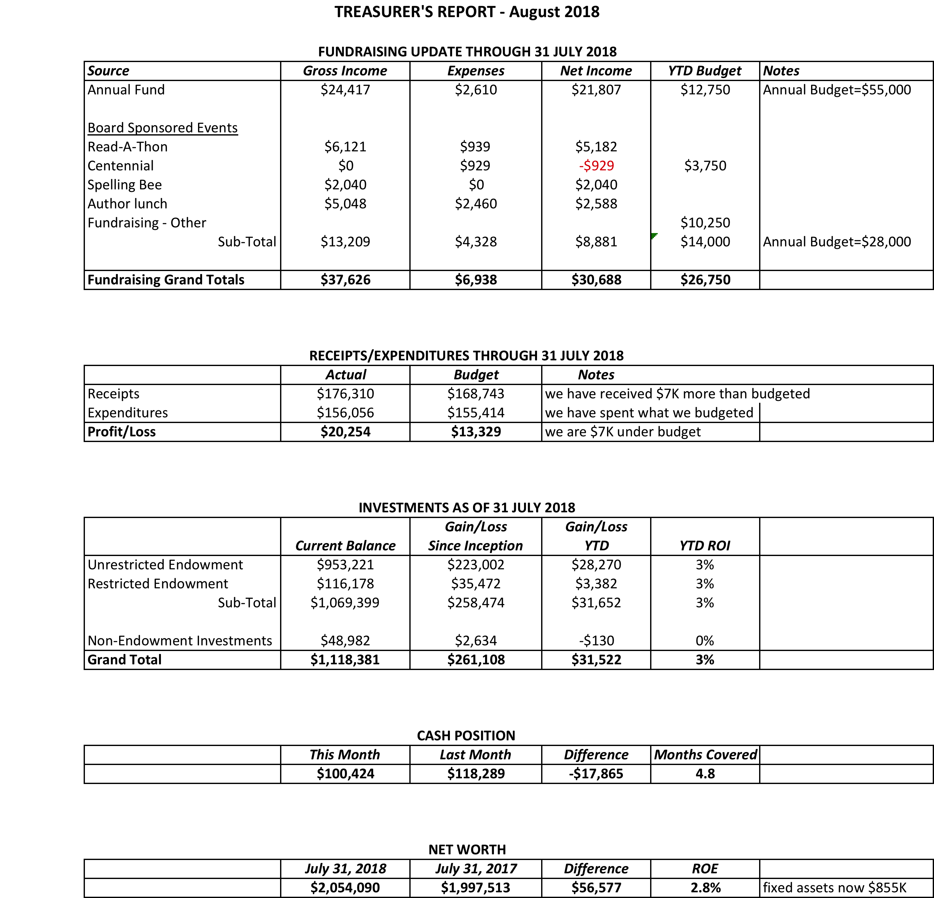

IV. DIRECTOR’S REPORT – Connie Hillman
- The Summer Reading Program concluded officially on August 3. We are still getting back reading information. The programs all went very well and we had a great attendance at all of them. Many thanks to Patricia Lynch, Darcy Fair and our teen volunteers for helping to make this summer a success.
- The library will be at Helen Tai’s Senior Expo this Tuesday, August 14. Helen also came to the library as a guest reader as part of our summer reading program.
- The library also plans to be part of the New Hope Kids’ Fest on September 22. We plan to share a table with the Friends of the Library at both events.
- E.J. Lee, the new borough manager, came over to introduce herself and see the library. She and Connie had a nice conversation.

Building:
  - Jim Meskill installed the new lighting fixture in the children’s department. It looks great and really brightens up the area. Thanks to the Friends of the Library for funding this.
  - Pamm Kerr has put Connie in touch with Cathy Begg to create an artistic door for the children’s department. This would be covered by the funds designated for a piece of artwork for the library. We are hoping that not only will this be a thing of beauty, but it will help cut down on the noise from the children’s section as well.
  - There will be training available for all Library Board Members at the Doylestown Library on September 11 @ 6:30. The training is on development and fundraising.

V. BUILDING/PROPERTY

Repairs are needed on the bathroom wall and Paul Spencer will be repairing that and 2 chairs.

VI. DEVELOPMENT

- Spelling Bee Progress – Carol
The securing of ads for the program are going well and the program will be expanded to 28 pages. The Board expressed gratitude to Pamm Kerr for all her efforts to secure ads.
The Board agreed that the focus now needs to be on getting the necessary 20 teams of spellers.

VII. MARKETING – Liz Jordan

Following a discussion and recommendation by Larry Davis, the Board agreed that the expenses for the Bee will come out of the money raised by the event and there is not a need for a motion to approve funding for the printing of tickets, etc.
Liz reported that her research showed that non- profits, on average should expect to make .50 for every $1.00 of gross proceeds and .20 per $1.00 raised from existing donors. For new donors, it would be between $1.00 to $1.25.
The target date for mailing the Fall Appeal letters is November 6, 2018.

VIII. FUNDRAISING – Doug Brindley
Doug reported that there will soon be a letter for Board members to review regarding approaching donors with the idea of creating long term stability for the Library by creating an endowment.

IX. FRIENDS’ REPORT – Karl Varnai
The Friends have secured the money for the matching dollars for the Keystone Grant that Connie has applied for. The Friends are also committed to having a book sale this year and they are currently looking for a place to hold it in New Hope.

Respectfully submitted,
Kay Reiss

