THE FREE LIBRARY OF NEW HOPE SOLEBURY
Board of Trustees Meeting Minutes – Draft Copy
September 19, 2018

In attendance: Beth Houlton, President; Ron Cronise, Treasurer; Polly Wood, Secretary; Liz Jordan, Doug Brindley, Larry Davis, Joanne Reszka,
Also in attendance: Pamm Kerr

I. CALL TO ORDER – Beth Houlton

The meeting was called to order by Beth at 5:35
MOTION by Ron, to accept the August Meeting Minutes. SECONDED by Larry, APPROVED by all.

II. FINANCE REPORT – Ron Cronise
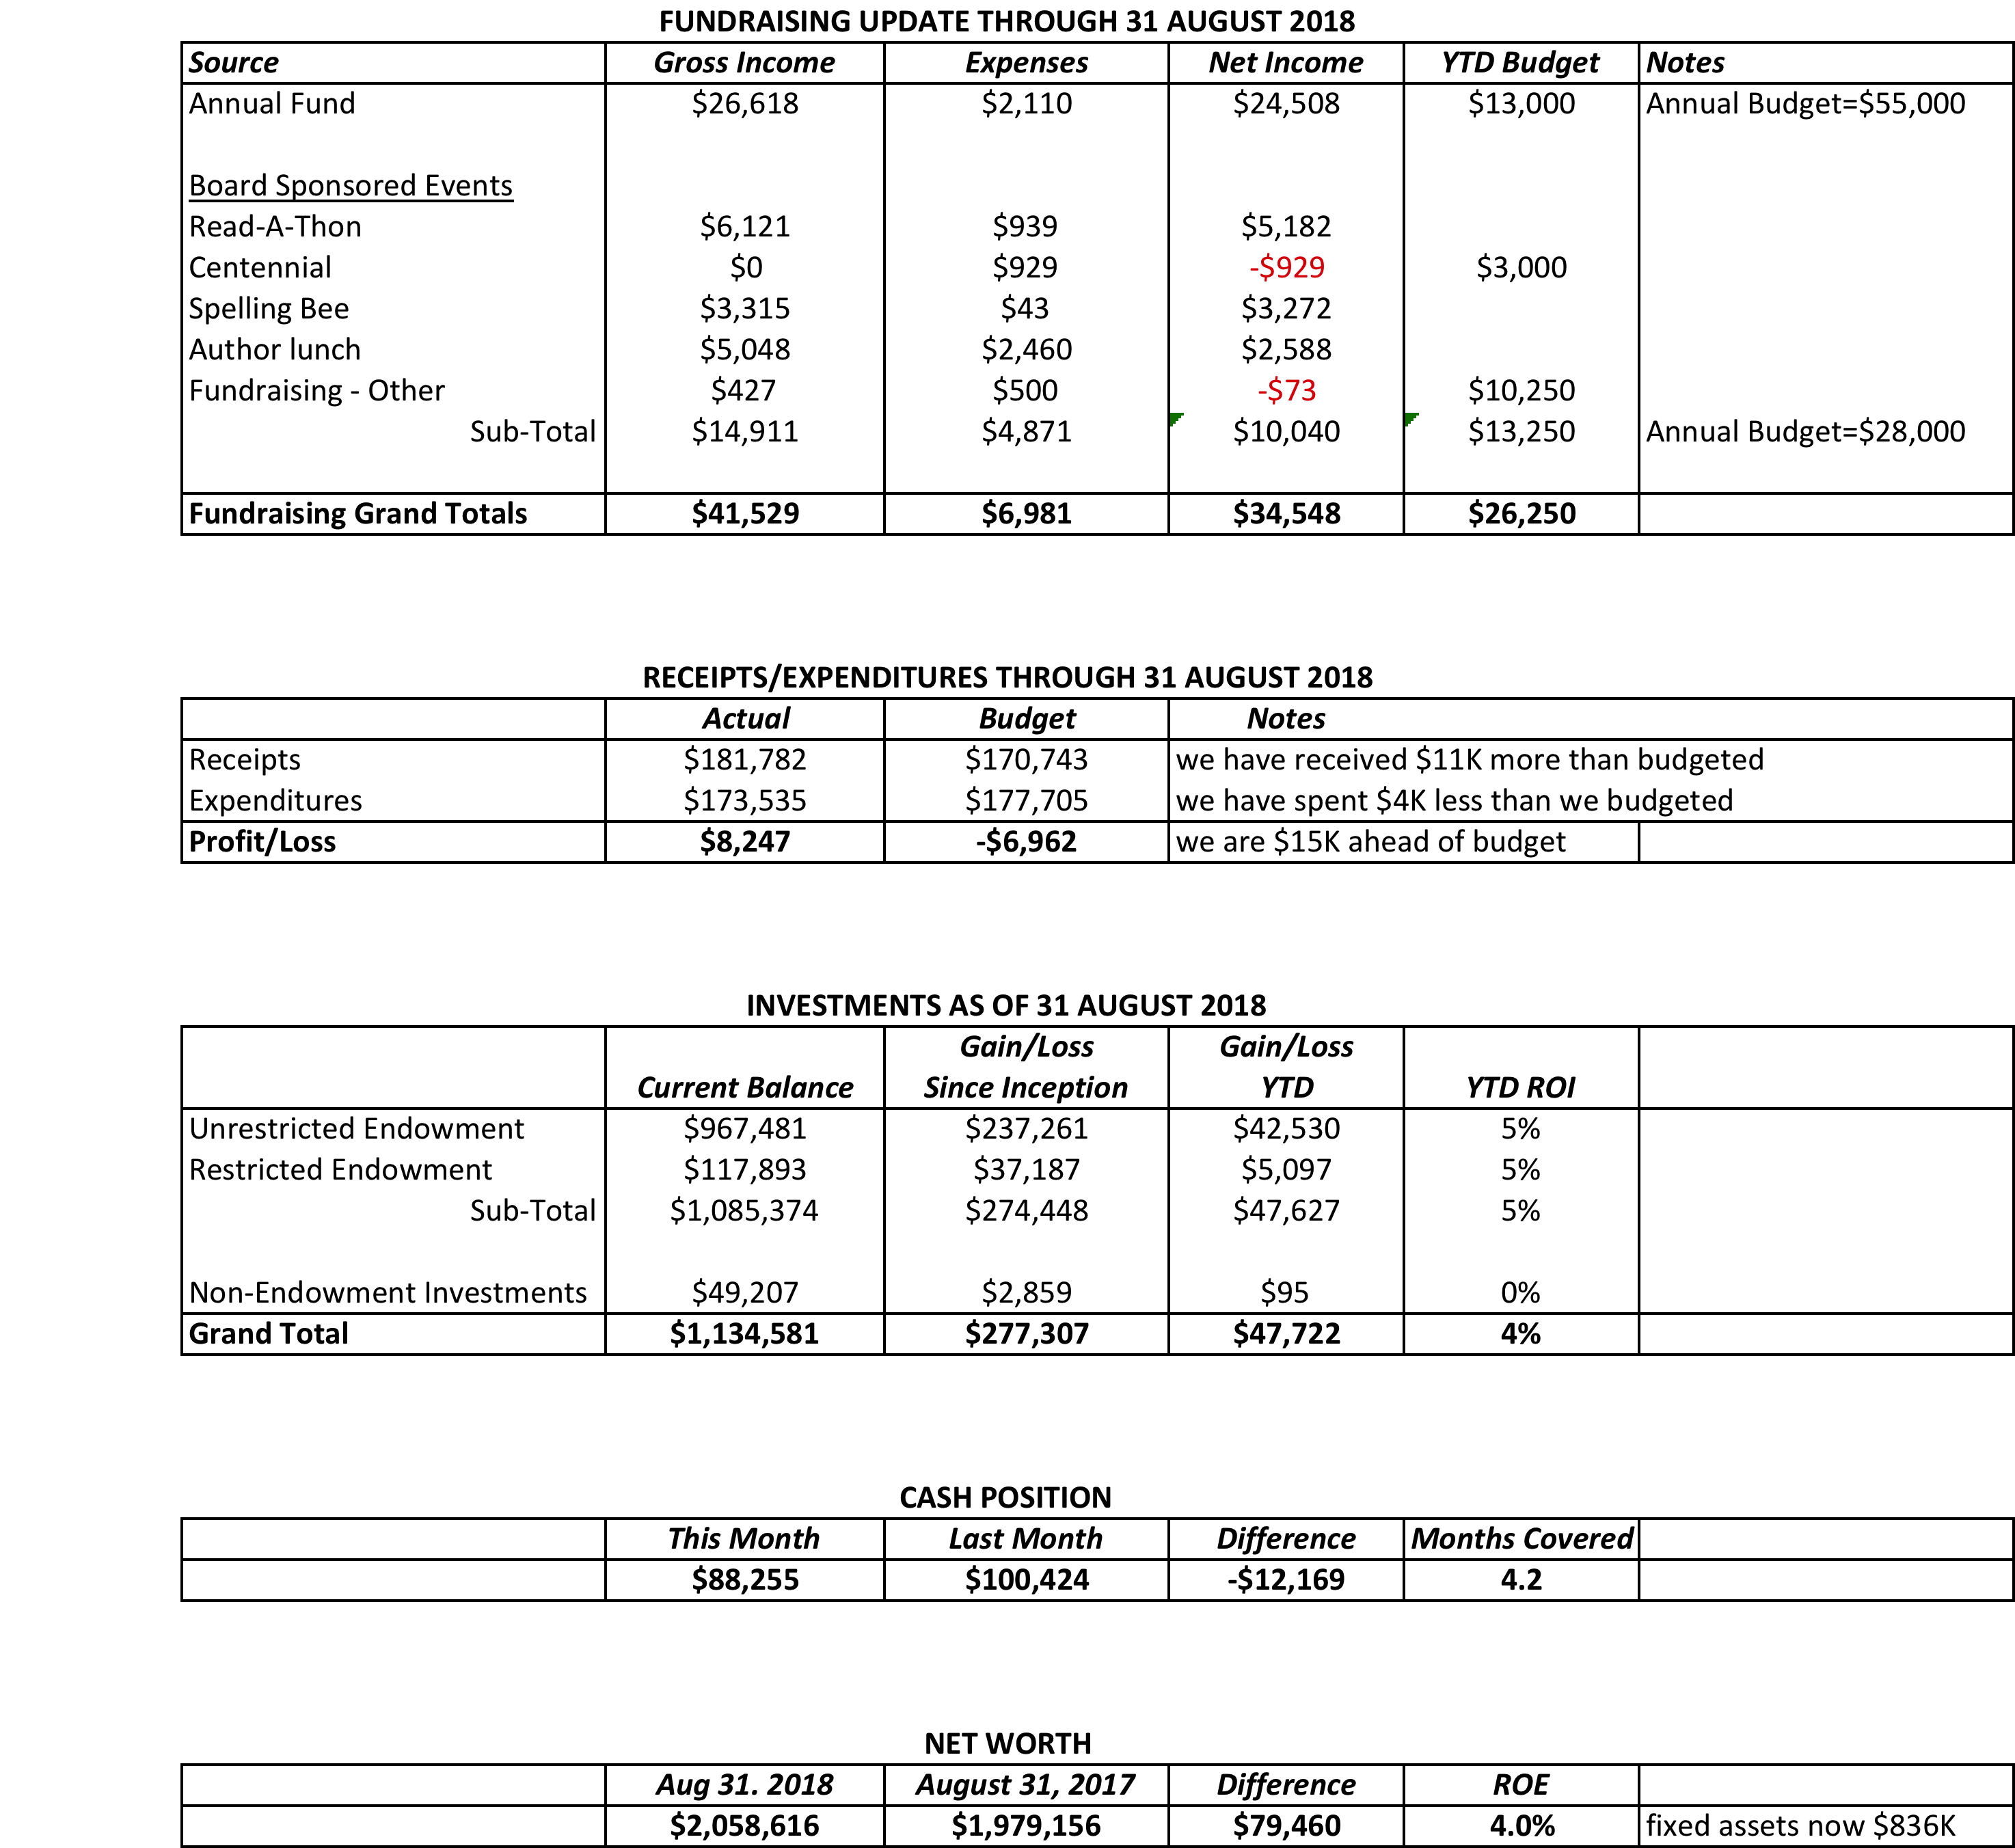

- Treasurer’s Report
- Proposed 2019 Operating Budget (Draft Only)
Ron passed out copies of the proposed budget. Discussion ensued.

III. DIRECTOR’S REPORT (Connie Hillman)
- The Summer Reading Program concluded officially on August 3. Overall, we had 826 kids participating in the program, reading 131,490 minutes over the summer. This is an increase of 18% from 699 in 2017. We also had 1,666 children and teens participating in summer programming, a 53% increase from the 2017 participation number of 1,087 children and teens. Well done, Patricia, Darcy and everyone who helped make the program a success this year.
- The library also plans to be part of the New Hope Kids’ Fest on September 22. We plan to share a table with the Friends of the Library at both events.
- Patricia and Darcy are setting up preschool visits for the fall. Darcy also plans to continue the Stories in the Park program in the parks of New Hope and Solebury this fall.
- Patricia is working on getting packets together for our 1000 Books Before Kindergarten program. The packets will be distributed to area preschools, at the Kids’ Fest event and will be available in the library. It will include reading logs to track books, book suggestions and information on early literacy. We are hoping to engage at least 20 families in the project.
- We are also collaborating with the Bucks County Audubon Society on several programs. Their preschool educator will be presenting a program on Bats! at the library on October 18 and Darcy will be telling spooky stories at their Haunted Trails event on October 20. We’re hoping to increase awareness of both organizations in the community.
Grant Status:
We have no word as yet on the Keystone Grant. Notices were supposed to be sent out to all applicants the last week in August.
We have however, been awarded a $3,000 grant from the PA Department of Health and Human Services to hold adult and child yoga classes in the library. This came through Helen Tai’s office.
Building:
  - Air conditioner: At the end of August in the heat, the air conditioner that services the children’s room and the second floor stopped working. We were getting air coming out of the vents, but it was not cool. It turned out that a mouse had gotten into the unit and fried it and himself. The repair cost $429, but was necessary due to the weather.
  - Cathy Begg came out to the library to take measurements for the interior door for our children’s department. We hope that not only will it be an attractive addition to the space, but also help contain some of the noise that travels upstairs. Cathy is working on some designs and will have them for us at the end of the month.
Upcoming Programming: We have a pretty packed schedule for the months of September and October. Highlights include: Voter Registration Information Session with the League of Women Voters on Saturday, September 29, I Want My Mummy! A presentation on mummies by Dr. Steve Phillips archeologist at the University of Pennsylvania on October 11, In Concert: Hungrytown on October 18 and the Tell-Tale Poe, the life and works of Edgar Allan Poe on October 22. Thank you again to the FOL for their support.
We will be participating on the Chamber of Commerce’s Scarecrow contest this year.

IV. BUILDING/PROPERTY

V. DEVELOPMENT – Doug Brindley

- Spelling Bee Progress – Polly Wood
Polly gave an update on raffle, teams and medals. The next Bee meeting will be Wed. September 26 at 5:30.
- Proposed Letter to Build Endowment
Group discussion regarding the endowment.

VI. MARKETING – Liz Jordan
Every Wed. there is a Facebook post about the Bee. There is also an email and another Facebook post at the end of the week. Please share this with friends. Liz mentioned we should have a photographer at the Bee. Beth will ask the photography teacher if there is a student who could help.
Liz is working on the copy for the fall appeal. She is hoping to have it go out Nov. 6.

VII. GOVERNANCE – (Kay Reiss)

- MOTION by Larry, to approve the new/revised management policies (posted on Dropbox) MNG 4 – Statistics and Reports, MNG 5 – Petty Cash, MNG 6 – Accounting, MNG 7 Fundraising and Donations, and MNG 20 – 3D Printer. SECONDED by Ron, APPROVED by all.

- Two new board members needed by end of 2018

VIII. FRIENDS’ REPORT – Pamm Kerr
Pamm mentioned that tomorrow is the poetry event at Paxson Hill Farm. It starts at 5:30 and she strongly encouraged board members to attend and bring people.
The FOL has committed to paying for half of the shelves in the children’s dept., which is the match for the grant from the state. We are still waiting to hear from the state regarding the grant.

Respectfully submitted,
Polly Wood
Secretary

