THE FREE LIBRARY OF NEW HOPE SOLEBURY
Board of Trustees Meeting Minutes – Draft Copy
October 17, 2018

In Attendance: Beth Houlton, President; Ron Cronise, Treasurer; Polly Wood, Secretary; Liz Jordan, Kay Reiss, Joanne Reszka, Connie Hillman, Larry Davis, Doug Brindley

I. CALL TO ORDER – Beth Houlton

The meeting was called to order by Beth at 5:30
MOTION by Ron, to accept the September Meeting Minutes. SECONDED by Larry, APPROVED by all.

II. FINANCE REPORT – Ron Cronise
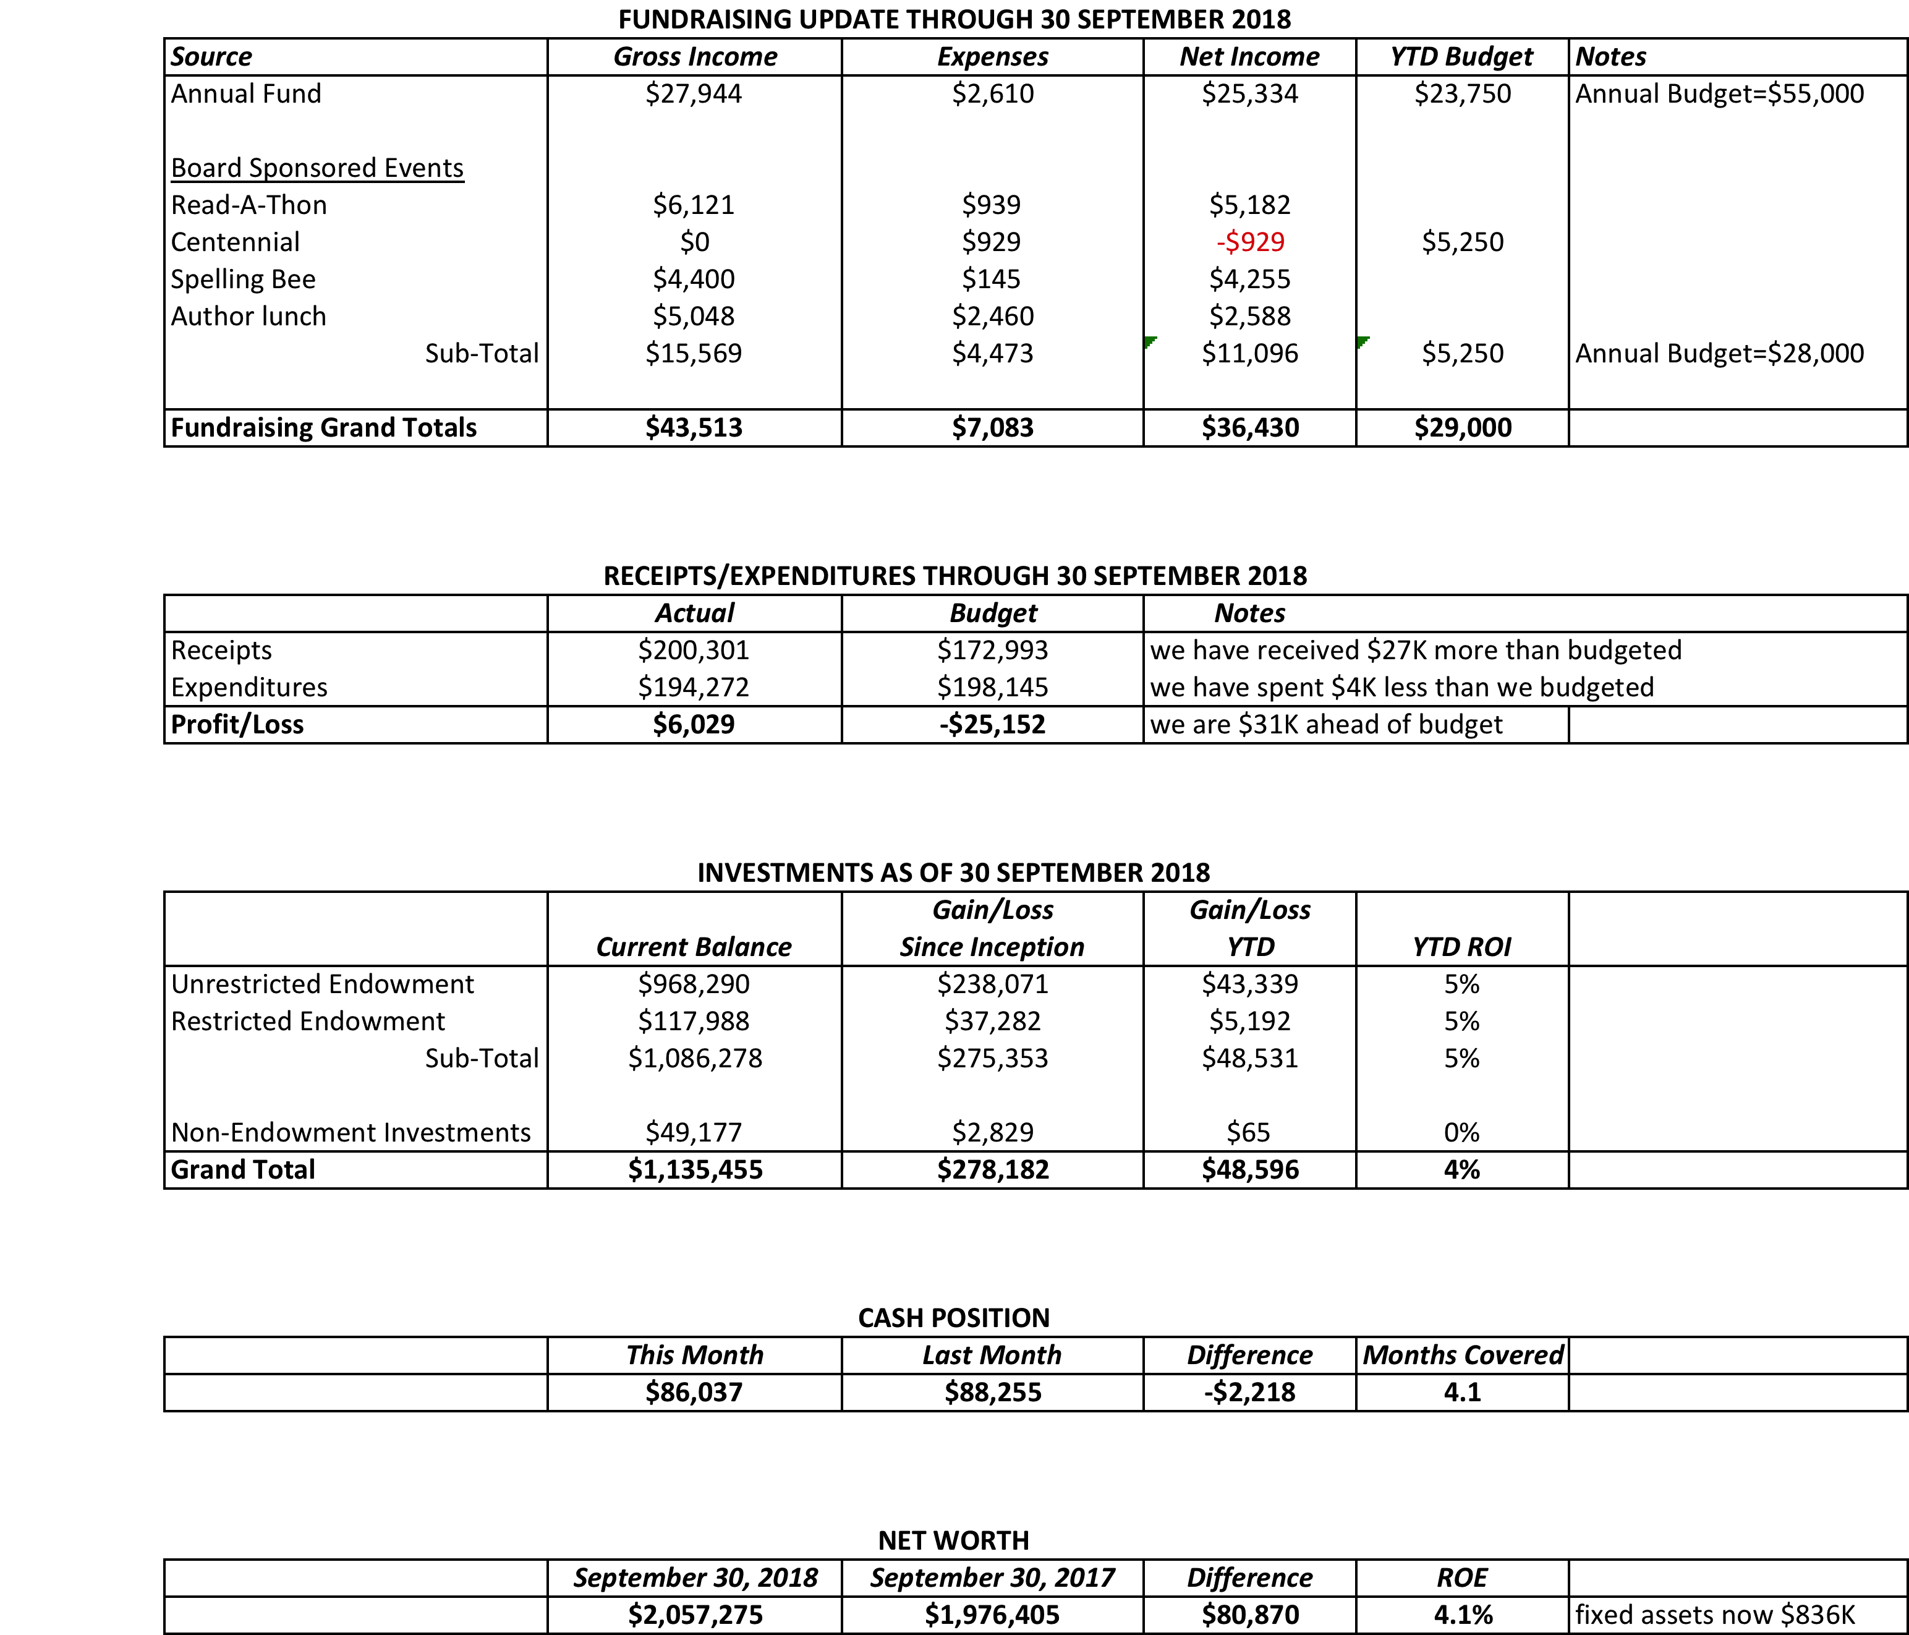

- Treasurer’s Report
- Proposed 2019 Operating Budget (Draft Only)
Ron handed out draft copies for next year’s budget. A final budget will be put fourth at the November meeting and voted on in December. Ron also handed out a sheet with information showing our projected income and expenditures for 2018. All of our fundraising goes towards the cost of operating the library. Because we have to raise approximately $100,000 a year to cover operating costs, we do not tend to have any additional funds to put towards our endowment. If New Hope and Solebury increased their funding for the library, any extra funds raised through fundraising, above the operational needs for the library, could go towards our endowment for long-term sustainability. The library’s goal is to become self-sufficient.

III. DIRECTOR’S REPORT (INCLUDING STRATEGIC PLAN UPDATE) – Connie Hillman
Strategic Planning Update: Patricia and Darcy have scheduled preschool visits throughout the fall. They will be taking 1000 Books Before Kindergarten to the schools to kick off the initiative. We are also exploring an after school book club for elementary age children to begin this winter. The Spelling Bee has taken up a lot of time this fall. Connie is hoping to start planning the One Book program following the Spelling Bee.
Building Issues:
- Sticky front door. The front door continues to stick, so much so that there have been a number of mornings where staff has to enter the building through the children’s department and then push and pull on the main door to get it open. The door has been planed a number of times but it doesn’t seem to help. The cleaning service also has been having trouble. We are getting into the colder weather, but replacing the door with a metal door should be a consideration for next spring/summer.
- Noise issues. Pamm and Connie met with Cathy Begg, the artist that is to work on an artistic door for the children’s section. Unfortunately installing the door is looking to entail a lot more work and cost than anticipated. We are now looking at installing doors on the main floor in an effort to try to afford additional options for quieter sections of the building. Connie has also placed a fan on the second floor to try to neutralize the noise.
Township: Larry and Connie met with Solebury supervisors Kevin Moressey and Mark Baum Baiker to answer questions that had risen from Ron’s presentation at the August supervisors’ meeting.
Outreach and Trainings: Eric and Patricia attended a Titlesource training for book ordering. Darcy represented the library at the Kids Fest event along with Kris Reilly from the FOL. Darcy has several pop-up story times scheduled this fall at the Carversville General Store, The Lumberville General Store, Paxson Hill Farm and the Bucks County Audubon Society.

IV. BUILDING/PROPERTY

V. DEVELOPMENT – Doug Brindley

- Spelling Bee Progress – Polly
Polly gave an update on the status of the Bee.
- Annual November Appeal – Liz
Liz plans to send out the appeal right after midterms. In the spring, the cost for the mailing was about $2,600. Her suggestion for this time is to get more people on our list as potential donors and to let them know more about the library. The printer suggested we could reach more people in a one-mile radius so we will print 4,000 mailers. This would cost only $375 more.
- Read-A-Thon 2019 Planning – Beth
Beth and Ellen plan to add a donation prize this year to help encourage more donations. The average amount donated the first year was $50. Since then, more people are participating in the event yet the dollar amount raised has gone down. Kathryn Polito has joined Beth and Ellen with planning the event. It will also be coordinated with Winter Festival.

VI. MARKETING – Liz Jordan
Liz would like to get our photo library more organized to make it more accessible for marketing.

VII. GOVERNANCE – Kay Reiss
MOTION by Larry, to approve Information policy INF 2 – Priorities for Outreach, Group Services Policy GSV3 – Community Presentation, Group Service Policy GSV4 – Special Events, and Group Service Policy GSV5 – Tours. SECONDED by Joanne, APPROVED by all.

Julia Klossner has agreed to join the board and will come to the November meeting, which will be the fourth Wednesday in November.
Colin Jenei has also agreed to join the board. He will also be at the November meeting.

They will be proposed at the November meeting and voted upon at the December meeting.

Ron mentioned that January 12 might be the date of our planning meeting. He is trying again for Thompson Church for the meeting.

VIII. FRIENDS’ REPORT – Karl Varnai

Respectfully submitted,
Polly Wood
Secretary

