Name:

1
2
3
4
5
6
7
8
9
10
11
12
13
14
15
16
17
18
19
20
21
22
23
24
25

26
27
28
29
30
31
32
33
34
35
36
37
38
39
40
41
42
43
44
45
46
47
48
49
50

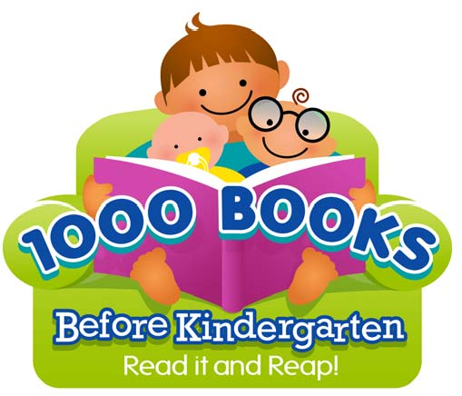
www.1000BOOKSBEFOREKINDERGARTEN.org

51
52
53
54
55
56
57
58
59
60
61
62
63
64
65
66
67
68
69
70
71
72
73
74
75

76
77
78
79
80
81
82
83
84
85
86
87
88
89
90
91
92
93
94
95
96
97
98
99
100

Congratulations! You have completed reading 100 books. Keep up the great work!

Did you know that Dr. Seuss’ first book was And to Think That I Saw It on Mulberry Street ?
www.1000BOOKSBEFOREKINDERGARTEN.org

