THE FREE LIBRARY OF NEW HOPE SOLEBURY
Board of Trustees Meeting Minutes
November 28, 2018

In attendance: Beth Houlton, President; Carol Taylor, Vice-President; Ron Cronise, Treasurer; Polly Wood, Secretary; Doug Brindley, Larry Davis, Joanne Reszka, Kay Reiss, Liz Jordan, Connie Hillman
Also in attendance: Julia Klossner, Pamm Kerr, Karl Varnai, Christopher Whitney

I. CALL TO ORDER – Beth Houlton

The meeting was called to order by Beth at 5:32
MOTION by Larry, to approve the October minutes. SECONDED by Ron, APPROVED by all.

II. FINANCE REPORT – Ron Cronise
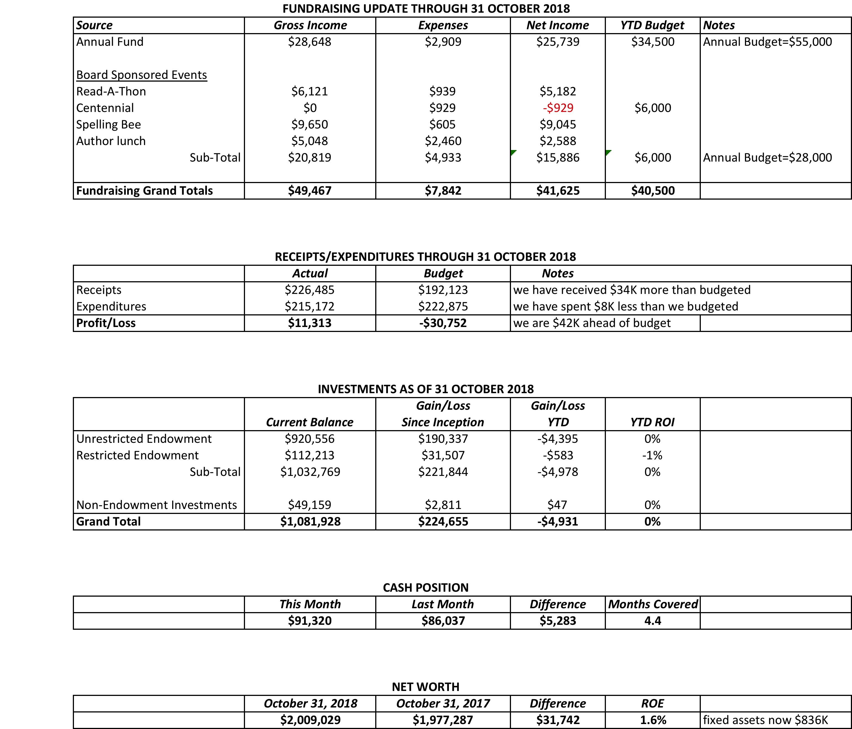

- Treasurer’s Report
- Propose 2019 Operating Budget
Discussion ensued regarding different items in the budget. One idea would be for Ron to add a line item regarding transferring funds from our fundraising in the amount of $10,000 to the endowment. Email reminders have gone out reminding people of our fund drive. Discussion was then tabled to be discussed further at the next meeting. New Hope still doesn’t have a budget for 2019 but we are assuming that we will not be getting an increase.

III. DIRECTOR’S REPORT – Connie Hillman
Programs and usage: We’ve been on a great run in terms of program attendance in October and it looks as though the trend is continuing through November. In October, 139 adults and 178 children attended programs at our library. E-circulation continues to increase, up by 22% this year.
Township: Ron, Larry and Connie attended several budget meetings with New Hope Borough.
Computer replacement: IT replaced two of our public use computers. We were able to reconfigure one of the old computers to be used as a catalog computer in the children’s department at no cost. Thanks to the Friends of the Library for funding the new computers.
Outreach and Trainings: Connie attended a Titlesource training for book ordering. She will also be attending the SEPLA workshop on December 7 on community relations. Patricia will be attending the state summer reading workshop on December 13. (The state requires full time staff to attend a stipulated number of continuing education trainings each year.)
We got a $3,000 grant from The PA Dept. of Health and Human Services. The check should be coming in January.

IV. BUILDING/PROPERTY

V. DEVELOPMENT – Doug Brindley
Doug has suggested that we have a bigger discussion regarding a major appeal now that the Bee has passed. Perhaps we could do this in January. Beth pointed out that we have accomplished many of the goals we set out for 2018 but Development is still an area that we need to tackle more successfully.

- Spelling Bee Follow-up – Polly
Christopher Whitney spoke about his experience with the Bee. He also spoke highly of the library and all that it offers. Doug offered up congratulations to Connie for her role in the Bee. All concurred!
- Annual November Appeal Progress – Liz
We need to raise more funds still as we are behind in what we are hoping to raise.
- Read-A-Thon 2019 Planning – Beth
Beth and Ellen have been meeting for a couple of months. They have a new committee member this year helping them. They are hoping to shift the running of the Read-A-Thon to new blood in the hopes that it can be reinvigorated. This year they will be offering a prize to the biggest fundraiser. They hope this will incentivize people to go back to fundraising more as this has dropped off. It will take place in January as usual. This is the sixth year!

VI. MARKETING – Liz Jordan
Larry has mentioned that he would like another board member to replace him on the Delaware River Towns chamber. It is good PR for the library.

VII. GOVERNANCE – Kay Reiss

- Vote to Approve New/Revised Policies
Connie mentioned that Doylestown does not have a social media policy, so we are the pioneers. Liz mentioned that there is not anything mentioned regarding reposting articles on the library’s website. This has been done but we don’t have any particular parameters. We do have something about comments on articles and our rights to remove content etc. so this just needs a little tweaking. We don’t allow others to repost as it stands. We will modify this and vote on it next month.
MOTION by Ron, to approve the proposed revisions to management policy 15 (Bulletin Boards) and governance policy 1 (Organizational chart). SECONDED by Larry, APPROVED by all.
- New board members for January 2019

VIII. FRIENDS’ REPORT – Karl Varnai
The FOL is ending their fundraising for the year. They have about $20,000 in the bank. This will be used to cover the shelving in the children’s area and money for the book on Gay History. They will discuss with Connie items on her wish list. The FOL also has two new board members. Pamm spoke with the FOL in Lambertville. They are interested in establishing an interconnection between the two organizations.
There will be a tour of Paxson Hill May 25 at 10:00 a.m., which will include the private gardens.

The meeting was adjourned at 6:58.

[EXECUTIVE SESSION for board members to follow end of regular meeting to discuss a personnel request.]

Respectfully submitted,
Polly Wood
Secretary

