THE FREE LIBRARY OF NEW HOPE SOLEBURY
Board of Trustees Meeting Minutes – Draft Copy
December 19, 2018

In attendance: Beth Houlton, President; Carol Taylor, Vice-President; Ron Cronise, Treasurer; Polly Wood, Secretary; Liz Jordan, Larry Davis, Kay Reiss, Joanne Reszka, Connie Hillman, Doug Brindley
Also in attendance: Colin Jenei

I. CALL TO ORDER – Beth Houlton

The meeting was called to order at 5:33.
Ron introduced Colin Jenei to the board.
MOTION by Ron, to approve the November meeting minutes. SECONDED by Joanne, APPROVED by all.

II. FINANCE REPORT – Larry Davis
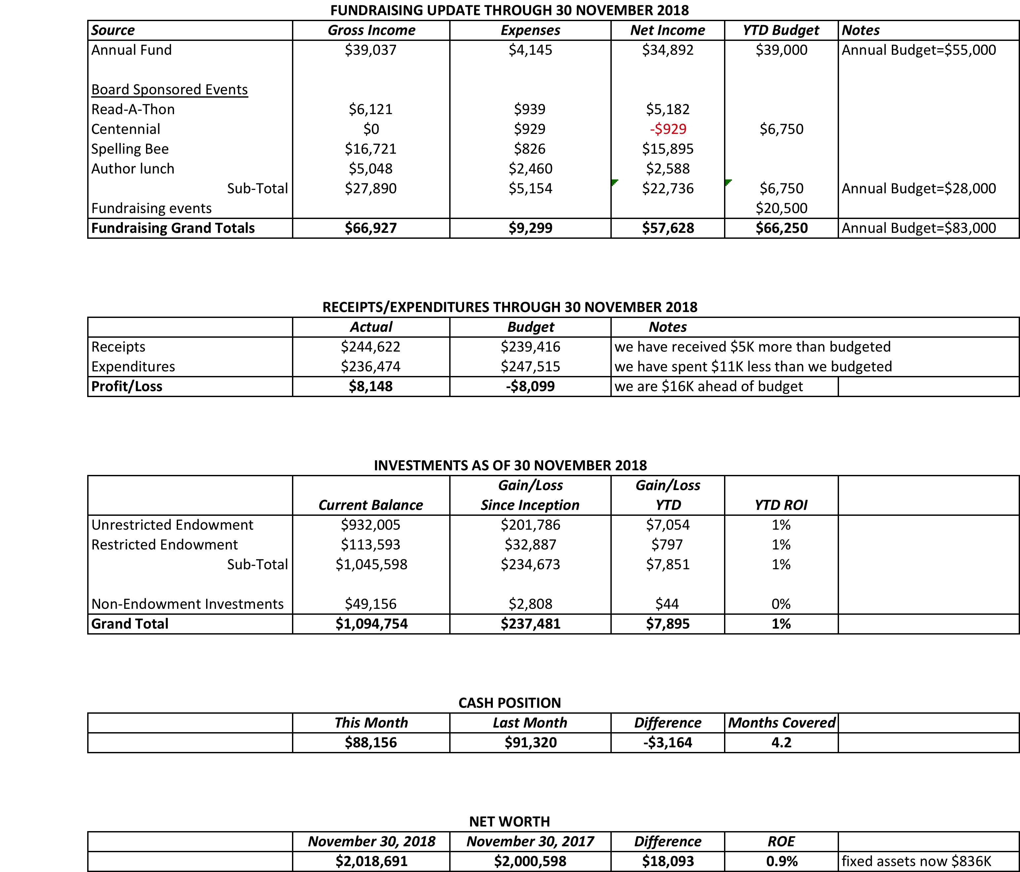

- Treasurer’s Report
- Approve 2019 Operating Budget
Ron reviewed the 2019 proposed budget.
MOTION by Ron, to approve the 2019 Operating Budget. SECONDED by Larry, APPROVED by all.
Ron has asked both Solebury and New Hope for the final amounts owed for the year. Solebury will most likely pay prior to the end of the year but New Hope will probably pay in the new year as they wait until they have collected taxes.

III. DIRECTOR’S REPORT – Connie Hillman
- District Information: BCFL has purchased Gayle Analytics for 2019 to help analyze the usership in their service areas to better direct services and advertising. They will be running these reports for each library when their contract goes into effect at the beginning of the year. Hopefully, we can get some good information from it so that we can increase our donor base.

- Plan for the Use of State Aid has been completed and submitted to the state.

- The Friends have agreed to give us up to $270 to purchase better floor mats for the foyer. Not only will this be a big help during the winter months when rain, snow and salt create a slippery situation in the foyer, but it will also help with sound deadening.

- Connie is currently working on staff evaluations. They should be completed by the end of the month.

IV. BUILDING/PROPERTY

V. DEVELOPMENT

- Annual November Appeal Progress
It has picked up a bit but we still need to build up our donor base.
- Read-A-Thon 2019 Planning – Beth
Planning is well under way. It is being publicized more as a fundraiser as this point seems to have been lost over the past couple of years. Ellen and Beth are running it again this year but bringing on a new member, Katheryn Polito, to eventually take over the fundraiser with a co-chair.

VI. MARKETING – Liz Jordan

VII. GOVERNANCE

- Vote to Approve New Social Media Policy
MOTION by Liz, to approve management policy 21 (social media).
SECONDED by Kay, APPROVED by all.
- Carol Taylor has resigned from the board as of December 31, 2018.
MOTION by Polly, to appoint Colin Jenei as a new library Board member, to serve a “C” term from January 1, 2019 through December 31, 2021. SECONDED by Ron, APPROVED by all.
MOTION by Polly, to appoint Julia Klossner as a new library Board member, to serve the remainder of Carol Taylor’s “B” term from January 1, 2019 through December 31, 2020. SECONDED by Doug, APPROVED by all.

- Vote to Appoint New Officers for 2019

Proposed Slate: President – Ron Cronise
Vice President – Liz Jordan
Treasurer – Larry Davis
Secretary – Polly Wood

MOTION by Beth to approve the proposed slate of officers for 2019. SECONDED by Carol, APPROVED by all.
- Reminder – January Board Planning Session
The meeting is January 12. It starts at 8:30 at Thompson Church. Ron will send out a reminder. The meeting should run to 1:30.

VIII. FRIENDS’ REPORT
No report

Respectfully submitted,
Polly Wood
Secretary

