THE FREE LIBRARY OF NEW HOPE SOLEBURY
Board of Trustees Meeting Minutes
JANUARY 16, 2019

In attendance: Ron Cronise, President; Liz Jordan, Vice-President; Larry Davis, Treasurer; Polly Wood, Secretary; Kay Reiss, Joanne Reszka, Julia Klossner, Colin Jenei, Doug Brindley, Connie Hillman
Also in attendance: Pamm Kerr

I. CALL TO ORDER – Ron Cronise
The meeting was called to order at 5:30.
MOTION by Doug, to accept the December meeting minutes. SECONDED by
Larry, APPROVED by all.

II. FINANCE REPORT – Larry Davis
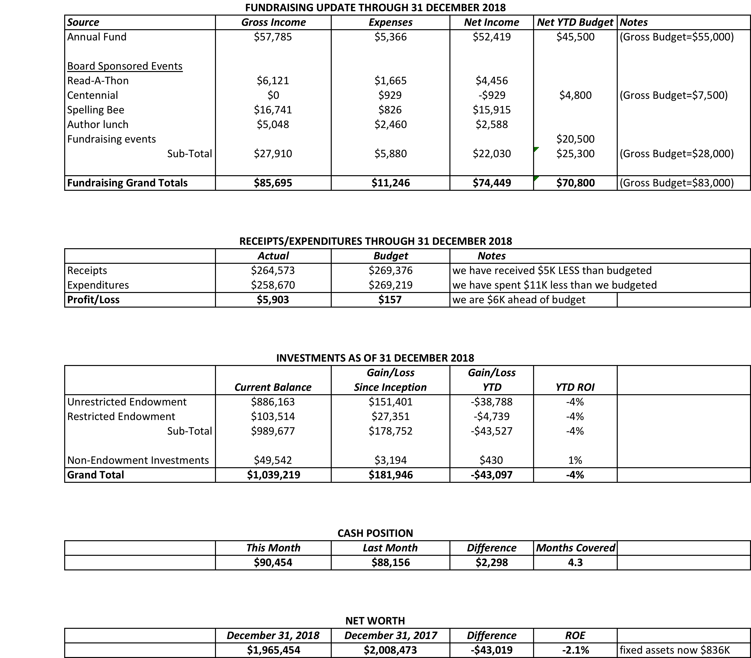

The board needs to raise $78,700 this year to meet our budget.

III. DIRECTOR’S REPORT – Connie Hillman
- Staff evaluations have been completed.
- Annual report. The information for the annual report will be coming from Chris Snyder, our district consultant, by the end of this month. It is due back to her by March 1. This deadline is firm. Linda and Connie work on this, Ron will need to sign off. We will need at least a working draft of our financials by mid-February, so that we can fill out the financial side of the report.
- S.T.E.A.M---this is becoming a major library initiative for 2019 and beyond. We will now be counting statistics for this on our annual report. Look for an increase in S.T.E.A.M. programs for all ages in the coming months.

IV. PROPERTY – Larry Davis
The front door continues to present a sticking problem. With heating and cooling, the wood expands and it is very difficult to open. Connie will give Larry the name of the contractor and he will contact him.

V. DEVELOPMENT – Doug Brindley
Doug has written a letter that we could send to larger donors. The question is: Is this how we wish to proceed? Should we do a test with a few donors first?

VI. MARKETING – Liz Jordan
Liz handed out updated copies of the elevator pitch. The spring appeal is coming! Liz would like to get it out by April 1. The national library week theme this year is: Libraries = Strong Communities. The marketing committee will be meeting in a couple of weeks to get the appeal underway.

VII. GOVERNANCE – Kay Reiss

Pamm mentioned the FOL ongoing raffle. She also asked the new owners of Poppy’s greengrocer if they could have a book sale there. River Cat Café also has a pop up book sale for the FOL. They are still looking for a place in town for a big book sale. May 25 will be a private tour of Paxson Farm to benefit the FOL. Ron asked if Pamm could get a list of dates for FOL events to the board so we don’t have any conflicts of dates.

The meeting was adjourned at 6:04.

Respectfully submitted,
Polly Wood
Secretary

Adjourn to Executive Session

