THE FREE LIBRARY OF NEW HOPE SOLEBURY
Board of Trustees Meeting Minutes – Draft Copy
February 21, 2019

In attendance: Ron Cronise, President; Liz Jordan, Vice-President; Larry Davis, Treasurer; Polly Wood, Secretary; Connie Hillman, Joanne Reszka, Julia Klossner, Colin Jenai, Doug Brindley
Also in attendance: Beth Houlton
I. Call to Order – Ron Cronise
The meeting was called to order by Ron at 5:30
MOTION by Liz, to accept the January 2019 Meeting Minutes. SECONDED by Joanne, APPROVED by all.

II. Report on RAT Results – Beth Houlton
The Read-A-Thon had 287 participants. Revenue was $4,153 (as well as a corporate donation that has not been received yet). Key chains were made to give out to participants and a large number are left over that we can use for future fundraising. There is a big drop in the number of participants. We don’t know why there are fewer than previous years, but the numbers have dropped. They did not have sponsors this year, as it has not raised much money in the past. The amount of hours that goes into the Read-A-Thon might outweigh the amount raised. We will discuss the future of the Read-A-thon at the March meeting.

III. Finance Report – Larry Davis
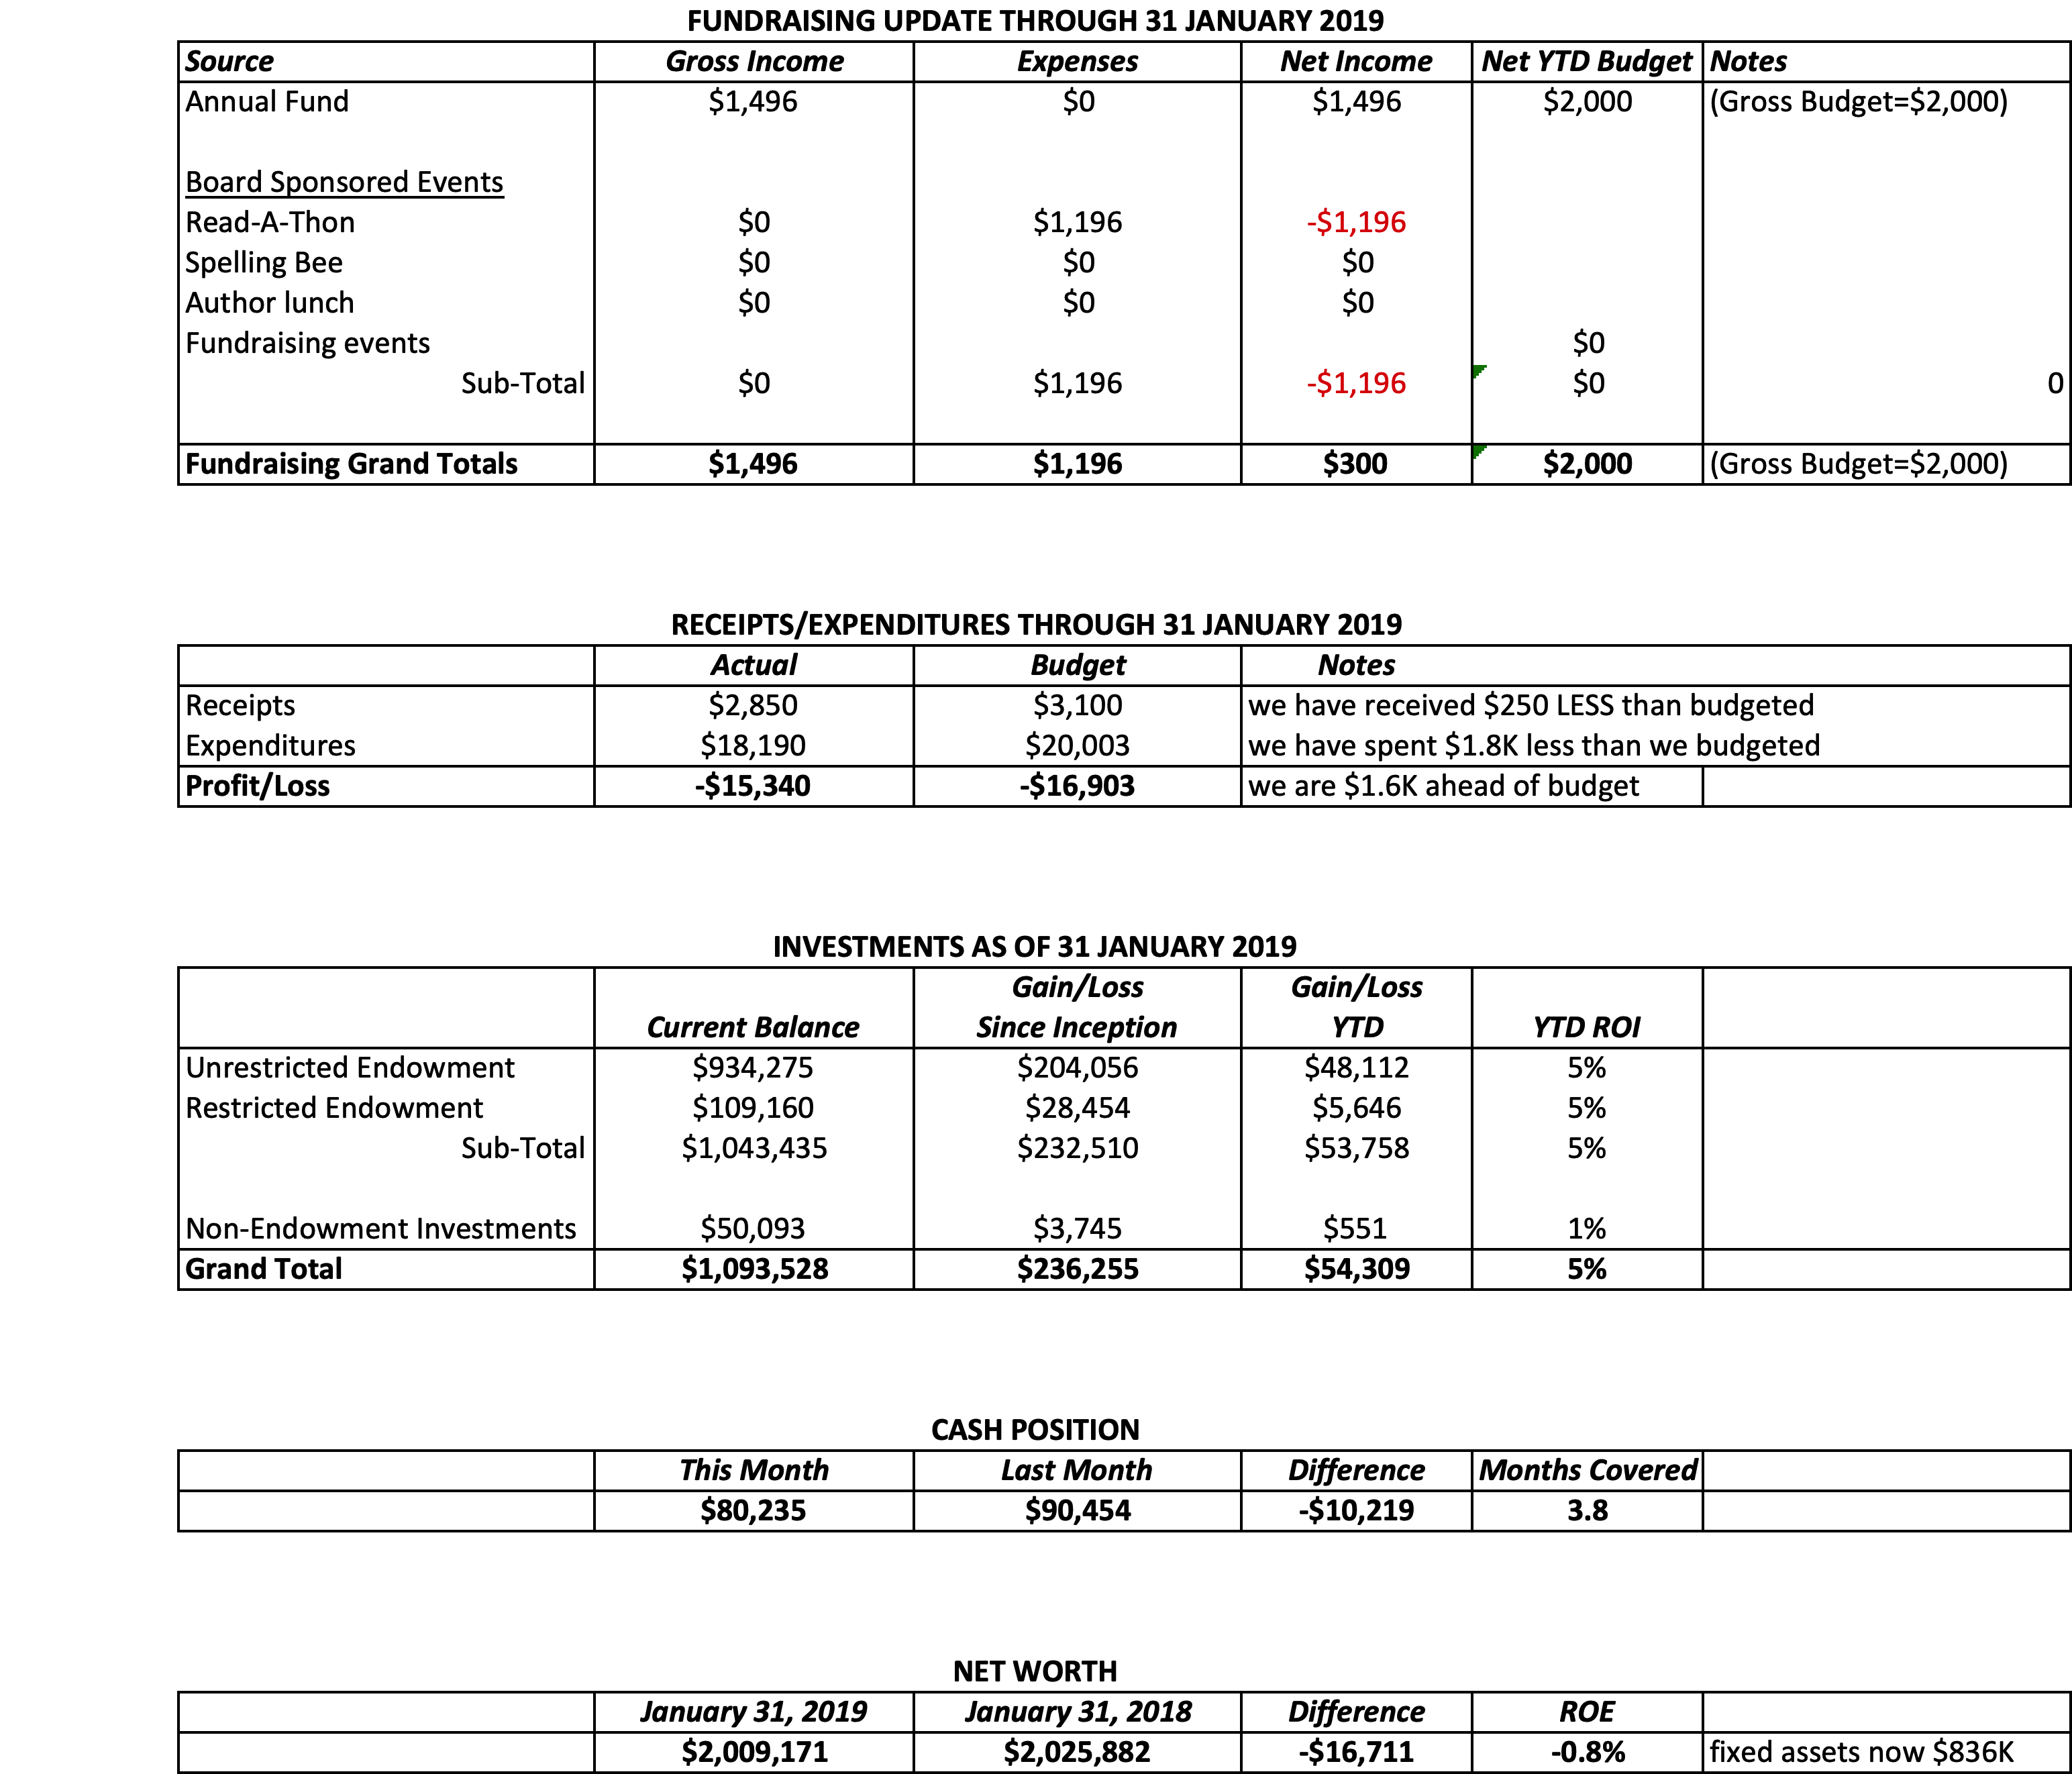

IV. Director’s Report – Connie Hillman
- Connie attended the DLC meeting to work on the annual report. Last year, our numbers dramatically increased, largely due to the new method of counting statistics. Unfortunately, other libraries did not fare as well, so this year, the district reverted to the old way of counting.
- Some changes to the annual report mean that we will begin counting things a bit differently on our monthly statistics. We are including a breakdown now for STEM programming for adults, teens, children and preschoolers. This is now a new section of the annual report.
- The annual report has a hard deadline of March 1. Linda has been giving Connie the most updated Profit and Loss reports. She will send the entire annual report to Ron and Larry at the end of this week so that they can review in order for her to send to Chris Snyder, our district consultant, by March 1. This is very important, as we want to cooperate with the state in order get our funding.
- Connie met with Dr. Chris Lentz, the new superintendent of the NH-S School district. He is very willing to partner with us and help us promote library services within the schools.
- The library closed early at 3pm on 2/12/2019 due to treacherous road conditions.
- There will be a board workshop the second Saturday in June. It is a state requirement that all library boards be represented at these trainings. Connie will send the information out as soon as she gets it.

V. Property – Larry Davis
Larry followed up on the issues with the front door sticking. It cannot be changed from wood to metal (per HARB). They are going to shave it down again and check on some drainage issues near the door.

VI. Development – Doug Brindley
Development met to discuss the appeal to major donors. They agreed to write a letter to those falling within the upper demographic explaining who we are and what we do. It would have an emphasis to stress that we are self–sufficient and hopefully lead to some one on one conversations with potential donors. These would be targeted to those not already on our donor list.

VII. Marketing – Liz Jordan
The spring appeal is on target. The look is being refreshed. Liz will put it on Dropbox for review by the end of March so we will be ahead of National Library Week. Liz and Joanne are working on ideas for a library card push. Once people have a card, we will have them in our system.

VIII. Governance – Kay Reiss

IX. Spelling Bee – Polly Wood
There will be a spelling bee meeting next Tuesday, the 27th at 5:30 at the library. We are confirmed with the school for Friday, October 4. One idea for this year is to have an area set up in the lobby for people to sign up for library cards.

X. Friends Report
Upcoming FOL events:
April or May – A Taste of New Hope with the Greater New Hope Chamber of Commerce
May 18 – NH Gay History Book to be sold at Pride Parade
May 25 – Paxson Hill Farm – guided tour of the entire property
November 2 – Country Blast at Havana
Dec. 1 – FOL march in Christmas Parade
Book Sale – TBD

Respectfully submitted,
Polly Wood
Secretary

