THE FREE LIBRARY OF NEW HOPE SOLEBURY
Board of Trustees Meeting Minutes
March 20, 2019

In attendance: Ron Cronise, President; Liz Jordan, Vice-President; Larry Davis, Treasurer; Polly Wood, Secretary; Julia Klossner, Colin Jenei, Connie Hillman, Doug Brindley

I. CALL TO ORDER – Ron Cronise
The meeting was called to order by Ron at 5:30.
MOTION by Larry, to approve the February 2019 Meeting Minutes. SECONDED by Doug, APPROVED by all.

II. FINANCE REPORT – Larry Davis
  - 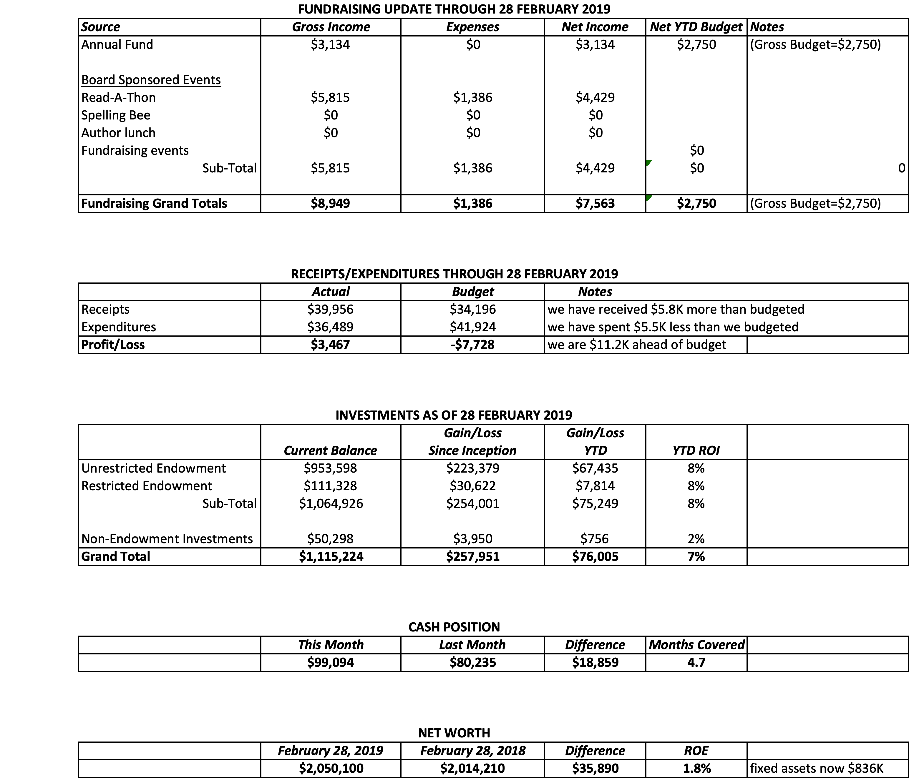

We got our check from the state in February. Larry handed out copies of a new report that we have to provide for our auditors. It is a functional expense report that shows what percentage of our overall expenses goes towards library services vs. overhead.

III. DIRECTOR’S REPORT – Connie Hillman
- The library opened at noon on Monday, March 4 due to a snowstorm.
- The annual report has been submitted and on its way to Harrisburg. Chris Snyder, our district consultant, extends her thanks to everyone who helped us make our deadline.
- Chris will be attending our April board meeting to give all board members an overview of the library structure and funding. This is important information for all board members, so please bring any questions you may have.
- The Friends of the Library will be giving us a check for $2,500 to cover the costs of upcoming adult programming. We’ve been getting a lot of compliments on our adult programming.
- We will be attending Wendi Thomas’ Senior Expo on April 18. In other outreach activities, Darcy has been paying monthly visits to area preschools and also holding pop-up story times at different venues such as the Lumberville General Store, Rivercat Café, etc. She is getting quite a following. This summer, she will continue her outreach with our area EXPLORE programs and story times in both Solebury and New Hope parks.
- Connie was contacted by Connie Gering from New Hope Borough Council for a photo opportunity with her and Solebury supervisor Mark Baum-Baiker. The two municipalities want to present a more united front, so as part of this campaign, will be coming to the library on March 26 to present us with our checks. I have been talking with Liz about ways the library can capitalize on this photo op.
- We received an invoice for our Internet connectivity in the amount of $656.13, which is due in August. This rate is based on the 50% of the 2013 rate. BCFL has been paying the other 50%. However, beginning in 2020, we will need to pay the full amount of our connectivity fee, which is estimated at $1,653.36. Connie will address this further at the board meeting.
- This fall, BCFL will be launching several pop-up library mobiles, which they intend to be part of festivals, parades and other events all over the county. These mobiles will have different focuses: technology, family fund and book sale. We can opt for them not to come to a specific event in our service area if we feel that it will conflict with our library.
- June 8 is the Trustees workshop
- The Haley Foundation will fund our summer reading program again.
IV. READ-A-THON – Julia Klossner
Discussion on continuing R-A-T. At this point, the funds raised have decreased considerably for all the work involved. Perhaps in the future when we are not dependent upon the fundraising piece, we could revisit this event. We will revisit this in 2020 to see if there is interest in bringing it back.
Collin has suggested an alternate fundraising idea. He will pursue this further and we will discuss details in the future. It has the advantage of tapping into people who are not regular library supporters.

V. PROPERTY – Larry Davis
Larry has not had an opportunity to reach out to HARB about our door.

VI. DEVELOPMENT – Doug Brindley

Discussion on letter to Experian database. Doug and Julia wrote a letter for potential donors. The question is whether this should be for our regular campaign or Development to try to get new donors or people to think of the library in their wills etc. Liz looks at marketing as going to the broader base list that we have and perhaps a few more. This message might be for a smaller list that has a higher income level and might be acquainted with some board members. Discussion ensued regarding whom to target with the letter. Ron has suggested that there should be a joint meeting between marketing and development to make a clear delineation between the two.

VII. MARKETING – Liz Jordan
Liz has suggested that we all have an email signature to help identify us as members of the library board. It looks more professional and cohesive. She will help us to set one up.
The spring appeal has been mailed (yesterday), so it should be arriving in people’s mailboxes Saturday or so. It is going to over 3200 people. Liz is working on the thank you letter that will go out to those who donate. There is a program called Double the Donation. It will enable people to tell if their donation is eligible for matching donations from their place of work. Spelling Bee forms have all been updated. Our library card drive is the month of April. There is a postcard at the printer which will go to library non-patrons encouraging people to get a library card. It will go to the top three lists on the Experian list, which is more than 1700 addresses. As part of the spring appeal, we are pushing the “card-a-friend” event. If you get a friend to sign up for a library card, bring them in during April and both of you will get free library key chains! This will not cost us anything as we have the key chains. Connie and Liz have been thinking of a small fundraiser, which would be a scavenger hunt/murder mystery. People have to find all the clues around town and they can get a prize at the end.
April 7 – 13 is National Library Week.

VIII. GOVERNANCE – (Kay Reiss)

IX. FRIENDS REPORT
The FOL will be participating in the Pride Parade. They need a pick up truck. Their new book will be out at that time. They are still looking for a book sale sight but they are currently storing books for the future sale.

Respectfully submitted,
Polly Wood
Secretary

