THE FREE LIBRARY OF NEW HOPE SOLEBURY
Board of Trustees Meeting Minutes
April 17, 2019

In Attendance: Ron Cronise, President; Liz Jordan, Vice-President; Larry Davis, Treasurer; Polly Wood, Secretary; Connie Hillman, Colin Jenei, Kay Reiss, Joanne Reszka, Doug Brindley

I. CALL TO ORDER – Ron Cronise
The meeting was called to order by Ron at 5:30.
MOTION by Doug, to approve the March minutes. SECONDED by Liz, APPROVED by all.

II. FINANCE REPORT – Larry Davis
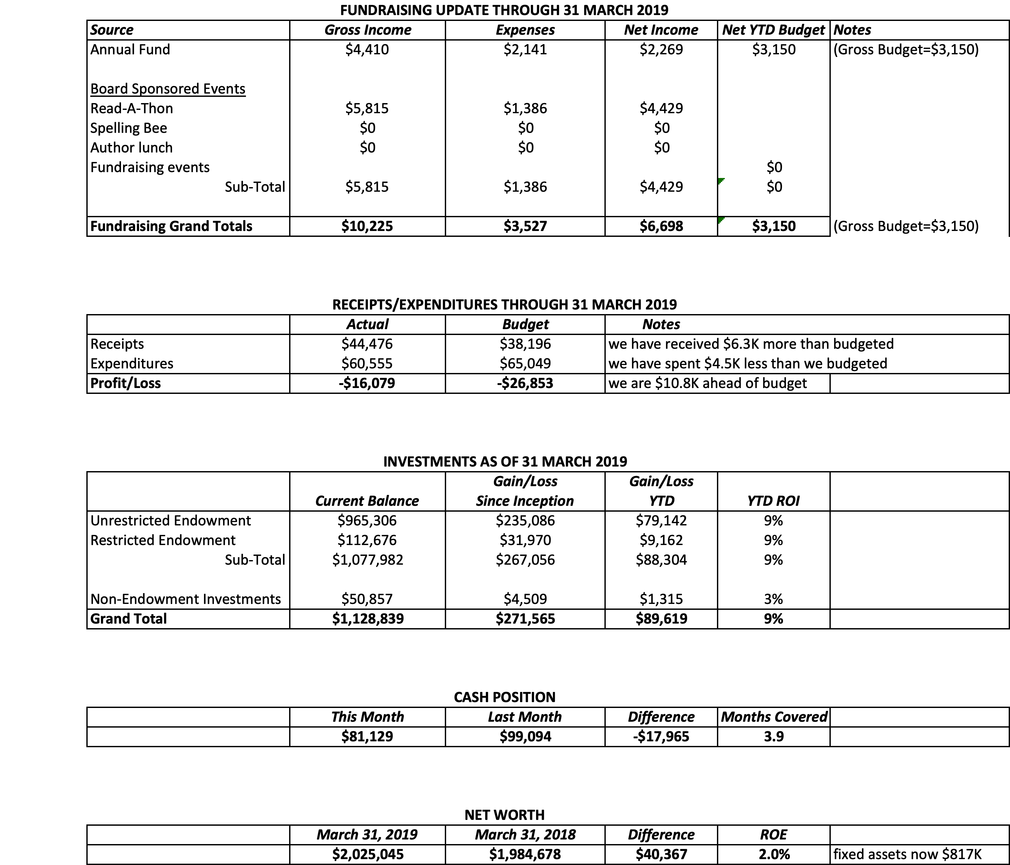
We are still awaiting some checks for the Read-A-Thon.
Larry also had copies of the audit report, which was briefly discussed. We have a clean report!
III. DIRECTOR’S REPORT – Connie Hillman
- The Haley Foundation committed to a $5,500 check in support of the summer reading program this year. We should receive the check at the end of April.
- The Friends of the Library gave us a check for $2,500 to cover the costs of upcoming adult programming.
- We are still waiting for the $3,000 direct deposit from the PA Department of Health for yoga programs. Connie will call at the end of April if it still has not arrived.
- Members of the staff will be attending Wendi Thomas’ Senior Expo on April 18.
- New Hope Borough and Solebury Township came to the library on March 26 to present the library with their respective checks and a photo op. (Since then, we received the real check from New Hope for $10,000). All went very well.
- We had a visit from Susan Pannebaker from the Office of Commonwealth Libraries. She was here for our DLC meeting and came by, as she had never been in our library before.
- Connie attended two online workshops as part of her continuing education credits: Library Data and Evaluation and Strategic Planning in a Deeply Weird World. Both workshops encouraged reconfiguring data and planning in non-traditional ways. Circulation across the country is on the decline. Other statistics, however, have been going up. E-circulation, tutoring in the library, programs are all going up. Hoopla and Overdrive are all used yet not recorded.
- Kyle Brucker came to plane the front door. It’s his feeling that the gutters are overwhelmed, thus flooding the downspout by the front door and causing the water to cascade over the door. This makes the door swell up. We can either create an overhang to deflect the overflow or use a small metal stripping above the door to deflect the water.

IV. PROPERTY – Larry Davis
The planing has helped the front door.

V. DEVELOPMENT – Doug Brindley
Liz, Julia and Doug met. They see no conflict and virtually no overlap in Marketing and Development functions, although they see opportunities for closer coordination, information sharing and common work products going forward (perhaps more than previously understood in actual practice).
The spring appeal should be permitted to run its full course in the immediate weeks ahead, prior to any strategic appeal by development, so as to avoid inadvertent overlap and confusion (of potential donors).
Once we have outcome statistics on the spring appeal (over the next month or two), the two committees will work together to analyze the donor information and to cross-reference with our other data sources (historical giving, as well as the wealth demographics) in order to focus the long-imagined strategic appeal to high-end targets.
Marketing will help to develop materials for the development appeal, which in its first incarnation is likely to attack the endowment build-up challenge.
The contacts and outcomes derived from the endowment challenge may then be further refined as we shift toward the search for a major donor to fund the new library building down the road--although should such a "name" donor emerge in the short run, we will apply all necessary energy to cultivating that relationship under your direct guidance.

VI. MARKETING – Liz Jordan
SOFA 2019
Mailed March 19
Sent to current and past donors
Quantity: 3,350 ($.79 a piece)
Cost $2,655 – Breakdown:
- Graphic design: $514 (includes graphic for email and Facebook)
- Envelope printing: $414
- Mailer printer and mail prep: $1,262
- Postage $465

Also:
Thank-you Letter (goes on our stationery)
5 email and Facebook reminders, sending weekly

Weeks 1 & 2: 43 donors gave $8,648.50

Library Card Drive / National Library Week

Postcard “Invitation” Mailed Week of April 1
Quantity: 1750 addresses (American Royalty, Platinum Plus & Silver Sophisticate)
Cost: $610

Patron Email and Facebook support with April “Card” a Friend campaign (giving out keychains)

Joanne wrote a great letter in support of National Library Week and our Library to the Bucks County Herald (printed in April 11 issue)

Met with Development Committee (Doug and Julia) April 5

Publicity for 2019 Community Spelling Bee

Meeting: Polly, Joanne, Liz and Connie April 10
Liz: Updated forms for 2019, sent in listing to Delaware River Towns, created new Bee flyer
Connie: updated website
Joanne creating Facebook event page, adding to local calendars

VII. GOVERNANCE – Kay Reiss

VIII. SPELLING BEE – Polly Wood
We reviewed who would approach which businesses that ran last year and assigned board members certain advertisers. Liz discussed what camera ready art looks like. Joanne discussed the Spelling Bee Facebook page.

IX. FRIENDS REPORT

X. OTHER ITEMS

Colin has spoken with Cheryl Baldi about doing a poetry reading fundraiser for the library. She has just had her first book of poetry published and we could do an event at the 1740 House.
Possible dates could be: October 7 or 21, or November 4 or 11. The board has suggested that Colin check on November 4. Colin suggested a ticket price of $75 - $100, which would include light fare and drinks.

At Ron’s request, Peter Stamphl and Ron met on 16 April 2019 at his office located at 711 Hyde Park, US Route 202, Doylestown, PA 18902. The business phone is 215/345-4609. This location is also the headquarters of ReAlliance, a real estate development company owned by Peter and a partner.

Ron thanked Peter for honoring the commitment originally made by Bob Hillier when he first applied for permits to develop the Cintra property.

Peter and Hillier have not settled yet though they have an agreement and Peter did not indicate there were any problems going forward.

He plans to start renovations and additions in mid-2019 that are likely to conclude near the end of 2021, perhaps as late as early 2022.

He would prefer that we wait until he has finished his work before we start our construction. At the earliest that would be the spring of 2022.

Ron asked about topographic information and all surveys have been completed and the drawings are at Van Cleef Surveying in Doylestown.

They discussed design and construction costs and Peter feels that the 5000 sq. ft. building currently approved could be built for under $3.5 million including soft costs, paving, landscaping and furnishings.

26 April is Volunteer Appreciation Day at 6:00 p.m.
07 May is initial 2019 meeting with Solebury and NH Borough
15 May next Trustee’s Meeting at 5:30
6 June is the Trustees workshop

Respectfully submitted,
Polly Wood
Secretary

