THE FREE LIBRARY OF NEW HOPE SOLEBURY
Board of Trustees Meeting Minutes
May 15, 2019

In attendance: Ron Cronise, President; Liz Jordan, Vice-President; Larry Davis, Treasurer; Polly Wood, Secretary; Julia Klossner, Colin Jenei, Connie Hillman, Doug Brindley, Kay Reiss
Also in attendance: Pamm Kerr

I. CALL TO ORDER – Ron Cronise
The meeting was called to order by Ron at 5:30
MOTION by Larry, to accept the minutes of the April 17, 2019 Meeting. SECONDED by Doug, APPROVED by all.

II. FINANCE REPORT – Larry Davis
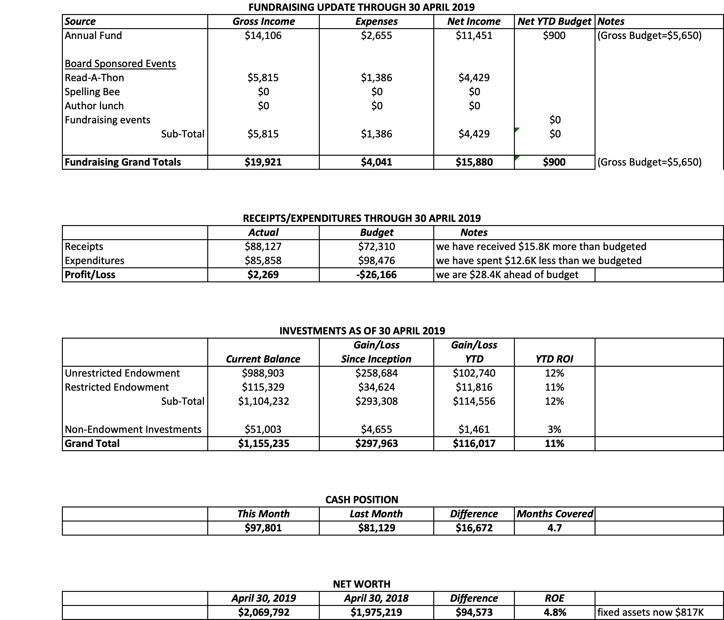
Investment Performance
Larry had emailed an updated investment report and also posted in Dropbox.

III. DIRECTOR’S REPORT – Connie Hillman
- We received the check from the Haley Foundation for the summer reading program. The Foundation also sent an additional check for $5,000 to go toward the cost of new shelving in the children’s department.
- We are still waiting for the $3,000 direct deposit from the PA Department of Health for yoga programs. Apparently our vendor number and bank account number are correct in the state database, but the DHS had the wrong coding on it. Hopefully this problem is now resolved.
- Connie attended two more webinars toward continuing education for directors: Dealing with Difficult People and Creating Community Dialogue in Your Library.
- We honored our volunteers with an appreciation party on April 26. Judy Jones and Charlie Huchet were honored as volunteers of the year.
- Connie attended Wendi Thomas’ Senior Expo on April 18. FOL’s Carol Spencer manned the table with me. The event was not as well attended as in the past.
- Connie met with middle school ESL parents to give them information about the library and obtain library cards for their children.
- Darcy Fair will be attending Carversville Day on behalf of the library on May 18.
- Due to heavy rains over the weekend of April 26, water seeped in through the stone walls of the dungeon (cellar at the front of the library) leaving a musty odor in the building. We left the doors open on a day when it was NOT raining to air the place out and it seemed to help. Larry stopped by to take a look. While it seems to be okay and drying out, there does not appear to be a way for condensation to leave the area (he will address).
- Connie had a meeting with the CPL directors on May 10. Apparently BCFL is looking at a way to take fine payments online. This could have a negative impact on our cash flow. So far this is just in discussion.
- Connie and Doug will be meeting soon to discuss strategic planning.
- Connie pointed out that our e-circulation numbers only include Overdrive. It does not include Hoopla or any other online service including other site services we offer such as Ancestry.com. This means our e-circulation numbers are most likely much higher. Our library represents about 2.7% of all the Overdrive downloads in the county. We are one of the highest. As the other sites cannot be broken down by library, Connie and staff are using this number to try to see how many more downloads and online usage we might have than are reflected in our numbers.

IV. PROPERTY – Larry Davis
Proposal to correct front door swelling
Moisture Problem in Basement
Offer to do additional planting at rear of property

V. DEVELOPMENT – Doug Brindley
Julie, Liz and Doug will be meeting before the June board meeting and hope to present a list of people to approach for larger donations.

VI. MARKETING – Liz Jordan
Right now we are in the final stages of the Spring Appeal. We are starting to get a few more sustaining donors. We are up to 11. We have five new donors thus far.

Colin has written a letter inviting people to come to Cheryl Baldi’s reading. Cheryl will give us a list of people to invite. There was some discussion regarding sending a letter of invitation or a more formal invitation.

VII. GOVERNANCE – Kay Reiss
Kay has asked Colin to join the Governance committee.

VIII. SPELLING BEE – Polly Wood
Joanne has gathered a number of raffle items. Board members are asked to continue soliciting ads and raffle donations as well as try to solicit teams.

IX. FRIENDS REPORT
Tomorrow night there will be a poetry event fundraiser at Ferry Market. On Saturday, the LGBT stories of New Hope will launch. The FOL has asked people to help pass out buttons and march at the Pride Parade this weekend.

X. OTHER ITEMS
07 May meeting with Solebury and NH Borough
Ron met with representatives from New Hope and Solebury. He took them through the website and showed all the library has to offer. He also went over financials and all the milestones the library accomplished last year. It was a very good meeting. They were interested in helping the library (although not necessarily with more money), and Ron gave them a list of ways they could help with the Spelling Bee, our biggest fundraiser.
19 June next Trustee’s Meeting

Respectfully submitted,
Polly Wood
Secretary

