THE FREE LIBRARY OF NEW HOPE SOLEBURY
Board of Trustees Meeting Minutes – Draft Copy
June 19, 2019

In Attendance: Ron Cronise, President; Liz Jordan, Vice-President; Larry Davis, Treasurer; Polly Wood, Secretary; Joanne Reszka, Julia Klossner, Doug Brindley, Kay Reiss
Also in attendance: Pamm Kerr

I. CALL TO ORDER – Ron Cronise
The meeting was called to order at 5:30.
MOTION by Joanne, to approve the minutes of the May 15, 2019 Meeting. SECONDED by Doug, APPROVED by all.

II. FINANCE REPORT – Larry Davis
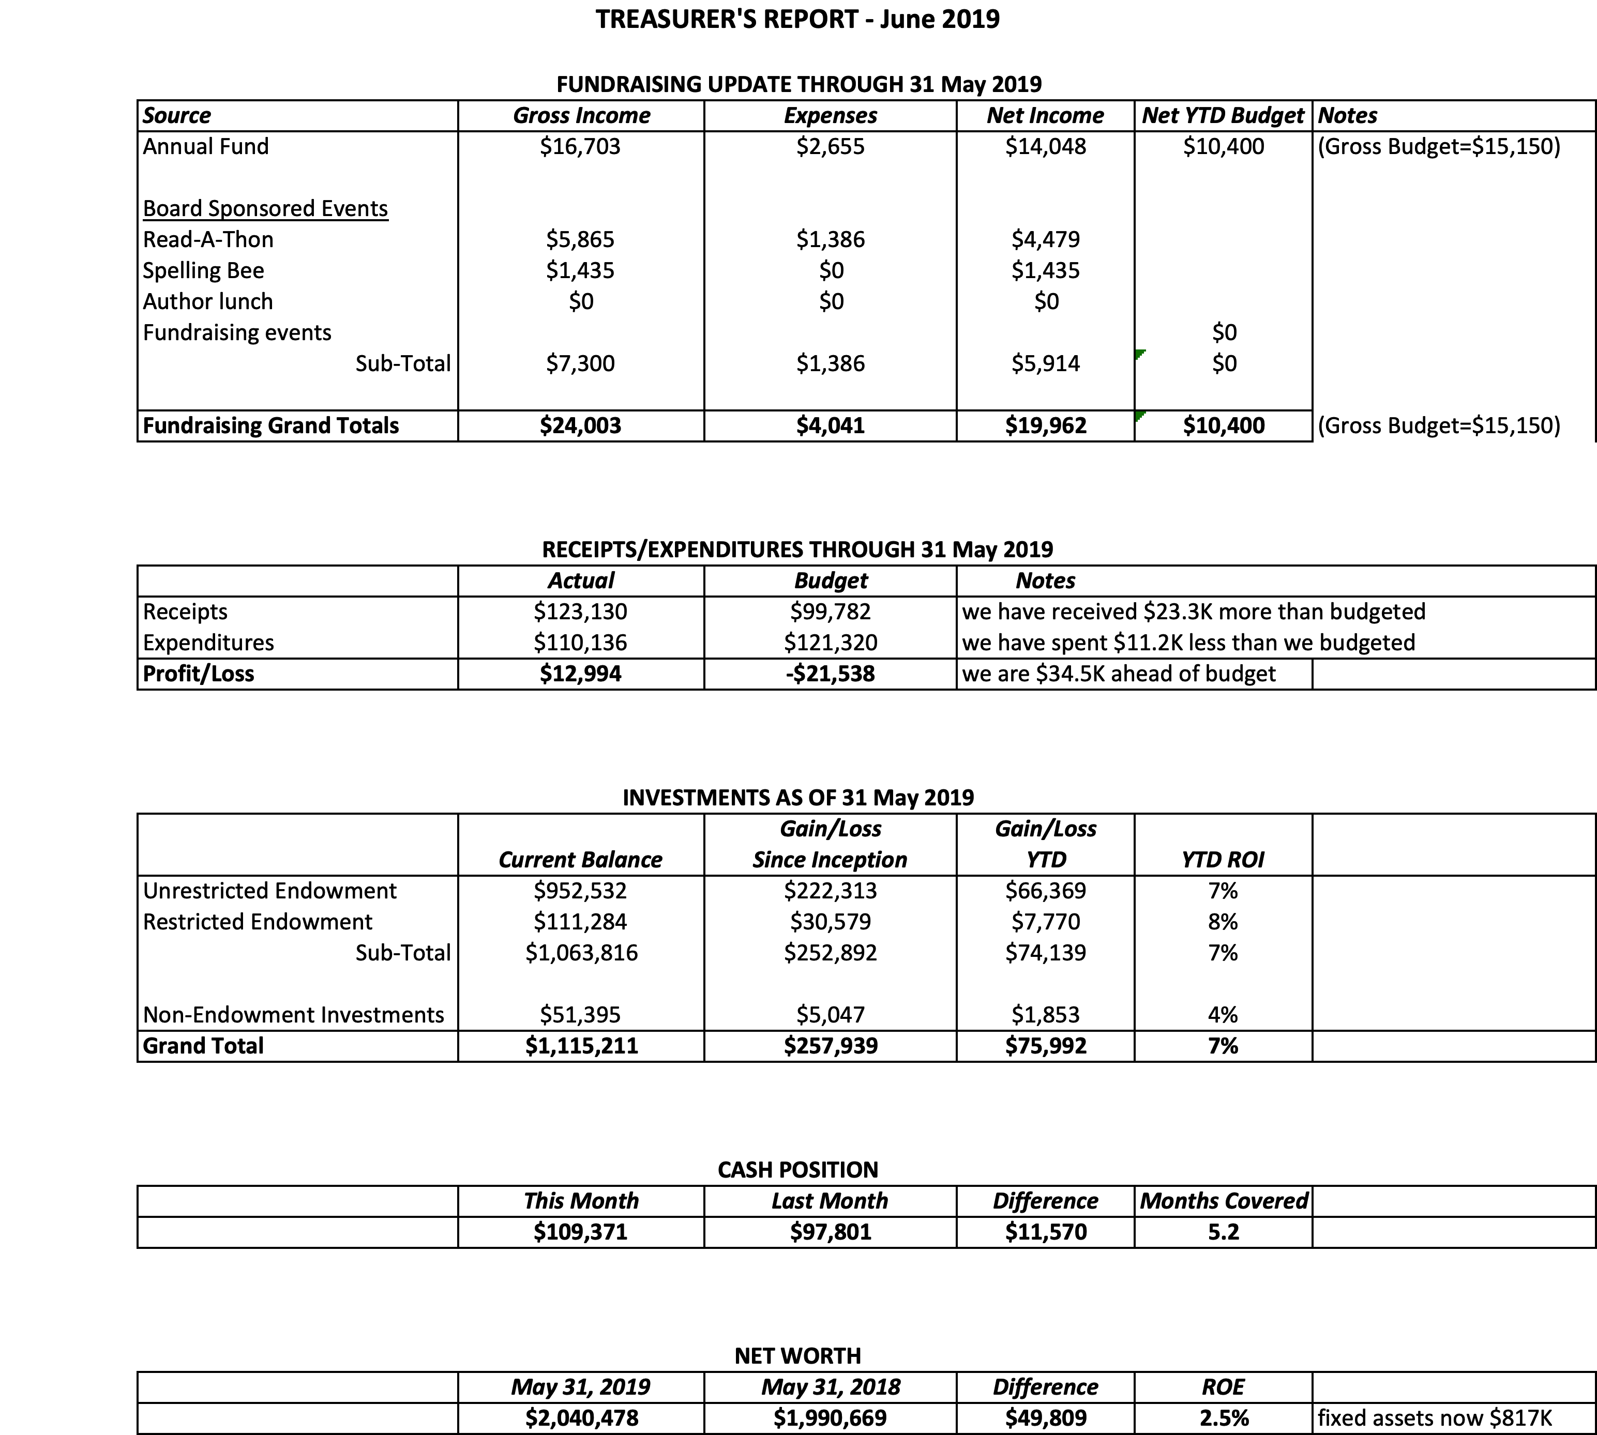
Investment Performance
Investments are doing reasonably well. Income is being reinvested.

III. DIRECTOR’S REPORT – (Connie)
- We are releasing information on our new Curbside Pickup program through our usual channels to prepare patrons for this new addition to our services. So far, people like the idea. A sign will be ordered next week. We are very excited. It is a July 1 kickoff.
- We finally received the payment from the state for the yoga program. After all the back and forth and setting up accounts for direct deposit, they sent us a check. We are now planning for the program to take place this fall.
- Patricia and Connie attended Wendi Thomas’ Senior Expo.
- Connie presented Summer Reading and general library information to ESL parents at the Upper Elementary on May 13.
- Darcy Fair attended Carversville Day on behalf of the library and also was a guest speaker on WDVR. While the radio broadcast was really about her work as a harpist, she was able to put in a nice plug for the library.
- Doug and Connie met to begin discussion on the new strategic plan.
- Summer Reading is just beginning. For the past month, Darcy, Patricia and Connie finalized plans, advertised our programs through the usual channels, visited schools to promote the program and distributed reading logs to get the kids started. Programs are filling up and we are hoping for a good turnout.
- Building issues:
  - We had some dampness seeping into the children’s department following the severe rains. Vic Lance came and gave the gutters a good cleaning, so hopefully things won’t overflow.
  - The fire alarm started sporadically going off, again after the heavy rains at the end of the month. Holicong ended up coming out three times to address this, resulting in a hefty bill which Larry was able to get discounted. At present, things are fine and up to date.
- Pamm Kerr has a proposal to place another sculpture on library property. Connie will allow her to present it to the board. However, we do use the outdoor space for programming, so it would be helpful to remove the old sculpture before adding a new one. Connie sent photos out to all board members.
- Quick and dirty fundraising:
  - Thanks to Joanne’s idea, we are now able to accept donations via Facebook. You may have seen fundraisers generated individually where the person asks people to donate to a particular charity as a birthday (or other occasion) gift. Joanne is very loved, because she generated over $900 in donations with her fundraiser. Facebook doesn’t charge a fee, so we get the full amount of the donation.
  - During the month of July, Giant will donate $1 for every $2.50 reusable bag sold. This is a particular bag sold at the register that has “Love is All You Knead.”. We don’t have to do much more than get the word out there.

IV. PROPERTY – Larry Davis
Update on fire alarm malfunction

V. DEVELOPMENT – Doug Brindley

VI. MARKETING – Liz Jordan
Spring appeal is now wrapped up. We raised a little over $14,000. The number of sustaining donors has increased. We will bring back the “Card a Friend” campaign in the fall. The materials are in good shape for the Cheryl Baldi event.

VII. GOVERNANCE – Kay Reiss
We are working on recruiting new board members. People with finance and fundraising experience are a plus.

VIII. SPELLING BEE – Polly Wood
Diana Michaels Gift certificate
McCaffrey’s sponsorship
Ron and Julia will approach a couple of other donors for jewelry

IX. CHERYL BALDI EVENT – (Colin Jenei)

X. FRIENDS REPORT
Pam Kerr regarding additional sculpture
Pamm sent along pictures of the three-piece sculpture for the board to review. She will get Ron in contact with the artist so he may ask questions regarding the voltage etc.
Tuesday, June 25 will be the book launch on the gay history of New Hope. They are $20 each and the profits will be split between New Hope Celebrates and the FOL.
Tomorrow is the monthly poetry event at Ferry Market. The FOL gets 10% of proceeds from food sales. June 26 is the Taste of New Hope event.
November 2 is the Country Blast.
The FOL will be volunteering at the car show in August.
There will be pop up book sales on the porch of a shop on Main St.

XI. OTHER ITEMS
21 June meeting with Wendi Thomas
Connie and Ron have reviewed what Ron will be talking about with Wendi to make sure he covers all the points we wish to present to Wendi. He would like to ask for federal funding.

Next meeting is July 17. Both Polly and Larry will not be able to attend.

Executive Session following regular meeting

Respectfully submitted,
Polly Wood
Secretary

