THE FREE LIBRARY OF NEW HOPE SOLEBURY
Board of Trustees Meeting Minutes – Draft Copy
July 17, 2019

In Attendance: Ron Cronise, President; Liz Jordan, Vice-President; Colin Jenai, Joanne Reszka, Julia Klossner, Doug Brindley, Kay Reiss and Connie Hillman. Excused: Larry Davis and Polly Wood. Also attending: Karl Varnai

I. CALL TO ORDER – Ron Cronise called the meeting to order at 5:26. MOTION by Doug to approve the minutes of the June 19, 2019 Meeting. SECONDED by Kay, APPROVED by all.

II. FINANCE REPORT – Larry Davis submitted the following report in advance. Ron spoke to the financials and noted that one of the reasons that receipts are down is that the Library has only received $10,000 from Solebury Township.
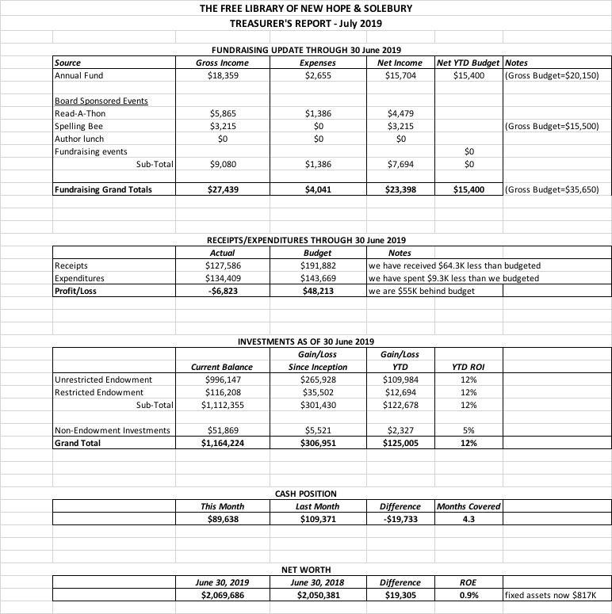

III. DIRECTOR’S REPORT – Connie
- Curbside pickup service has begun. We’ve had a few patrons using it thus far and they seem very pleased. Please spread the word to help encourage the use of this service.
- We have been invited to be a part of Wendi Thomas’ KidsFest on September 21, which will be held at St. Martin’s. The Library will be represented.
- Summer Reading is well underway. We continue to be busy with programming and reading logs
- Building issues: One of our air conditioning blowers died and needed to be replaced. The total cost was about $526. The alarm is also going off again. Holicong Security will come out again and promise not to charge.
- The Friends of the Library told Connie that they should have the funding ready for the new shelving in the children’s department shortly. Connie is working on getting an up-to-date estimate for the shelving, removal of the old shelving and any prep work that might be necessary for the installation. Thank you to the FOL for all of their hard work!
- Connie was approached by Karina Raude, a local artist who is currently working with the Upper Elementary on an interactive mural. Ms. Raude asked if the Library might want to install a mini-version of the mural here. Money and space are of course the main issues. Connie met with Dr. Michael McKenna, principal of the Upper Elementary School, to discuss the feasibility of the project, in particular the cost, which was estimated at $30,000. Neither the school nor the library has this sort of money to dedicate to the project, so it was decided that the project be tabled for the time being.
- Good news from the state! The new budget which was just passed includes a $5 million dollar increase to the public library subsidy. After the funding cuts in 2007, our funding has been flat at best, so this is very good news. Advocacy works! Thanks to Ron and everyone who works to keep the library at the forefront of any political discussions.

IV. PROPERTY – Larry was excused from this meeting. Property issues were discussed within the Director’s report. However, the Board did discuss the issue of signs marking the Library’s spaces on the north side of W. Ferry Street. (See Marketing.)

V. DEVELOPMENT – Doug Brindley
Doug and Julia are currently working on next steps on who to approach, what talking points to hit and how to best deliver the development message. They plan to beta test this with appropriate members of the community before rolling out.

VI. MARKETING – Liz Jordan
- Julia, Joanne and Liz had a very informative session with Chris Snyder, Bucks County Library District Consultant, on June 21. In addition to learning more about the public library system in PA and how it works, they discovered that there are District services available to support the Library’s marketing efforts.
- On July 26, the Marketing Committee and Connie will meet with Regina Fried, the District’s Marketing and PR Consultant, to review the Library’s materials and tap into her expertise on library marketing, PR and development.
- Additionally, the Marketing Committee is working on Bee publicity and program and planning ahead for the Cheryl Baldi event and NOFA mailing.
- Joanne spoke about the Double the Donation program and how it might work to increase corporate match donations. Double the Donation has a $499/year subscription fee. Connie is going to investigate other similar options as well as turn back on some of the messages (receipt of donation, etc.) that are available through eTapestry.
- Lastly, Liz presented photos and ideas about the parking signs on the Library spaces across the street.
  - Two signs are very faded and hard to read. Information is outdated (mentions parking meters).
  - Colin confirmed that the parking spots are for Library patrons during Library hours according to a Borough ordinance.
  - While it is impossible to monitor the use of the parking spaces, replacing the signs and painting “Library” on the spots will alleviate confusion, especially for out-of-towners.
  - Liz suggested this for the copy: Reserved for Library Patrons, M-W 10 am-7 pm, Th-Sat 10 am-5pm.
  - Polly (in absentia) had offered to bring up the signage issue with EJ Lee and Connie Gering (Borough Hall and Borough Council) in September.
  - Kay also mentioned that there is a parking spot at the High School that is marked “Library.”

VII. GOVERNANCE – Kay Reiss
Work on recruiting new board members is continuing, and resumes will be posted on Dropbox. Joanne will ask Dr. Michael McKenna to attend the August Board meeting.

VIII. SPELLING BEE – Joanne Reszka
- Connie reviewed the process of how to deliver checks for ads/sponsorships for the Bee.
- Kay encouraged Board Members to seek out more raffle prizes.
- Joanne asked Board Members to post flyers and help work on getting teams.
- Bee yard signs will be printed for August.
- Joanne is increasing Facebook posts and other publicity. Press releases to the Patch, Courier Times/Intel, Herald, plus online resources, have been sent.
IX. CHERYL BALDI EVENT – Colin Jenei
Colin updated the Board that the date and venue are secured (Monday, November 4 at 1740 House). Cheryl has offered suggestions on how to structure the evening for maximum enjoyment (short reading, Q&A session). Her list of invitees will be coming to the Board in late August.

X. FRIENDS REPORT – Karl Varnai

- The Taste of New Hope was a great event for the FOL. Next year, they will plan to announce Board events like the Bee.
- The FOL can now fund the shelving for the children’s room and still has $9500 in uncommitted funds.
- Events on the horizon:
  - Poetry Slam, Thursday, July 18, and every third Thursday.
  - Volunteering at the Auto Show in August.
  - The Pop-up Book Sale on North Main Street has been successful and has already brought in $800 in two weekends. The FOL can accept more book donations, which they hold in a storage unit.
  - The FOL’s Country Blast will be held November 2 at Havana’s. It will be a three-hour afternoon event with line dancing.

XI. OTHER ITEMS
Ron met with Wendi Thomas on June 21 and gave her information about the quality of our library and how we are funded. A packet of grant information will be coming to us. Ron is still trying to meet with Brian Fitzpatrick.

Next meeting is August 14. Polly and Kay will not be able to attend.

Respectfully submitted,

Liz Jordan
Vice President

