THE FREE LIBRARY OF NEW HOPE SOLEBURY
Board of Trustees Meeting Minutes – Draft Copy
September 18, 2019

In attendance: Ron Cronise, President; Liz Jordan, Vice-President; Larry Davis, Treasurer; Polly Wood, Secretary; Julia Klossner, Kay Reiss, Joanne Reszka, Colin Jenei, Doug Brindley
Excused: Connie Hillman
Also in attendance: Dr. Michael McKenna, Pamm Kerr

Introduction of potential Board Member, Dr. Michael McKenna

- CALL TO ORDER – Ron Cronise
The meeting was called to order by Ron at
MOTION by Doug, to accept the minutes of the August 14, 2019 Meeting. SECONDED by Larry, APPROVED by all.

- FINANCE REPORT – Larry Davis
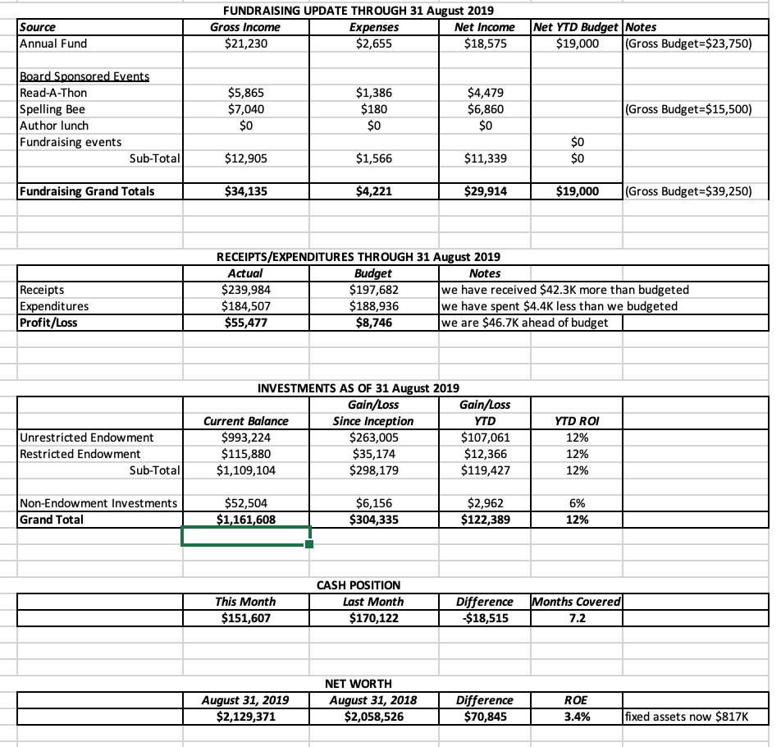
Investment Performance
Review of Proposed Budget
Larry presented a preliminary budget for next year. Discussion ensued.

- DIRECTOR’S REPORT – (Connie Excused)
Summer Reading Statistics: We had 100 preschoolers, 660 elementary aged children and 60 teens counted as participants in our summer reading program. A total of 1,623 participants attended a summer program at the library. A survey conducted at the end of the summer indicated that the programs about the Moon Walk were very popular and Science in the Summer continues to leave a great impression with the children. When asked what they liked about the library, children said they liked to learn new things, read, make new friends and enjoyed the programs. They wished the library had more books, a bigger room for kids, weekend programs and a chess club. We will work on implementing the last two this fall.
Issues with museum passes. Connie reported that two of our museum passes were checked out and were long overdue (well over 30 days). She contacted the patrons several times and neither returned their respective passes. The passes are worth $200 and $250 each and it is a criminal offense in PA to steal library materials, so Connie contacted the New Hope Police Department in order to get our passes back. Neither patron is a member of this community. UPDATE: Thanks to the efforts of the NHPD, the passes were returned. The overdue fines still remain on the users’ cards, but we do have the passes back.
Children’s shelving. Kris Reilly of the FOL asked Connie for a revised quote on the children’s shelving as well as an estimate on the removal of the old shelves. Connie forwarded her a new quote which is pretty close to what it was when we applied for the Keystone Grant. Hugh Marshall came out to give us an estimate on the shelf removal (still waiting to hear) and John Danaher offered to do the job for free, as he is part of a random acts of kindness group. Connie tried to contact him to make sure he understands the full scope of the job. If all goes well, with the FOL approval, we should be able to install the new shelving in January. UPDATE: Hugh Marshall sent Connie an email offering to do the job as a donation to the library. John Danaher would be helping him.
Outreach. In addition to monthly story times at area preschools, Darcy will continue her monthly programs at the Carversville General Store and Lumberville General Store. We met with folks at New Hope Manor to see about making monthly library visits. Darcy also reached out to Rice’s Market and will have them added to her rota this fall. She is going to approach McCaffery’s to see about offering an outreach there. Darcy will also be representing the library at Wendi Thomas’ Kids Fest on Sept. 21.
Upcoming Programs for the October:
  - Women of the Supreme Court (Oct. 1)
  - Horror Movie Quiz Night (Oct. 17)
  - Canvas Painting Workshop (Oct. 18)
  - Cry Witch! A Recreation of the First and Only Witch Trial in PA (Oct. 24)

IV. PROPERTY - Status of Parking Signs – Polly Wood & Liz Jordan
Liz suggested we might take a picture of the sign and post it on Facebook. We also should thank the Borough.
- DEVELOPMENT – Doug Brindley
Julia and Doug met with Jacqui about how to increase the endowment. They are looking for a strategic target. Jacqui suggested starting small with a target group of potential donors. She said she would do a capital campaign for the endowment for the Library. There will be another meeting next week with Ron included. The meeting would focus on what type of event to hold, where to hold it and when. This would be a pilot to see if they can get traction.

- MARKETING – Liz Jordan
There was a meeting a couple weeks ago with Regina Fried, the marketing and PR specialist for Bucks County Libraries, and she can send out our press releases, help us with press releases and media contacts. She suggested doing a patron survey. She offered to help with that. She said we should try to frame the benefits towards what the patrons need or want in their life? The life stage questions: I have a child going to college, I am about to retire, etc. We have the services; we need to present them in a way that would help the patrons.

VII. SPELLING BEE – Polly Wood & Joanne Reszka
Polly will send an email to the teams regarding fundraising on Facebook. Tell teams it is Homecoming and leave time for parking. Carpooling is a great idea.

VIII. CHERYL BALDI EVENT – Colin Jenei
Colin has asked Cheryl for her list of invitees for the event. Tentatively, we will meet next Thursday, September 26 at 4:00 to do the mailing.

IX. FRIEND’S REPORT
A new raffle basket came out today. It has tickets to two shows. There is another pop-up book sale on Sept. 21 & 22. Every third Thursday, there is a poetry slam event at Ferry market. TheFOL are awaiting funds for helping with the car show. The FOL will be getting a check to Connie to cover the cost of the new shelving for the children's area of the library. The initial $9,000 came from The Kerr Foundation last year, with an additional $1,500 this year. The FOL board had promised to match the Kerr donation should the Keystone grant not come through. In the interim, The Huxley Foundation donated $5,000 directly to the library for the new shelving, so the FOL just needs to provide the rest of what's needed, once Connie has a final amount needed. Kris Reilly put out on Facebook a need for the shelving to be taken out. John Danaher and Hugh Marshall offered to donate their services. The current estimate for the shelving is $21,000. The Board is tremendously grateful to the Kerr’s the Huxley’s and the FOL for this extremely generous gift. All of the donors will be mentioned and thanked in some manner. The FOL will also be selling An Enlightened Community at Roy Zeigler’s booth at the New Hope Arts Show.

X. OTHER ITEMS
Meeting with Dan Dougherty – New Hope Borough
Presentation to Solebury Supervisors – 15 October
Meeting with Steve Santarsiero – State Senator
Meeting with Diane Marseglia – Bucks Cty Commissioner
Next Regular Meeting is 16 October

Respectfully submitted,
Polly Wood
Secretary

