THE FREE LIBRARY OF NEW HOPE SOLEBURY
Board of Trustees Meeting Minutes – Draft Copy
October 16, 2019

In attendance: Ron Cronise, President; Liz Jordan, Vice-President; Larry Davis, Treasurer; Polly Wood, Secretary; Joanne Reszka, Julia Klossner, Colin Jenei, Doug Brindley, Connie Hillman
Excused: Kay Reiss
Also in attendance: Pamm Kerr, Karl Varnai

I. CALL TO ORDER – Ron Cronise
The meeting was called to order by Ron at
MOTION by Larry, to accept the minutes of the September 18, 2019 Meeting. SECONDED by Colin, APPROVED by all.

II. FINANCE REPORT – Larry Davis
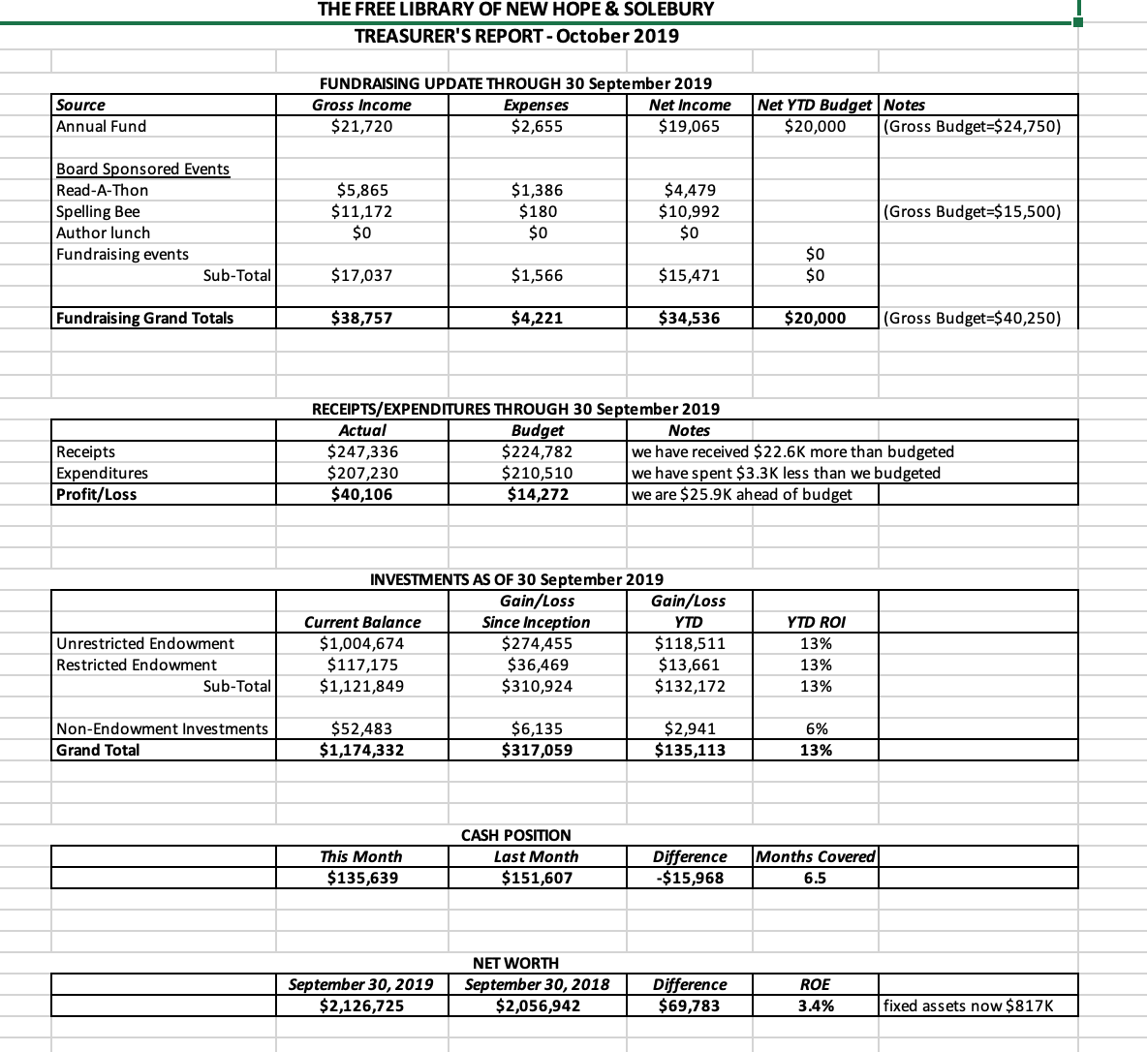
Investment Performance
Review of Proposed Budget
The board reviewed the proposed budget for next year. The Spelling Bee is not included as a fundraiser as it may be moved to January/February.

III. DIRECTOR’S REPORT – Connie Hillman
- Children’s shelving: Angela Benner from Reed Associates was out last week to take a final measure for the children’s shelving. Because there were a few changes, the cost will be slightly higher than the estimate from before. Kris Reilly of the FOL assured Connie that a slight increase will be covered by the FOL. We are looking at an early January installation.
- Two new public computers were installed as per our IT service agreement.
- Operational procedure manual is being revised. This is basically to assist desk staff in the day-to-day operations of the library.
- We are all Bee’d out! Liz and Connie are following up with our team showcase on Facebook this month. Turning to the Cheryl Baldi event, here is how things stand: 14 tickets have been sold ($1,050) and we received $600 in donations thus far.
- Upcoming programs:
  - Doylestown Hospital will be here on October 24 for wellness screenings and flu shots.
  - Jane Faraco, former owner of Havana’s, will be here October 19 from 1pm to read from her recently published memoir.
  - Patricia will be the storyteller at the Bucks County Audubon Society’s Haunted Trails program this weekend. In exchange, the Audubon Society will be presenting a nature program here in December free of charge.
  - We are adding to our yoga lineup in November with StoryTime Yoga for children and Gentle Yoga for older adults. These programs are being paid for by a grant from the Pennsylvania Department of Health.

IV. PROPERTY – Larry Davis

V. DEVELOPMENT – Doug Brindley
Doug, Ron and Julia met with Jacqui Griffith about a very direct, targeted appeal for substantial donations to increase the endowment more rapidly than a seven-year plan. It would initially be targeted at a small group of families. They are working on who they wish to invite. It would occur in early spring.

VI. MARKETING – Liz Jordan
Currently, Liz is working on the November appeal. It is about to go to the printer, and she would like it to be in mailboxes around November 6-9, so it would come after the election. It will go out to about 3,200-3,300 people. Liz asked if we wished to add to the mailing list additional names that are on our Experian list? It would not be personally addressed but “To our neighbors”. This would add about $430 more to the cost. The board felt this would be a good idea and another way to spread our message and raise awareness of the library.

VII. SPELLING BEE – Polly Wood & Joanne Reszka
We discussed feedback we received after the bee and possible changes or new ideas we could do for the next bee.

VIII. CHERYL BALDI EVENT – Colin Jenei
Invitations have been mailed and people are responding. We will not be charged for the event space and Colin has offered to pay for the wine and beer. The board does not need to do anything other than attend.

IX. FRIENDS REPORT – Karl Varnai
The FOL is pleased to hand over the check for the shelving and there will be a photo event on October 29. There are several activities that they are pursuing to raise additional funds. They have raised over $1,500 from the pop-up book sales already. They have also raised over $2,500 so far from the book they published. They would like to have a goal for what project they could raise money for next. Ron suggested that the board could spend some time brainstorming ideas at the January retreat.

X. OTHER ITEMS – Ron Cronise
Nomination of New Trustees
MOTION by Julia, to nominate Michael McKenna and Christopher Whitney to the board of trustees starting in January. SECONDED by Liz. APPROVED by all. MOTION by Colin, to extend Ron Cronise’s term on the board for one more year. SECONDED by Polly. APPROVED by all.

Presentation to Solebury Supervisors – 15 October
Meeting with Steve Santarsiero – State Senator
Ron met with Steve and Steve was upset that we weren’t being funded. A meeting with him, Ron, New Hope and Solebury had been scheduled but had to be cancelled. They have offered some new dates, but these don’t seem to work for all parties.

Next Regular Meeting is November 20 at 5:30.
January planning meeting is proposed for January 11, 2020 from 9-1.
December 18 is the December meeting followed by an executive session at Ron’s house.

Respectfully submitted,
Polly Wood
Secretary

