THE FREE LIBRARY OF NEW HOPE SOLEBURY
Board of Trustees Meeting Minutes – Draft Copy
November 20, 2019

In attendance: Ron Cronise, President; Liz Jordan, Vice-President; Larry Davis, Treasurer; Polly Wood, Secretary; Joanne Reszka, Julia Klossner, Colin Jenei, Kay Reiss, Doug Brindley, Connie Hillman
Also in attendance: Robert McEwan, Pamm Kerr

I. CALL TO ORDER – Ron Cronise
The meeting was called to order by Ron at 5:30.
MOTION by Colin, to Accept the Minutes of October 16, 2019 Meeting. SECONDED by Larry, APPROVED by all.

II. DISCUSSION with Mr. McEwan
Ron introduced Mr. McEwan. Ron mentioned that there are some compliance issues regarding financials and board staffing, which Robert will address. The Nov. 7
Supervisor’s meeting reflected a split within the board for an increase in funding for the library. The board wants to see more community support for the library at the meetings. The motion has helped to push this issue into the next year for a special meeting January 14 at 6:00 pm at the high school. They need to see community support. Ron handed out copies of the PA statutes for local library governance. Solebury residents are allowed to speak. The Supervisors will make their case. The library is not to speak. Mr. McEwan will speak in favor of the increase. The budget for the library is $120,000. It can be amended, which is what we are hoping for. The Supervisor’s would like a bullet point list to help inform the residents of the issues for their website. Mark Baum Baiker announced the BOS is working on a survey for the residents about the financial commitment they want to see for the library. The survey will be on their website and will also be pushed to those who have listed emails with the township.
Ron has said that the Library Board needs to have a meeting to prepare for the January meeting.
We discussed the by-laws. Both the Township and the Borough may appoint two representatives. We discussed how this could/should be done (whether we make suggestions to the Township/Borough or they advertise the openings along with specific qualifications that are needed for the library board).
Also, our financial reports, while on the website, do not go back several years. Perhaps posting a budget or results that would be updated every six months. Also, the audit could be up there. Additionally, our circulation reports could be up there. This could avoid the situation where the Supervisor’s/Council members could say they didn’t have the information in advance.
Ron mentioned that appointing board members by the Township/Council could be challenging. He reviewed the history of board representatives from the two municipalities and how, in the past, we have ensured there were two members from each municipality, and we have sent the names to the respective groups which has always worked out fine. There is a time commitment to serving on the board. In addition to the monthly meetings, members must serve on one or two committees that meet separately, fundraising duties, a financial commitment, as well as attending state meetings for library board members.

III. DIRECTOR’S REPORT – Connie Hillman
- District/State:
  - Our state aid for 2020 is $31,915. This is an increase of 9.18%. Connie has filled out the Plan for Use of State Aid and submitted it to the state. Larry looked it over and validated her numbers.
  - As of November 1, patrons will now be permitted to make online payments toward fines and lost items through our ILS system. Because our circulation agreement between libraries allows the library where the fines are paid to keep the fine regardless of where the check-out occurred, the BCFL will be keeping any fines paid online. We can buy into the system so that any New Hope patrons paying fines online will come to us at a cost of $299 per year. We will have to wait and gather more data before making a decision as to how to proceed.
  - Doylestown has been closed for the past two weeks as they are getting a new roof. We’ve seen an increase in Doylestown library users at our library. All remark on how charming and friendly we are.
- Continuing Education
  - All the staff attended the 2020 U.S. Census Workshop for information on the upcoming census.
  - Connie attended a course on Managing Difficult Volunteer Transitions on October 23.
- Building:
  - The FOL gave us the check for the new shelving and made a special presentation with coverage from the Bucks County Herald on October 29.
  - The glass on one of the main reading room windows is cracked. It is on the outside and probably should be replaced before it gets any worse.
  - One of our story time parents was kind enough to cover the cost of a brand-new vacuum cleaner for the library. We purchased a commercial grade Oreck and it works beautifully.
  - We’ve managed to reconfigure the wiring at the front desk so that we are able to better use the credit card machine for taking payments for fines. All staff has been trained. It is working well thus far.
- Upcoming programs:
  - We’ve increased our yoga offerings to include a Gentle Yoga class as well as a Story Time Yoga class for children. Both have been well received.
  - The New Hope-Solebury-Lambertville Community Choir will be performing at the library on Saturday, December 7 at 3pm. We are having a holiday craft workshop earlier that day at 1pm.
  - For Star Wars fans, we are going to hold a Star Wars Trivia Night for adults and teens on December 19 in anticipation of the new Star Wars installment scheduled for release on December 20. May the force be with us!
  - Colin has suggested that we participate in Winterfest with a poetry competition. There will be a submission competition ahead of time and we will award a prize at Winterfest. The winners will (hopefully) read their poems at Winterfest.
  - Facebook has offered up to 7 million dollars in matching funds for any qualified organization on Giving Tuesday.

Dropbox Issues
Connie has updated with our new credit card which could account for past problems.
McMillan eBook Embargo
They will not sell libraries an ebook until two weeks after its release and then they will only sell one copy. Several libraries are no longer purchasing ebooks from McMillan, just the hard copies.

IV. GOVERNANCE – Kay Reiss
Vote in New Trustees: Christopher Whitney and Dr. Michael McKenna
MOTION by Kay to appoint Christopher Whitney and Michael McKenna to the board starting January 2020. SECONDED by Julia, APPROVED by all.

V. CHERYL BALDI EVENT – Colin Jenei
Wrap-up
Colin suggested for next year, we could do a fundraiser where a painting is donated to the library and Neil Cohen (an artist) come in and speak about it and we do a similar event as the poetry event. Kay would love to see Cheryl come and do an event at the library.
Date for 2020 Spelling Bee – Joanne Reszka
After a bee post-mortem meeting, it was decided that keeping the Bee in early October would be best. This also keeps it in the budget for a fundraiser for 2020. A possible date would be the first Friday in October.

VI. MARKETING – Liz Jordan
Response to NOFA mailing
There were 4100 mailings printed. The cost was $2,800. Liz has created Facebook posts and several emails that will be coming out. The marketing committee will be meeting to discuss what to do in 2020. They are thinking about doing a survey to find out what people want and to see if they are aware of all the services that we offer.

VII. PROPERTY – Larry Davis

VIII. DEVELOPMENT – Ron, Doug & Julia
Meeting with Potential Contributor on 6 November
Presentation tentatively scheduled for 17 April 2020
More at December Meeting

IX. FINANCE REPORT – Larry Davis
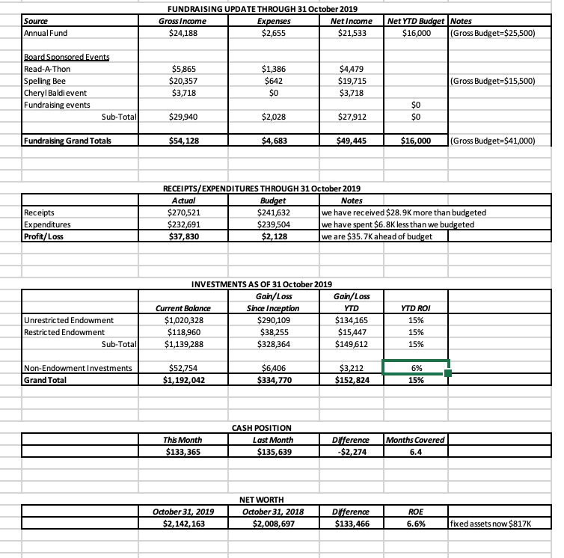

Linda Landis has had some issues with Quickbooks and needs to upgrade to a newer version with a cost of $500. We do not know the history of who pays for this, but she has several clients and we would be willing to pay a portion for our share. Larry will check if this is the total cost or our share.
Approval of 2020 Budget
Larry handed out copies of the budget (as well as placed it in Dropbox). Discussion ensued. There was a motion from the finance committee to approve the budget. The motion passed.

X. FRIENDS REPORT
Karl Varnai will be at the planning meeting in January. The FOL will be walking on Dec. 1 at the Holiday parade. They would appreciate any extra walkers. Let Kris know if you can attend. Victoria Short, (who owns the River Cat building), had offered the FOL the use of the building for a few months. After much back and forth with the borough, they were supposed to get a temporary certificate of occupancy for the book sale. Ultimately, this fell through as the Borough would not issue the certificate. This, unfortunately, has cost the FOL several thousand dollars in revenue.

XI. OTHER ITEMS – Ron Cronise
We will have a meeting December 4 at 5:00 at the library to prepare for the January 14 meeting.
Results from “Powerful Women” Meeting on 13 November
Meeting with Steve Santarsiero (State Senator) 22 November
Next Regular Meeting is 18 December
Executive Session following 18 December Meeting at Ron’s house
Planning Meeting 11 January 2020, 9:00AM @ Thompson Church

Respectfully submitted,
Polly Wood
Secretary

