THE FREE LIBRARY OF NEW HOPE SOLEBURY
Board of Trustees Meeting Minutes – Draft Copy
January 15, 2020

In Attendance: Ron Cronise, President; Joanne Reszka, Vice President; Larry Davis, Treasurer; Liz Jordan, Secretary; Connie Hillman, Julia Klossner, Doug Brindley, Christopher Whitney, Colin Jenei and Mike McKenna. Also in Attendance: Pamm Kerr

- CALL TO ORDER – Ron Cronise
The meeting was called to order by Ron at 5:24 p.m.
MOTION by Doug, to accept the Minutes as amended of the December 18, 2019 Meeting. SECONDED by Colin, APPROVED by all.

- FINANCE REPORT (Preliminary) – Larry Davis

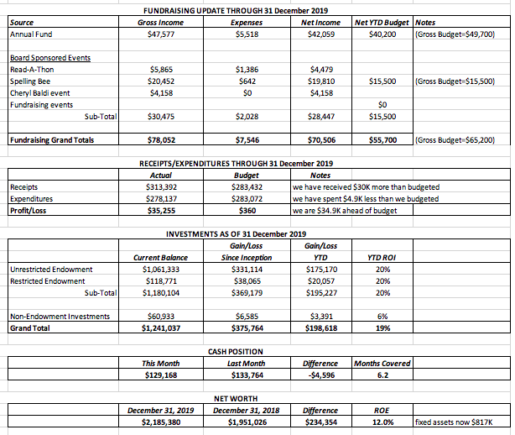
Larry offered these key points regarding the approved 2020 budget.
- It stands at $275,000.
- Annual fundraising appeals are split between spring and fall.
- Board events are budgeted on the low side, as discussed previously.
- Payroll expenses include a 2.5% cost of living increase.

For 2019 “actual,“ certain items have been accrued for the sake of comparison.
- Children’s shelves has been taken out.
- Solebury’s $6,000 contribution has been added in.
- Augenblick distribution of $4,800 has been added in.
- Funds withdrawn from Endowment ($8,000) have been taken out.

Considerations for 2020: hiring an additional part-time staff member and providing an amount for partial health care reimbursement.

- DIRECTOR’S REPORT – Connie Hillman

Building
- The broken glass window has been repaired. Total cost $249.
- Children’s Shelving: The update is well underway. Thanks to Susan Laher and Nick Hillman, all of the children’s shelving were emptied on Monday morning. Demolition of the existing shelving is scheduled to begin Thursday by Hugh Marshall and John Danaher, with installation to begin Tuesday. So far, the project is on target.
Personnel
- JoAnn Kern will be out on a two-month medical leave. We are happy to welcome Ryan Donnelly temporarily to the staff to fill in for JoAnn. Ryan is a college student who currently works at the circulation desk at the Feasterville Library.
- Connie is working on staff evaluations and plans to have them completed by the end of the month.
Other
- On Monday, January 13, Connie attended the first meeting of the New Hope Community Coalition at NH-S High School. This is a group of local agencies that hope to share resources, support each other and create community spirit in New Hope. Mike McKenna is also a part of this group.
- We had approximately 200 entries for our first-ever Poetry Contest that is part of the Winter Festival activities. We look forward to welcoming everyone to an Evening of Hot Chocolate and Poetry, on Thursday, January 23 at 6:30 p.m. to hear the winning entries.
- With emails, Facebook posts and other advocacy to garner attendance for the January 14th Solebury Supervisors forum, it has been a busy month. Thanks to all the staff, volunteers and Friends who helped push attendance at the Solebury Supervisor meeting.
- Thanks to the Friends of the Library for $2,500 donation for adult programming.
- Circulation statistics for year-end 2019 are now in; e-circulation is up 67.9%, and all programming is up.

- PROPERTY – Larry Davis (No report needed.)

- DEVELOPMENT – Doug Brindley
Doug and Connie said that they will soon file a letter of intent to the Norman Raab foundation, asking for a $10,000 grant that will be used on technology and technical updates.

Doug suggested that we set up schedule of meetings to prepare for the April 17 Endowment Event. Mike will be meeting with a high school student as a possible videographer for an overview video. Doug and Julia will coordinate questions to ask hostess Lynn Breen at a kick-off meeting.

VI. MARKETING – Liz Jordan
- Final results of NOFA 2019: 215 total donors (36 new, 3 from Experian list) and $29,640 raised. (2018: 181 donors, $35,717.) We have more donors, more new donors, but we raised less money. It would be a good idea to review list and see if we have lost a major donor or two.

- Board members are asked to write thank-you notes to 2019 NOFA donors whom they know personally. In February, Liz and Joanne will work on a program for realtors. Liz will work with Julia on creating a pledge card and a leave behind for the April 17 Endowment Event.

VII. SPELLING BEE – Joanne Reszka
Joanne put in a request for Friday, October 2, 2020, with the school district’s facilities for next Spelling Bee. Joanne suggests that we seek out outside individuals to serve on Bee committees. We also need to aim for 20 teams, more corporate sponsorships and more unique Raffle basket items.

VIII. FRIENDS REPORT
Pamm asked Board members on Facebook to connect with the FOL. Roy Ziegler will be presenting a writer’s salon on February 24, 2020. The FOL is also looking for page sponsorships for a new book of poetry to be published called Smiles and Smirks.

IX. GOVERNANCE – Colin Jenei

Colin sent a potential update to bylaws for us to consider and work on it the future.

X. OTHER ITEMS – Ron Cronise

Ron commented on the January 14 Solebury Township meeting on future funding. We had a fantastic turnout of library supporters.

Next meeting: February 19, 2020

Respectfully submitted,
Liz Jordan, Secretary

