THE FREE LIBRARY OF NEW HOPE SOLEBURY
Board of Trustees Meeting Minutes
December 18, 2019

In Attendance: Ron Cronise, President; Liz Jordan, Vice-President, Larry Davis, Treasurer; Polly Wood, Secretary; Connie Hillman, Kay Reiss, Julia Klossner, Colin Jenei, Doug Brindley,
Also in Attendance: Pamm Kerr

- CALL TO ORDER – Ron Cronise
The meeting was called to order by Ron at 5:36
MOTION by Colin, to Accept the Minutes of the November 20, 2019 Meeting. SECONDED by Doug, APPROVED by all.

- FINANCE REPORT – Larry Davis

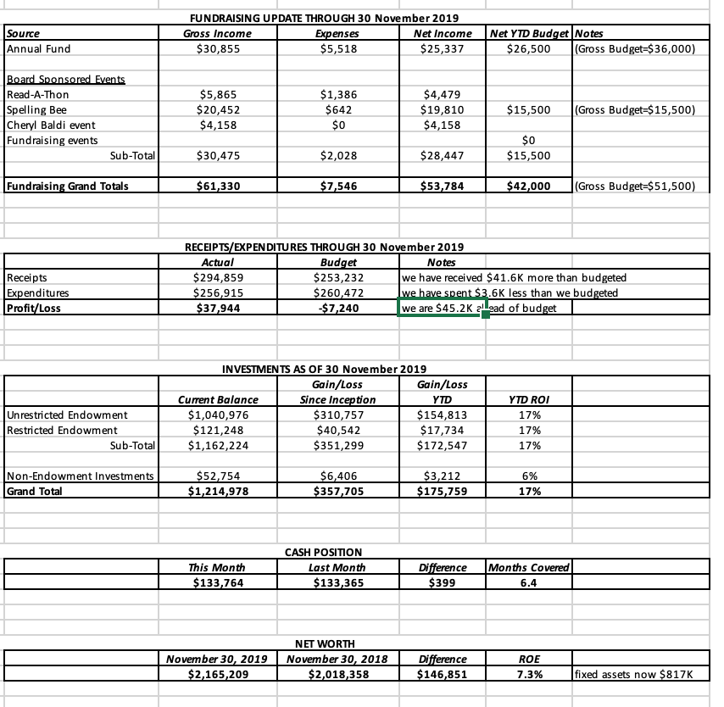

Treasurer’s Report – Larry reviewed the finance report.
Investment Performance – Larry has rebalanced our portfolio after Nov. to keep our assets in balance with our investment objectives.
MOTION by Colin, to authorize Larry to retain Bee Bergvall & Company for 2020 as our accountants. SECONDED by Julia, APPROVED by all.

- DIRECTOR’S REPORT – Connie Hillman
Building:
  - Broken glass. Connie had two estimates regarding the broken window in the front of the library: one for $250, the other for about $350. The issue is that this is antique glass and the glaziers would be using antique glass to replace the damaged glass.
  - Children’s Shelving: We now have some dates for the installation.
    - We will officially be “closing” the children’s department of the library from Monday, January 13 through Saturday, January 25.
    - We will begin emptying the shelves January 13-15. We have been collecting moving boxes for the occasion. The boxes will be stacked in the center of the children’s room so no need for any outside storage. The installers said this should be fine. They will probably need help with the boxing of the books.
    - Hugh Marshall will be removing the existing shelving January 16-17. Hugh will be donating the use of a dumpster (saving us about $300). Connie has already reached out to the Borough as well as the police department to see if we need to do anything else. The new shelving will be installed January 20-21.
    - Reshelving materials will begin January 22-25.
It is entirely possible that we will reopen the children’s room before the 25th, but we are giving ourselves a buffer in case of unforeseen circumstances. A huge thank you to the Kerr Foundation- especially Barbara Olds, Haley Foundation and the FOL for the new shelves!
Quest for funding:
  - Survey: Many, many thanks to Liz for her incredible writing skills.
    - The Solebury Survey went live Monday afternoon. Our email notice went out asking Solebury residents to fill out the survey.
    - Notices have gone out through Social Media. An article was in the Herald. We are asking all Solebury residents who come into the library to fill out the survey. We also have fliers explaining the case for the library at the front desk.
  - Solebury Supervisors Meeting: We plan to push this heavily following the survey. The amazing Liz is preparing Facebook posts and other wonderful verbiage to encourage people to come to the meeting. We’ve already had a number of patrons promise to come.
  - Response from township. Connie has had a number of requests for additional statistical data regarding our circulation from Kevin Morrissey.
Personnel: One of our part time librarians will be out on medical leave for the months of February and March. Connie is looking into hiring a temporary person to replace her during this time.
Our e-circulation stats are down as the person who used to record this information is no longer working at the main library and the job has not been filled.
Giant has chosen us to be the non-profit for the month for January.
Ron pointed out that attendance at events across all ages as well as circulation are up from last year.
IV. PROPERTY – Larry Davis

- DEVELOPMENT – Doug Brindley
Doug has been talking to the Norman Raab foundation, speaking with Sarah Raab. He feels they may be favorably inclined to us via a grant for technology and computer improvement. This could be up to $10,000. Deadlines are the end of January. It is strictly an online process. This is an ongoing discussion.

VI. MARKETING – Liz Jordan
NOFA results – There are no newer numbers than what was already sent out. We have 22 new donors. We still have a few more weeks to go. There will be one more email and Facebook post. Starting in January, we will focus on the Supervisor’s meeting.

IX. FRIENDS REPORT
There is a coloring book ($5) that the Kerr’s wrote and a local artist illustrated that were supposed to be given out at the parade (which was cancelled), but may be given out at the winter carnival. Pamm asked New Hope Cyclery for a donation for the spring. They offered a children’s bike for the raffle in May!

X. OTHER ITEMS – Connie, Polly, Liz
Colin stressed the importance of our openness with both New Hope and Solebury. We are a board, not a standing committee. It would be a huge conflict of interest for New Hope Borough Council or one of the Solebury Supervisors to be a voting member of their zoning hearing boards. The same applies to the Library. One may appoint people but not council or township officials. The people who are vetted by the board and brought on the board may not be out voted by the municipal members. We should review the language of our by-laws for clarification. If we have two Solebury residents and two New Hope residents on our board, we should make sure the municipalities know who they are. We should make sure they know who the representatives are and, if they wish to be more involved in the process, they should let us know. Colin then gave a presentation that he would like to make to the Supervisors and Council.

Report on 17 December New Hope Borough Council Meeting
Next Meeting is Annual Planning Meeting on 11 January 2020

Respectfully submitted,
Polly Wood
Secretary

