THE FREE LIBRARY OF NEW HOPE SOLEBURY
Board of Trustees Meeting Minutes – Draft Copy
February 19, 2020

In Attendance: Ron Cronise, President; Joanne Reszka, Vice President; Larry Davis, Treasurer; Liz Jordan, Secretary; Connie Hillman, Julia Klossner, Doug Brindley, Christopher Whitney and Mike McKenna. Excused: Colin Jenei. Also in Attendance: Pamm Kerr

- CALL TO ORDER – Ron Cronise
The meeting was called to order by Ron at 5:30 p.m.
MOTION by Christopher to accept the Minutes of the January 15, 2019 Meeting. SECONDED by Larry, APPROVED by all.

- FINANCE REPORT (Preliminary) – Larry Davis

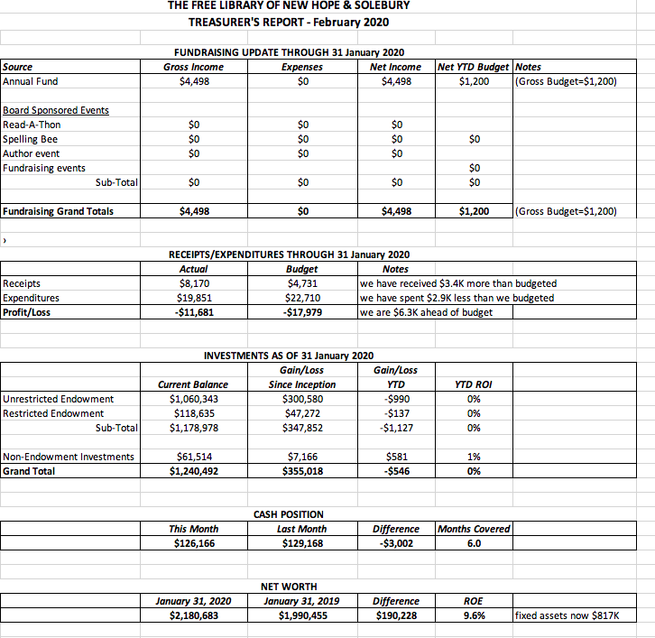
Larry added that investments were flat in January but are holding their own overall.

- DIRECTOR’S REPORT – Connie Hillman

Building
Children’s Shelving: Boxing books, removing old and installing new shelving and returning the collection to the shelves went off without a hitch. Everything looks great, and the Children’s Room was opened a day and a half early. Many thanks to volunteers Hugh Marshall (who removed the shelves for us and took them away), Paul and Carol Spencer, Susan Lehre and Nick Hillman for all of their help. Thank you to the Friends of the Library, The Kerr Foundation and the Haley Foundation for financing the project. No library funds were used for this renovation.
Public Printer: It has been crashing and needs replacing. A patron has donated $200 to be used toward a new printer. Connie has found a printer that can purchased for that amount.
District News
Chris Snyder, The Free Library’s district consultant, is retiring at the end of February. Chris has many valuable years of experience, and her replacement has not been named. Board members Mike and Christopher will meet with her for a board orientation on Monday, February 25 before she leaves.
Due to Chris’s departure, The Free Library’s annual report is now due for review by February 24. Connie will need the end-of-the-year profit and loss statement as soon as possible to complete it by this deadline.
Personnel
- JoAnn Kern’s surgery went well, and she expects to return to work in April.
- Staff evaluations have been completed and delivered to staff.
Other
- Evening of Hot Chocolate and Poetry (January 23, 2020) went very well. Fifty people attended for hot chocolate, coffee, cookies and some delightful poetry. Overall, it was a very enjoyable evening that can be repeated at future Winter Fests.
- The Letter of Inquiry was written and submitted to the Raab Foundation. Doug, who is the contact, hopes to hear that the library has the green light to formally apply for a $10,000 grant to cover replacements of public and staff computers and upgrades to both the hardwiring and wireless network.
- Upcoming programs: February is Mystery Month. Patrons are invited to check out a “mystery” book, attend Neill Hartley’s adaptation of Sherlock Holmes and the Speckled Band (February 20) and learn about the Queen of Crime: Agatha Christie in a presentation (by Connie) on her life and works (February 27). Thank you to Liz and Joanne for promising to provide scones for the event!

- PROPERTY – Larry Davis
The Board discussed the amount of insurance coverage the Library has for its fine arts pieces in response to the Kalmia Club’s offer of a permanent loan of a Fern Coppedge painting. Larry stated that the $50,000 coverage for fine arts is acceptable, and it is not worth incurring added expenses for appraisals and increased coverage at this time.

- DEVELOPMENT – Doug Brindley & Julia Klossner

Discussion about April 17 presentation.
- Julia updated the Board on the status of invitation, which will be mailed on February 24.
- A visit to presentation site will be scheduled.
- The Board discussed speakers and topics, including the value of libraries overall, what The Free Library does and what it brings to the community, the link between of the Library and the school system, and the Library’s future financial need.
- Liz updated the Board on the timeline for a brief video about the history and services of the Library that will premiere at the presentation. Devon Beacham, a NH-S HS senior interested in film studies, has graciously agreed to film this video.

VI. MARKETING – Liz Jordan
- Liz checked in with the Board on the status of thank-you notes to donors.
- Writing the Spring Appeal is in process with the theme: Our Stories, Our Library. The intent is to have it in the mail around May 1.
- Liz and Joanne have been working on an outreach program to local realtors and builders. It includes a short presentation/speech and a leave-behind for the realtors/builders to give to their clients. This piece would be an oversized postcard with information about The Free Library and how to obtain a library card. The print/design estimate for the postcard is: $185/250 and $262.75/500. The postcard could also be used at events like the Senior Expo.

VII. FRIENDS REPORT

Pamm updated the Board on the Mystery Raffle Basket, the book Smiles and Smirks, the writer’s salon on February 24 featuring Roy Ziegler and upcoming events.

VIII. GOVERNANCE

The Board will review the bylaws at the March meeting.

IX. OTHER ITEMS – Ron Cronise

- Ron updated the Board on the Solebury Supervisor’s Meeting on January 21, the appointment of a five-person Task Force and subsequent meetings with Mark Baum Baicker and John Francis.
- Joanne showed the Board information about a potential fundraiser with local cabaret singer Karen Gross.

Next meeting: March 18, 2020

Respectfully submitted,
Liz Jordan, Secretary

