THE FREE LIBRARY OF NEW HOPE SOLEBURY
Board of Trustees Meeting Minutes – Draft Copy
April 15, 2020
The Board met via Zoom teleconference due to the COVID-19 shutdown. Attending: Ron Cronise, President; Joanne Reszka, Vice President; Larry Davis, Treasurer; Liz Jordan, Secretary; Connie Hillman, Julia Klossner, Doug Brindley, Colin Jenei, Christopher Whitney and Mike McKenna. Also attending: Patricia Lynch.

- CALL TO ORDER – Ron Cronise
The meeting was called to order by Ron at 5:31 p.m.
MOTION by Christopher to accept the Minutes of the March 18, 2020 Meeting. SECONDED by Colin APPROVED by all.

- FINANCE REPORT (Preliminary) – Larry Davis

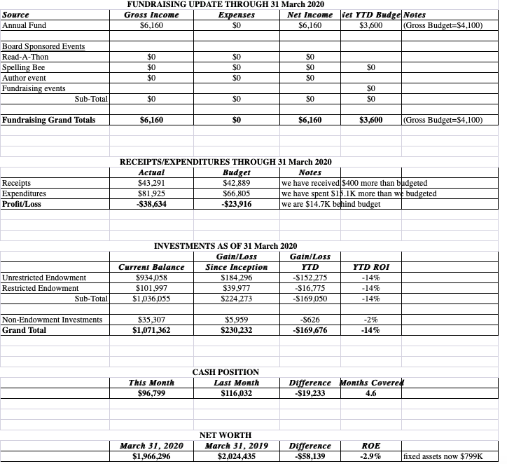
- While investments are on a roller coaster for now, Larry stated that The Free Library’s investments are in decent shape.
- The First National Bank of Newtown now has all of the information they need for the Paycheck Protection Program application. We are now waiting for next steps.
- Results of the audit were consistent with generally accepted accounting practices. There are no issues to talk about. An audit report is available.
- The next check from Solebury Township is expected in July.

- DIRECTOR’S REPORT – Connie Hillman

Operations During COVID-19 Closure
As per instructions of Governor Wolf, The Free Library closed at the end of the day on Saturday, March 14 for a two-week period. That time has recently been extended “until further notice.”
- Initially, the staff was taking turns coming into the Library from 9–12 a.m. each day to perform routine tasks, shelf read and be available for patron questions via the phone or email. By the end of the first week of quarantine, we were ordered to strictly stay at home. Connie is permitted to come in once a week for a short time to get timesheets and bills ready for Linda; she also empties the Book Drop and sorts any incoming mail into quarantine as per the ALA’s instructions.
- The staff is working from home in a number of ways, including attending continuing education workshops and working on virtual programming for our patrons. Everyone is taking a turn.
- Connie and staff have been having regular Zoom meetings to discuss ways to continue to serve our patrons remotely during the quarantine, as well as how to reopen the Library and offer the Summer Reading Program.
Reopening The Free Library
It is highly unlikely that we will go from closed to fully open. Reopening plans cannot be concrete because the situation remains uncertain. We will also follow PA state guidelines for reopening. However, some ideas we are considering in progressive order are:
- Offer curbside pickup/return and delivery drop-off/return. This would allow the staff to work relatively independently and without patron contact. We would continue to provide library assistance via telephone and email.
- Allow patrons into the building for brief visits to use the internet and browse the collection while maintaining social distance.
- Permit those who wish to work independently to remain at separate tables.
- Programming and group gatherings will be the last things permitted.
- We will request that anyone who is not feeling well to not enter the building. Also, staff should be permitted to wear protective gear (masks and gloves) while exposed to the public.

Summer Reading Program
This is also going to be very different this year. We are currently looking into purchasing software (Bean Stack is being offered at discount to Bucks County Libraries) that will allow children to track their reading online rather than using a physical reading log. We are also working on creating virtual programs and independent challenges for the children to encourage them to work independently. We would like to continue to award prizes for milestones reached. Connie has not heard from the Huxley’s (who have regularly funded the program) and has asked the Friends of the Library if they would be willing to help cover the costs if needed.

Other Updates
- Monthly statistics are understandably off; however, it will be interesting to see the increase in electronic circulation for April. (See Addendum for March statistics)
- The Raab Foundation has given us the go-ahead to proceed with the grant application. It is due May 1.
- Connie and Mike are working together to NHS families about available Library resources.

- PROPERTY – Larry Davis No report.

- DEVELOPMENT – Doug Brindley & Julia Klossner

- Julia suggested that the endowment event be rescheduled for spring 2021.
- Recommended date for a Referendum is the primary election on May 18, 2021. Ron shared background from Hatboro about EveryLibrary.org, and Doug will reach out to this organization for guidance.

VI. MARKETING – Liz Jordan

The Spring Operating Fund Appeal is ready to send to the graphic designer. Estimated timeframe is to have it printed and in the mail by early May. Liz will check in with the printer about adding voter lists to the mailing.

- SPELLING BEE – Joanne Reszka

Joanne has reached out to Committee members. This event is in a holding pattern as we wait to see when the community will reopen.

VIII. GOVERNANCE – Colin Jenei

MOTION by Colin to approve the amended Bylaws. SECONDED by Larry, APPROVED by all.

IX. FRIENDS REPORT – No report.

X. OTHER ITEMS – Ron Cronise

The interview with Deidre Alderfer for the upcoming open position on the Board of Trustees went extremely well, and Ron will send a letter of resignation to New Hope Borough Council and will recommend Deidre for the open New Hope resident spot.

Next meeting: May 20, 2020

Respectfully submitted,

Liz Jordan, Secretary

ADDENDUM
Note: The Free Library closed on March 14 per Governor mandate.

