THE FREE LIBRARY OF NEW HOPE SOLEBURY
Board of Trustees Meeting Minutes – Draft Copy
May 20, 2020
The Board met via Zoom due to the COVID-19 shutdown. Attending: Ron Cronise, President; Joanne Reszka, Vice President; Larry Davis, Treasurer; Liz Jordan, Secretary; Connie Hillman, Julia Klossner, Doug Brindley, Colin Jenei, Christopher Whitney. Also attending: Eric Jacobson and Patricia Lynch. Mike McKenna excused.

- CALL TO ORDER – Ron Cronise
The meeting was called to order by Ron at 5:31 p.m.
MOTION by Christopher to accept the Minutes of the April 15, 2020 Meeting. SECONDED by Doug APPROVED by all.

- FINANCE REPORT (Preliminary) – Larry Davis

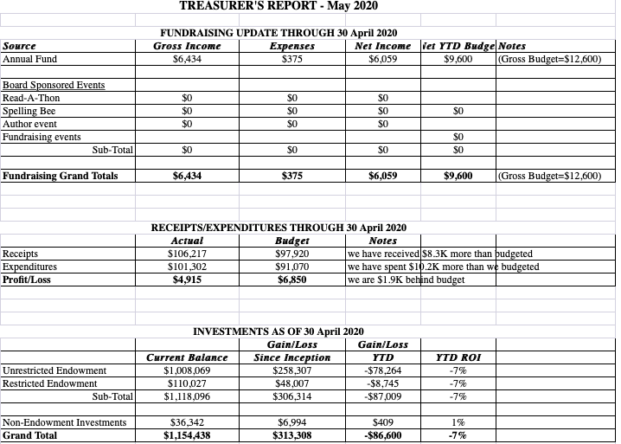

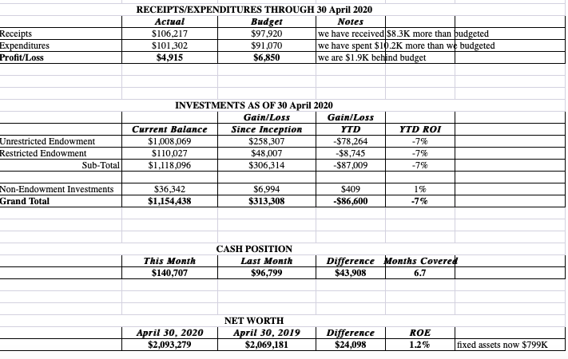

- Larry noted that the Library has received payments from Solebury Township, as well as funds for the Paycheck Protection Plan on May 4 (2½ months of payroll).
- Investments were down 14% in March and 7% in April.
- DIRECTOR’S REPORT – Connie Hillman

District Information:
Connie has had two meetings with other directors of district libraries regarding the development of “yellow zone” reopening procedures. Highlights:
- District Consultant Chris Snyder retired at the end of February, and the onset of the pandemic has made it impossible to seek a replacement at this time (her position is state mandated). Fortunately for the district, this means her salary for several months is now available for us to use on things that might benefit us in our current situation.
- Beanstack is an online summer reading app that will allow us to virtually hold our summer reading program. District funds are now able to pay for this program for all libraries for the next three years. (Saving us about $1,000 this year and $700 in each subsequent year.)
- District funding will cover the cost of plexiglass to protect our staff once we reopen to the public, as well as distancing reminder signs. BCFL placed an order on May 1. We are not sure when they will arrive.
- Each library is now required to develop a reopening plan. Connie and staff have developed a plan, which is largely based on CDC and OSHA guidelines for businesses and the ALA’s guidelines for disinfecting materials. The state library is also working on general guidelines for reopening which are forthcoming. All libraries in Bucks County have similar plans.
- BCFL has developed online staff safety training, which will be made available to all staff a weekly basis. This information has been forwarded to the staff. It is mandatory that the staff take this training.
Moving into the Yellow Zone:
We are waiting to hear from the governor as to when this will take place. The Yellow Zone, for most libraries, will be a series of phases based on a number of criteria including, but not limited to, our ability to acquire adequate cleaning supplies. We will begin our return to physical public service with a slight modification to our curbside pickup program. Email announcements, as well as social media posts, will alert the public to our changes.
Cleaning Supplies Stock Up. Connie has been working to acquire supplies for reopening. We have ordered additional face masks and gloves that should arrive late June. 8 Oaks Farm distillery in New Tripoli, PA donated hand sanitizer. Joanne Reszka donated two boxes of liquid cleaning solution, antibacterial soap and dish detergent before the library closed. We are working on getting more Lysol wipes. We also have a UVC light and safety equipment to use regularly.
Weekly Staff Zoom meetings. Connie and the staff have been sharing information that comes from the district and state. We will continue virtual programming throughout the summer, as well as offer curbside service. Additional new services for our patrons include:
- Special service hours for vulnerable populations (once the library allows public entry.)
- Personal library services. This will be like a “personal shopper” for those who are a bit reluctant to come in and browse. The staff will put together a collection for library materials based on the patron’s preferences.
- Summer Reading Grab Bags. We initially thought of this for kids, but this could also be extended to adults. Staff collects 10-15 children’s books (based on age, theme, etc.) and then puts them in bags for families to grab and go. Again, for folks who do not want to spend a good deal of time in the building.
- Outside benches can be placed 6 feet apart so that folks who usually spend time chatting in the library can meet outside at safe social distance. This, of course, depends on State guidelines regarding group gatherings.
Summer Reading Program:
- Patricia, Darcy and Connie meet weekly on the summer reading program, which will be virtual using Beanstack.
- Friends of the Library are willing to help cover the costs.
- We are working on fleshing out our website with program information.
- We will have a list of library resources, as well as summer reading information, to go out to the schools by the end of the month.
Other:
The Raab Foundation grant was submitted on May 1.

- PROPERTY – Larry Davis No report.

- DEVELOPMENT – Doug Brindley & Julia Klossner

Doug has been looking into PA Humanities Grants for the library and will also be reaching out to EveryLibrary.org for information.

VI. MARKETING – Liz Jordan

The Spring Operating Fund Appeal (SOFA) mailed the week of May 11. USPS seems to be a bit delayed, so the mailer is landing in mailboxes the week of May 18. The thank you letter has been written, as well as six follow-up emails featuring more “library stories.” Connie has added a page on the website that features these patron quotes, which are a wonderful testimonial to the library’s service to the community during COVID-19. Weekly Facebook posts will encourage SOFA support, as well as direct followers to the library stories page.

- GOVERNANCE – Colin Jenei No report.

VIII. SPELLING BEE – Joanne Reszka

At present, we are thinking about ideas for virtual programming if we can’t hold a big group event.

IX. FRIENDS REPORT – No report.

X. OTHER ITEMS – Ron Cronise

Ron briefed the Board on the recent Solebury Supervisors Library Committee meeting.

Next meeting: June 17, 2020

Respectfully submitted,

Liz Jordan, Secretary

ADDENDUM

