THE FREE LIBRARY OF NEW HOPE SOLEBURY
Board of Trustees Meeting Minutes – Draft Copy
June 17, 2020
The Board met via Zoom due to the COVID-19 shutdown. Attending: Ron Cronise, President; Joanne Reszka, Vice President; Larry Davis, Treasurer; Liz Jordan, Secretary; Deidre Alderfer, Connie Hillman, Julia Klossner, Doug Brindley, Colin Jenei, Mike McKenna, Christopher Whitney. Also attending: Deidre Alderfer, Eric Jacobson, Patricia Lynch, Megan Mendonca and Audrey Meyer (both from Morrisville Library).

- CALL TO ORDER – Ron Cronise
The meeting was called to order by Ron at 5:33 p.m. Ron welcomed Deidre Alderfer and Megan and Audrey from the Morrisville Library.
MOTION by Christopher to accept the Minutes of the April 15, 2020 Meeting with a small change from Joanne Reszka. SECONDED by Colin. APPROVED by all.

- FINANCE REPORT (Preliminary) – Larry Davis

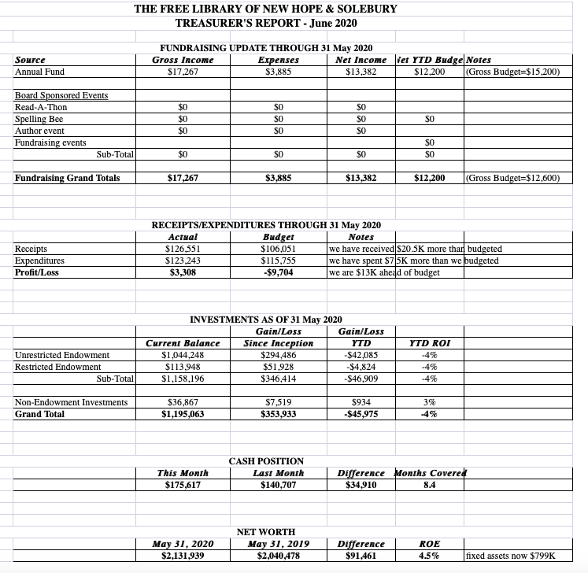
- Larry noted that all or substantially all of the money from the Paycheck Protection Plan loan should be forgiven due to recent changes.
- New Hope Borough payments are running late, perhaps because of reduced tax revenue. Solebury Township’s payments have been accelerated.
- Investment performance for restricted and non-restricted endowment is down 4%.
- Larry and Connie have submitted an application for a PA CARES Grant. Funds from this grant can pay for operational costs.

- DIRECTOR’S REPORT – Connie Hillman

Yellow Phase:
On Friday, June 5, Bucks County entered the Yellow Phase of Governor Wolf’s plan to reopen Pennsylvania.
- Staff reported to work Monday, June 8 on an abbreviated schedule to begin to prepare the building for curbside delivery, which began on June 15.
- Notices regarding how the move to the Yellow Phase will impact library operations were posted on our website and Facebook pages. Email blasts on Moving to Yellow, Instructions for Curbside Delivery and the Summer Reading Program have or are in the process of being sent out.
- Instructions on the Summer Reading Program, which starts June 20, were sent through the school list serve. Thank you to Mike McKenna for helping facilitate this communication.
- The staff is getting used to the new world order, wearing masks, staying socially distant, placing items in quarantine, etc.
- IT came out on Wednesday, June 10 and helped reconfigure our computers to allow for staff to work in separate socially distant areas.
- We are starting to move furniture around in preparation for allowing the public back into the building on July 6. We are still waiting for the plexiglass to be delivered from BCFL.
- On Tuesday, June 9, the state house and senate voted to override Governor Wolf’s state of emergency order, encouraging businesses to reopen immediately and the public to “go live your lives.” This is a constitutional matter and is headed for the courts. We have a plan in place to reopen, and we will follow this provided we have adequate cleaning supplies and health conditions are stable.
District Information:
- State Funding: The state fiscal year runs from July 1 to June 30. The state usually passes a budget somewhere around the end of June. This year it quietly passed a budget at the end of May. It is a bifurcated budget. Funding has been approved for the next 5½ months. In November, the second half of the budget will be determined. While the entire budget is flat (same as last year), we do not know if there will be cuts in the second half of the budgetary year.
- The library directors continue to collaborate to tweak reopening procedures. While there are some differences between libraries, we are, overall, on the same page.
- There is a new digital resource available to our patrons. JobNow offers assistance with resume building, honing interview skills and tips for job searching.

Summer Reading Program
The Huxley Family has traditionally supported the summer reading program, and we are grateful that they have donated $2,500 toward this year’s program.
Information has gone out to the schools and through an email blast. All parts of the digital program are expected to be live on June 20.
PROPERTY – Larry Davis No report.

DEVELOPMENT – Doug Brindley & Julia Klossner

Doug is in a continuing dialogue with Patrick Sweeney from EveryLibrary.org for input on future development plans. He has not heard from the Raab Foundation regarding a $10,000 grant; however, the process may be slowed by Covid-19.

VI. MARKETING – Liz Jordan

2020 SOFA (Spring Operating Fund Appeal) Results

- As of Week 4, 122 donors have given $16,015.00. Not only has 2020 SOFA surpassed 2019’s total SOFA intake of $13,683.50, it is on track to bring in more than the Library’s best SOFA total (2016: $16,515.00). This outcome is very encouraging. We will continue to follow up with weekly emails and Facebook posts for a full six weeks.

- Additionally, 30 new donors have contributed to the 2020 appeal, including 14 from the voter registration list. This list cost $200 and brought in $915.00.

- We would like to follow up this effort with handwritten, personalized notes to all new SOFA donors. Trustees who are interested in writing notes should contact Liz.

In other marketing news, Joanne sent out an “Intro to the Library” PowerPoint to local realtors and will follow up to see how it has been received.

- GOVERNANCE – Colin Jenei

Colin made a motion to elect Deidre Alderfer as member the Board of Trustees to take Ron Cronise’s place. Julia seconded the motion. Approved by all. Deidre will be one of the New Hope Borough representatives on the Board.

VIII. SPELLING BEE – Joanne Reszka

Joanne would like to meet with the Bee committee about potential plans. She will also survey past teams. She is checking with the High School’s facilities person to see if outside groups will even be able to meet in the auditorium in the fall. Julia added that the Board does not want to burden the staff with the extra work involved with planning a Board fundraising event.

IX. FRIENDS REPORT – No report.

X. OTHER ITEMS – Ron Cronise & Doug Brindley

Ron briefed the Board on meetings held by the Solebury Supervisors Library Committee before saying a few parting words of thanks to Connie, the Staff and the Board.

New Board President Doug Brindley offered words of gratitude for Ron’s dedication and hard work. Current and former members of the Board, as well as Solebury Township Supervisor Robert McEwan, joined the Zoom meeting to thank Ron. A thank you gift included a plaque in Ron’s honor, which will be displayed in the Library.

Next meeting: July 15, 2020

Respectfully submitted,

Liz Jordan, Secretary

ADDENDUM:

