THE FREE LIBRARY OF NEW HOPE SOLEBURY
Board of Trustees Meeting Minutes – Approved
July 15, 2020
The Board met via Zoom due to Covid-19. Attending: Doug Brindley, President; Joanne Reszka, Vice President; Larry Davis, Treasurer; Liz Jordan, Secretary; Deidre Alderfer, Connie Hillman, Julia Klossner, Colin Jenei, Christopher Whitney. Excused: Mike McKenna. Also attending: Darcy Fair, Eric Jacobson.

- CALL TO ORDER – Doug Brindley
The meeting was called to order by Doug at 5:34 p.m.
MOTION by Christopher to accept the Minutes of the June 17, 2020 Meeting. SECONDED by Joanne. APPROVED by all.

- FINANCE REPORT (Preliminary) – Larry Davis
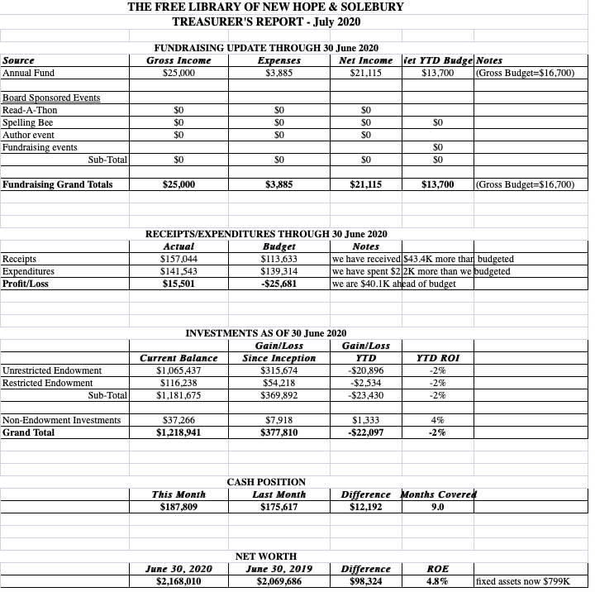

The Finance Committee asked for approval of the July Finance Report. APPROVED by all.

- DIRECTOR’S REPORT – Connie Hillman

Green Phase:
On Monday, June 16, The Free Library resumed its Curbside Delivery Service for items on hold. The building was staffed but remained closed to the public.
On June 26, Bucks County moved into the Green Phase of Governor Wolf’s plan to reopen Pennsylvania. On Monday, July 6, the building opened to the public on a limited basis: 12pm-5pm Monday through Friday; 12-3pm Saturdays; and a special at-risk/65+ hour on Tuesday mornings from 10-11am. Curbside pickup is continuing with already established hours. Home delivery is available for at-risk patrons, and virtual programming continues. Details on reopening:
- Volunteer Paul Spencer did a wonderful job of installing plexiglass shields at the Front Desk.
- Furniture and toys have been removed.
- Computer use is limited to one hour.
- Newspapers and magazines may be read on the socially distant benches in front of the building.
- The bathroom is closed.
- Any materials coming into the building are quarantined for three days.
- The building is wiped down every hour.
- If conditions improve, we can slowly start to ease these restrictions.
Additionally, for the safety of staff and patrons, masks will be required (except for allowable exemptions per PA mandate) while in the Library building. Discussion followed on how to address the public’s questions about mask wearing, and Colin suggested appropriate language to respond to any inquiry.
Visitation to the library has been light thus far, but this is to be expected after a nearly four-month hiatus. Many people prefer Curbside service. Fortunately, patrons who have visited have been grateful, very cooperative about the guidelines and supportive of our efforts.
Summer Reading Program:
The program opened online June 20. Participation so far has been very light. This has been the case all over the county. We are continuing to advertise the program as well as the virtual programs we are hosting. Nearly half of participants are teens and adults–and this is a big change from previous years. A number of families are participating together, which is really nice.
District Information:
To comply with e-rate, we are changing internet providers from Comcast to Verizon. Verizon came out, along with an IT technician from BCFL, to prepare the lines for the switch on August 1. This should result in a savings over our current plan.
Overdrive, one of our e-platforms, will terminate at the end of August. It was a cost-driven decision (we currently have a total of three e-platforms). The only regret is that Overdrive is the e-platform compatible with Kindles, so this will be somewhat of a disappointment to our Kindle users. However, the Free Library of Philadelphia will give anyone a card online which allows users access to their e-library, which includes Overdrive. We’ve been directed to offer this as an alternative for Kindle users.
Library directors continue to meet on a biweekly basis to re-examine procedures and protocols as we endeavor to adapt to a new rendition of library service.
PROPERTY – Larry Davis

The A/C pump needed a slight repair. The building’s slate roof has some discoloration, so we will monitor it and possibly have a roofer take a look at it.

DEVELOPMENT – Julia Klossner & Deidre Alderfer

Doug has asked Julia and Deidre to be co-chairs of this committee. Julia reached out to Lynn Breen and that door is still open for holding an endowment event in the future.

Julia and Deidre will send handwritten notes to top SOFA donors.

Doug shared his discussion with Patrick Sweeney at EveryLibrary.org.

The Raab Foundation has awarded the Library a grant of $10,000 to use for technology. It should be made available to the Library in early August.

VI. MARKETING – Liz Jordan

We concluded a successful Spring Operating Fund Appeal (SOFA) at the end of June, raising $18,507.50. The mailer cost $3,885 (design, 5,900 print run, mail prep, postage + $200 for voter registration mailing list). Thanks to Joanne, Julia and Christopher for helping handwrite thank-you notes to our 30 new donors.

We will continue to look for more library stories to feature in the November Operating Fund Appeal (NOFA), which will go after the general election but before Thanksgiving. Additionally, we will augment the campaign with additional asks – perhaps in video format.

- GOVERNANCE – Colin Jenei No report.

VIII. SPELLING BEE – Joanne Reszka

Based on current conditions, potential usage restrictions at NH-S High School and input from past Spelling Bee teams, the 2020 Community Spelling is cancelled for 2020.

IX. FRIENDS REPORT – No report.

X. OTHER ITEMS – Doug Brindley
The Solebury Library Committee may be presenting its read-out at the next Supervisors meeting.
Solebury Township did agree to have the Library on the agenda for the August meeting. Discussion followed on the format of that presentation.
Eric Jacobson will research a possible fundraising idea and forward to Joanne.
Christopher moved to adjourn. Larry seconded. APPROVED by all.

Next meeting: August 19, 2020

Respectfully submitted,

Liz Jordan, Secretary

ADDENDUM:

