THE FREE LIBRARY OF NEW HOPE SOLEBURY
Board of Trustees Meeting Minutes – Approved
August 17, 2020

The Board met via Zoom due to Covid-19. Attending: Doug Brindley, President; Joanne Reszka, Vice President; Larry Davis, Treasurer; Liz Jordan, Secretary; Deidre Alderfer, Connie Hillman, Julia Klossner, Mike McKenna, Christopher Whitney. Excused: Colin Jenei. Also attending: Eric Jacobson

- CALL TO ORDER – Doug Brindley
The meeting was called to order by Doug at 5:31 p.m. MOTION by Larry to accept the Minutes of the July 15, 2020 Meeting. SECONDED by Christopher. APPROVED by all.

- FINANCE REPORT – Larry Davis

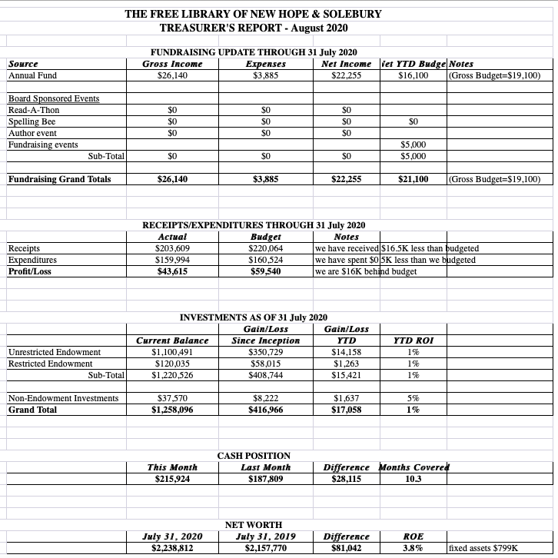

Larry is working on information requested by the bank for the payroll protection program loan forgiveness. The 2021 budget is forthcoming for Board input and approval.

The Finance Committee asked for approval of the July Finance Report. APPROVED by all.

- DIRECTOR’S REPORT – Connie Hillman

Operations During Covid-19
- A new study from the IMLS recommends that library materials quarantine for four days instead of three. The Library is now compliant with this requirement. This has resulted in staff shifting and borrowing additional book carts from the Southampton and Warminster Libraries to accommodate books.
- An informal count of curbside vs. in-house visits shows that in-house visits are picking up considerably. The patrons seem pleased with these options.
- The Library building is cleaned every hour. While all the patrons have been very good about wearing masks, there has been a trend recently to remove the mask when no one else is in the room. The staff is reminding patrons to wear masks properly at all times when in the library for the safety of staff and fellow patrons.
Summer Reading Program
- Program attendance and participation have been light, but this is the situation with libraries all over the county. We have extended the program an additional two weeks. The program used to track reading (Beanstack) is available going forward.
- The state is still asking for our statistics, which we are giving them based on Facebook views and Zoom attendance. This numbers will be skewed for 2020 since this is not usually how attendance or participation in participation is registered.
- Grab-and-Go craft kits have become very popular and will continue to be offered through the fall.
New Hope-Solebury School District
Now that the school district will begin classes virtually, the Library is reaching out to schools and area daycare centers to let them know the Library is open and ready to support them in various ways, including setting up a Beanstack reading program.
District Information
- As previously reported, the e-platform Overdrive ends in August. In addition, other Overdrive offerings, RB Digital (audiobooks) and Zinio (magazines), will be phased out by mid-September. A new e-zine platform, Flipster, will be available mid-September. All books currently in Overdrive and RB Digital will migrate to CloudLibrary.
- We also had an in-depth discussion on the District and County Coordination budgets in anticipation of a possible funding cut at the beginning of 2021. These are painful decisions as the budget is already austere. We should have a better sense of what the budget will look like in November.
- All libraries are currently operating with reduced hours to give everyone a chance to clean and process returns and deliveries before opening to the public. All libraries are conducting virtual programming through at least the end of the year. All are following the IMLS quarantine recommendations of four days.
Building
Due to humidity, the front door is sticking, and the stress of pushing and pulling to open it has broken the latch mechanism. An estimate for repair is about $1,800, but it may be time to consider a long-term solution.
Grants
The Library has been awarded a Pennsylvania Humanities Council CARES grant for $4,500. This money is to be used for operations.

Volunteers
Marilyn Lanctot, one of The Free Library’s long-time volunteers, passed away on August 3. While she loved working behind the front desk, Marilyn’s contributions went far beyond that. She was instrumental in originally setting up and managing the fund drive, wrote library pieces for the newspaper, assisted with summer reading, ran the Monday morning book club and many other duties that made her contribution to the library extraordinary. She will be greatly missed by our staff, patrons and fellow volunteers. Her family has kindly asked that donations be made to the library in her memory. Discussion followed on how to memorialize Marilyn, and the Board agreed to go forward with a memorial in the front check-out lobby.
- PROPERTY – Larry Davis

See Director’s report for front door issues. Larry also suggested talking to the door installer to see if the hardware needed could work on another door in the future.

- DEVELOPMENT – Julia Klossner & Deidre Alderfer

The Development Committee will look at ways to coordinate with the November Operating Fund to reach larger donors.

VI. MARKETING – Liz Jordan

Status of Appeals
- The Spring Operating Fund Appeal (SOFA) cleared approximately $14,600 for the Library.
- The November Operating Fund Appeal (NOFA) will continue with the same theme (What’s Your Library Story?) and will drop in the USPS mid-November.

Update on New Fundraiser, the Community Buzz-a-thon
- Takes the place of the Community Spelling Bee, while also keeping the Spelling Bee top of mind for 2021.
- Runs Sept. 25-Oct.3, 2020.
- Combines bee- and spelling-related virtual programming with sponsorships and giving challenges.
- Beekeeping, Planting Pollinators (with Bowman’s Wildflower Preserve), Health Benefits of Honey, Escape Room, Winnie the Pooh Storytime among programs.
- Joanne, Doug, Deidre and Mike are reaching out for sponsorships (past and new).
- Asking patrons and community for small donations to not impinge on November appeal.
- Goal is to raise $5,000.

- SPELLING BEE – Joanne

Joanne will cancel the NH-S HS auditorium for the 2020 Bee and try to reserve it for a similar date for 2021.

- GOVERNANCE/PERSONNEL – Christopher Whitney

Christopher and Colin will begin discussion of the annual director review in the fall.

IX. FRIENDS REPORT – No report.

X. OTHER ITEMS – Doug Brindley
- Doug shared further thoughts on Solebury Task Force readout on 7/18/20, including confusion on the relationship of per capital amounts and municipalities
- Doug, Joanne and Larry reported on the presentation to the Solebury Supervisors on 8/18/20. Overall consensus was that it went well and had good feedback. The Board will request again to give the same presentation to the New Hope Borough.
Doug made the call to adjourn the meeting at 6:53 p.m.

Next meeting: September 16, 2020

Respectfully submitted,

Liz Jordan, Secretary

ADDENDUM:

