THE FREE LIBRARY OF NEW HOPE SOLEBURY
Board of Trustees Meeting Minutes – Draft Copy
October 21, 2020

The Board met via Zoom due to Covid-19. Attending: Doug Brindley, President; Joanne Reszka, Vice President; Larry Davis, Treasurer; Liz Jordan, Secretary; Deidre Alderfer, Connie Hillman, Julia Klossner, Colin Jenei, Mike McKenna, Christopher Whitney. Also attending: Eric Jacobson, Carol Spencer.

- CALL TO ORDER – Doug Brindley
The meeting was called to order by Doug at 5:31 p.m. MOTION by Christopher to accept the Minutes of the September 21, 2020 Meeting. SECONDED by Larry. APPROVED by all.

- FINANCE REPORT (Preliminary) – Larry Davis

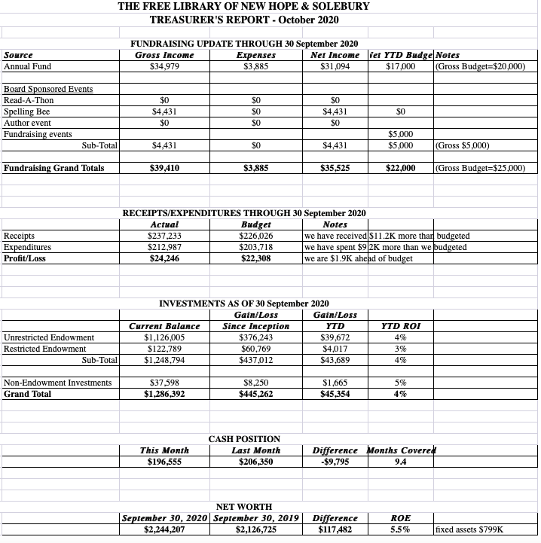
- There has been no further guidance on loan forgiveness for the Paycheck Protection Plan.
- No additional contributions were received from New Hope Borough or Solebury Township in September.
- There have been no suggested changes to the 2021 budget, which has an approximate $18,000 deficit. Larry believes our cash position is solid and could fund the deficit. The Board also believes that alternative fundraising events could be more robust, in case we can’t hold the Spelling Bee in 2021. Doug suggested that the Board table 2021 budget approval for now since the current financial environment is still uncertain.

The Finance Committee asked for approval of the October Finance Report. APPROVED by all.

- DIRECTOR’S REPORT – Connie Hillman

District
- The Library received a check in the amount of $121 from BCFL for our share of fines that were paid online from July 15-September 15. We will be receiving these quarterly.
- The application for the use of state aid was submitted. We should know the amount we will be receiving in 2021 in November.
- Computer replacements are ordered and are expected to be installed in November.
- E-library statistics: With the loss of Libby/Overdrive earlier in September, we are now also at a loss as how to compile our e-circulation. Up until now we have been basing our e-circulation on our Overdrive statistics since this was the only way to obtain a breakdown of e-circulation as per individual library. CloudLibrary is now our primary e-platform; however, the statistics we are receiving are compiled in such a way that they are difficult to break down on a monthly basis. We are doing our best with what we have, but our numbers will not be consistent with what has been previously reported.
- Connie is a member of the committee to vet and interview candidates for the District consultant position. There are only two applicants thus far.
- Regina Fried, our Doylestown district marketing person who has been very helpful in publicizing our events, will be retiring October 23.
- The district is receiving a Cares grant to help provide PPE to the district libraries. We are looking into purchasing sanitizing wands to help disinfect computers after each use, since the “shower cap” covers are frustrating for the patrons.
Programming
- In honor of the 100th anniversary of women’s suffrage, Cate Conti, Joanne Reszka and Connie presented the ladies of suffrage as Susan B. Anthony, Emmeline Pankhurst and Alice Paul respectively. They are planning to reprise the program next month as an outreach program to several Girl Scout troops.
- The staff received positive feedback about the Buzzathon from patrons. Many thanks to the staff, board and friends for helping to promote, create events and keep track of donations.
Building
Many, many thanks to the Friends of the Library for purchasing air purifiers for the Library. These will hopefully help keep us healthy during the winter months.

- PROPERTY – Larry Davis

Doug has submitted the proposal to replace the front door to the Historical Architectural Review Board (HARB). Once the HARB meeting is announced, Larry will attend the meeting.

- DEVELOPMENT – Julia Klossner

Julia is looking for small venues for 2021 development donor events. She is also spearheading a campaign to write personal thank-you notes to large donors. Colin suggested a virtual auction event of works by local artists as a potential development event.

VI. MARKETING – Liz Jordan

The November Operating Fund Appeal (NOFA) is scheduled to go to the printer on 10/26. It will mail to the Library’s eTapestry list and current voter mailing list and should deliver around 11/20. The mailer will be followed by weekly email and Facebook reminders through the end of the year.

- SPELLING BEE/COMMUNITY BUZZATHON – Joanne Reszka & Liz Jordan

Joanne reported that a 2021 Spelling Bee date cannot be secured with New Hope-Solebury High School until the new year. Final revenue from the Community Buzzathon was $6,615. It featured multi-day virtual programming and three giving challenges, plus was covered in the Bucks County Herald and the Patch. Approximately 30 donors received “thank you” swag bags. Thanks go to our four local sponsors (Addison Wolfe Real Estate, First National Bank & Trust of Newtown, McCaffrey’s Food Markets and Penn Community Bank) and Golden Blossom Honey (gifts). This was the Library’s first completely online donor event, and participation was very encouraging.

- GOVERNANCE/PERSONNEL – Colin Jenei & Christopher Whitney – No report.

IX. FRIENDS REPORT – Carol Spencer

While the Friends of the Library have not been able to hold in-person events or book sales, they did sell a large group of their book donations to the Doylestown Bookshop.

X. OTHER ITEMS – Doug Brindley

Solebury Township Supervisors have the Library offered an additional $5,000 in 2021 to help offset costs for employee benefits. It was agreed that the Board would not pursue this until a plan could be developed that would fund benefits beyond the one year.

Motion to adjourn from Larry. APPROVED by all. Doug adjourned the meeting at 6:38 p.m.

Next meeting: November 18, 2020

Respectfully submitted,

Liz Jordan, Secretary
ADDENDUM:
