THE FREE LIBRARY OF NEW HOPE SOLEBURY
Board of Trustees Meeting Minutes – Approved
September 21, 2020

The Board met via Zoom due to Covid-19. Attending: Doug Brindley, President; Joanne Reszka, Vice President; Larry Davis, Treasurer; Liz Jordan, Secretary; Deidre Alderfer, Connie Hillman, Julia Klossner, Colin Jenei, Mike McKenna, Christopher Whitney.

- CALL TO ORDER – Doug Brindley
The meeting was called to order by Doug at 5:32 p.m. MOTION by Christopher to accept the Minutes of the August 17, 2020 Meeting. SECONDED by Joanne. APPROVED by all.

- FINANCE REPORT – Larry Davis
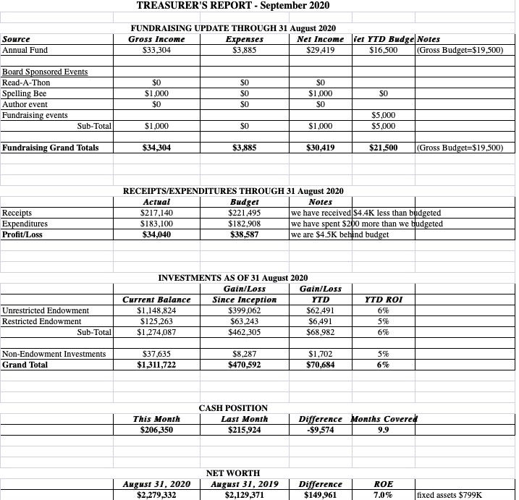
- The Library received a $4,066 contribution from New Hope Borough in August, bringing their total 2020 contributions to $31,423.
- The Paycheck Protection Program loan forgiveness situation remains unresolved, as the bank has told the Library to stop the application process until further guidance is provided by the government.
- Questions and discussion followed on the proposed 2021 budget. The Board will continue discussion and approve the budget in October or November.

The Finance Committee asked for approval of the September Finance Report. APPROVED by all.

- DIRECTOR’S REPORT – Connie Hillman

District News
- Per state guidelines, Connie had an annual meeting with Jessica Gruber, the pro-temp district consultant, and Regina Fried, the district marketing and PR specialist.
  - Jessica is new to the role and was seeing what our individual needs are as a library. As it is with most other libraries, our needs are funding and advocacy.
  - Regina was pleasantly surprised that the Library is holding the Community Buzzathon since most district libraries have elected to defer all fundraising efforts until better days.
  - Regina also discussed migrating the Library’s newsletter and email blasts to LibraryAware. This system is free and does not have email limits like the Library’s current system, MailChimp.
- Another study was released from the REALM project on the duration of coronavirus on library materials. This time the materials were tested in a stacked situation, and it was discovered that the virus could last at least six days on the covers. During discussion at the district meeting on September 10, it was decided to keep the quarantine period at four days but encourage patrons to isolate their materials for an additional three days after checkout. The Library does not have the space for extended quarantining of items.
- In September, the Library will accept online bill payments. Any bills that had been paid on our library items to BCFL from July to September 15 will be separated, and BCFL will send a reimbursement check. While the Library will need to pay the processing fee for online payments, this is still an advantage. Any fines paid directly are kept by the Library entirely.
- The Application for Use of State Aid is to be filed in October this year rather than December to help us get the most amount of state aid as possible for 2021.
Community News
- On September 11, Connie attended a task force meeting with NHCares regarding establishing normalcy for children of the community during this time. She is also scheduled to meet with another task force to see how the Library might best help out the schools and students.
- In mid-October, there will be a dedication of the lobby in memory of long-time Library volunteer, Marilyn Lanctot, who passed away in August.

Programming
- In addition to scheduling a full week of Community Buzzathon programs, Connie has been helping behind the scenes with promotional efforts. Eric has provided photography and video support.
- The Library is partnering with a local chapter of Teens Teach Technology (TTT) for a series of virtual basic tech workshops for senior citizens. Sessions are scheduled for the end of the month.
Building
Connie reported that the front door latch has been repaired at a cost of $1,800, and that there has been evidence of mice in the building.

- PROPERTY – Larry Davis

Front Door Issues

Larry has received a quote for a more permanent solution from Alderfer Glass. Cost of materials and installation for a new aluminum door with sidelights is $6, 595. Larry has prepared an application for a Certificate of Appropriateness, along with a proposal and cover letter describing the challenges of the current wood door, to go to the Historical Architectural Review Board (HARB). Money to pay for the door would come out of the general fund.

Christopher made a motion to proceed with sending the proposal to HARB. Julia seconded the motion. APPROVED by all.

- DEVELOPMENT – Julia Klossner, Deidre Alderfer & Mike McKenna

Julia asked for ideas on holding small outdoor donor events (5-10 people) in April/May. This topic will be on the agenda for the October meeting.

VI. MARKETING – Liz Jordan

The November Operating Fund Appeal will continue the theme “What’s your library story?” Once the Buzzathon is complete, work will get underway to secure stories and photos for this appeal. The goal is to have it in mailboxes in mid-November. Cost to produce should be approximately the same as the Spring Appeal.

- SPELLING BEE/COMMUNITY BUZZATHON – Joanne Reszka & Liz Jordan

- The Community Buzzathon takes the place of the Community Spelling Bee, which was cancelled due to Covid-19. The virtual Buzzathon will be held September 25-October 3 and is a joint effort of the Board of Trustees and the Library Staff.
- The Buzzathon has four sponsors: Addison Wolfe Real Estate, First National Bank & Trust
- of Newtown, McCaffrey’s Food Markets and Penn Community Bank. Addison Wolfe is a new sponsor, and thanks to Deidre for securing their support. The other sponsors have supported the Community Spelling Bee. Thanks to Joanne for reaching out and getting their support for the Buzzathon.
- Connie and staff have put together a great lineup of virtual programs.
- Press outreach netted stories in the Bucks County Herald and the Patch.
- Numerous email blasts and Facebook posts have been sent to publicize the event, thank the sponsors and encourage giving. Many feature Buzzi, the Buzzathon “mask-cot.”
- Joanne, Julia and Liz put together 30 swag bags to give to “first buzzer” donors. Thanks to Golden Blossom Honey for 20 jars of honey and to Solebury Township for providing logo gifts.

- GOVERNANCE/PERSONNEL – Colin Jenei & Christopher Whitney – No report.

IX. FRIENDS REPORT – No report.

X. OTHER ITEMS – Doug Brindley

- The Library’s line of credit has been renewed with the First National Bank & Trust of Newtown.
- A political candidate inquired about using the Library as a backdrop for an advertisement. The Board agreed that this would set a precedent that would conflict with the Library’s status as a public institution that is open to all and apolitical. The decision was to turn down the request.

Motion to adjourn from Christopher. APPROVED by all. Doug adjourned the meeting at 6:40 p.m.

Next meeting: October 21, 2020

Respectfully submitted,

Liz Jordan, Secretary

ADDENDUM:

