THE FREE LIBRARY OF NEW HOPE SOLEBURY
Board of Trustees Meeting Minutes – Approved
November 18, 2020

The Board met via Zoom due to Covid-19. Attending: Doug Brindley, President; Joanne Reszka, Vice President; Larry Davis, Treasurer; Liz Jordan, Secretary; Deidre Alderfer, Connie Hillman, Julia Klossner, Colin Jenei, Mike McKenna, Christopher Whitney. Also attending: Eric Jacobson, Carol Spencer

- CALL TO ORDER – Doug Brindley
The meeting was called to order by Doug at 5:32 p.m. MOTION by Christopher to accept the Minutes of the October 21, 2020 Meeting. SECONDED by Larry. APPROVED by all.

- FINANCE REPORT – Larry Davis

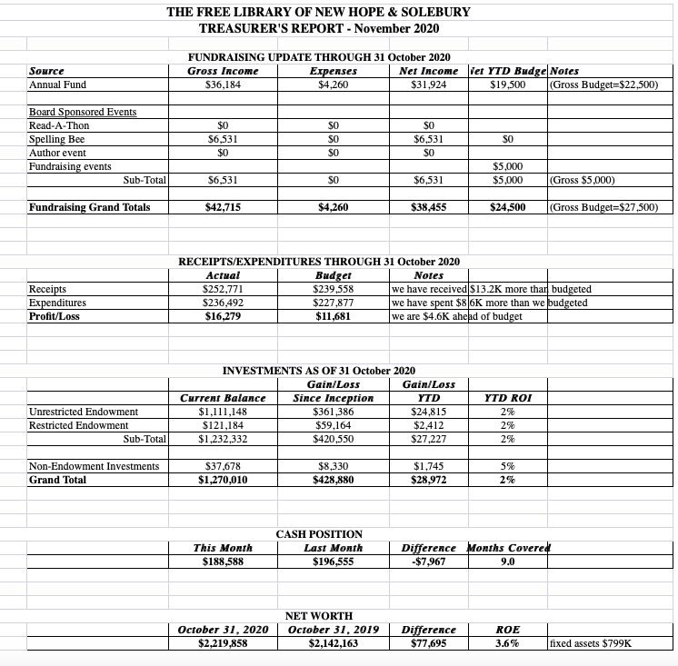
- The Paycheck Protection Plan continues to be unresolved.
- In October, the Library received $1,680 from New Hope and $10,000 from Solebury, making their total 2020 contributions $33,104 and $115,000, respectively.
- Total receipts year-to-date are $252,771 ($13,000 more than what was budgeted), and total expenses are $236,492 (over budget by $8,600). The gain for the year now stands at $16,279.

The Finance Committee asked for approval of the October Finance Report. APPROVED by all.

2021 Budget

Larry made and Christopher seconded a motion to approve the 2021 budget with an $18,000 deficit. The budget deficit can be balanced through additional fundraising revenue, expense reductions or a contribution from either the bank savings account or the general fund. APPROVED by all.

- DIRECTOR’S REPORT – Connie Hillman

District & State News
- The District has applied for a PA Cares grant, which can be used for PPE supplies. It is being divided among the libraries based on population and usership. The Free Library will be able to submit expenses for approximately $800 of PPE and cleaning supplies through November 2021.
- The Free Library has received the 5/12 of our state aid. The District is monitoring the deliberations at the state level to get an idea of what to expect for the remainder of the state aid.
- The State has sent out an email regarding the increasing COVID numbers. While the State Library does not anticipate a state-wide shutdown as we had in the spring, libraries are advised to adapt services or close based on the situation in their areas. Libraries in the area are beginning to close (Philadelphia, the Grundy Library). As of now, New Hope and Solebury is doing well, but the Library is ready to make changes should the need arise.
Building & Programming
- Computer replacements will be installed on November 24.
- The Staff has been weeding through the books, DVDs and audiobooks in the main collection (fiction and non-fiction). The next step is to work on the children’s department.
- Since Macy’s and, most likely, the malls will not offer Santa visits this season, the Staff decided to spread holiday cheer by providing a “Santa Zoom” program on December 19. Children will visit virtually with Santa via Zoom, facilitated by Miss Patricia the Elf. Special thanks go out to Larry Davis, without whom this would not be possible.
Volunteers
- We are sad to announce that one of the Library’s wonderful volunteers, Susan Lehre, passed away suddenly. Her family was kind enough to ask for donations to be made to The Free Library in her memory, which will be a meaningful tribute for her family.
- Connie has ordered a plaque in memory of Marilyn Lanctot for the lobby. Once it is ready, a time will be set for a formal dedication, probably with only her immediate family present, but opened up to others on Zoom. Thank you all again for making this possible.
- PROPERTY – Larry Davis

There has been no response from the Historic Architecture Review Board (HARB) regarding the front door replacement.

- GOVERNANCE – Colin Jenei & Christopher Whitney – No report.

- DEVELOPMENT – Julia Klossner, Deidre Alderfer, Mike McKenna – No report.

- MARKETING – Liz Jordan

November Operating Appeal (NOFA) Unfortunately, a majority of the staff at 3D Printers, which is printing NOFA, has been afflicted by COVID. The remittance envelope is yet to be printed, so the mailer will not be sent as scheduled. Other pieces of the appeal (thank you letter, follow-up emails and Facebook posts) will need to be tweaked because of the delay. It is hoped that it will go out the first week of December.

The Marketing Committee has reached out to Kris Reilly, president of the Friends of the Library, with ideas on how to hold online raffles.

VIII. FRIENDS REPORT – No report.

IX. OTHER ITEMS – Doug Brindley

Doug and Joanne have been reaching out to past Board members for suggestions on a new Board member to join in January. The Board is urged to think of possible nominees, especially someone who lives in New Hope Borough.

Motion to adjourn from Doug. APPROVED by all. Doug adjourned the meeting at 6:31 p.m.

Next meeting: December 16, 2020

Respectfully submitted,

Liz Jordan, Secretary

ADDENDUM:

