THE FREE LIBRARY OF NEW HOPE SOLEBURY
Board of Trustees Meeting Minutes – Draft Copy
December 16, 2020

The Board met via Zoom due to Covid-19. Attending: Doug Brindley, President; Joanne Reszka, Vice President; Larry Davis, Treasurer; Liz Jordan, Secretary; Deidre Alderfer, Connie Hillman, Julia Klossner, Colin Jenei, Mike McKenna, Christopher Whitney. Also attending: Deborah Heffernan, Eric Jacobson, Patricia Lynch, Carol and Paul Spencer.

- CALL TO ORDER – Doug Brindley

The meeting was called to order by Doug at 5:33 p.m.

Doug introduced Deborah Heffernan as a potential Board member. Debbie shared her background and experience, answered questions, and expressed her interest in the Library and serving on the Board.

Doug also stated that the December 16 meeting will serve as the annual meeting per the Library’s Bylaws.

MOTION by Christopher to accept the Minutes of the November 18, 2020 Meeting. SECONDED by Joanne. APPROVED by all.

- FINANCE REPORT (Preliminary) – Larry Davis

Financial Narrative Highlights

- The Paycheck Protection Plan continues to be unresolved.
- In November, the Library did not receive any contributions from New Hope or Solebury; the Library anticipates contributions by year-end of $9,800 and $5,000 respectively to fulfill 2020 commitments.
- Receipts from operations year-to-date are $261,496 ($14,000 more than what was budgeted), and total expenses are $258,768 (over budget by $6,000). The gain for the year now stands at $2,728.
- Shortly after Board approval of the 2021 Budget in November, it was learned that the State will provide its full amount of funding support for next year, which serves to reduce the budget deficit from $18,000 to $10,000; and it would seem to be appropriate to revise the approved budget accordingly.

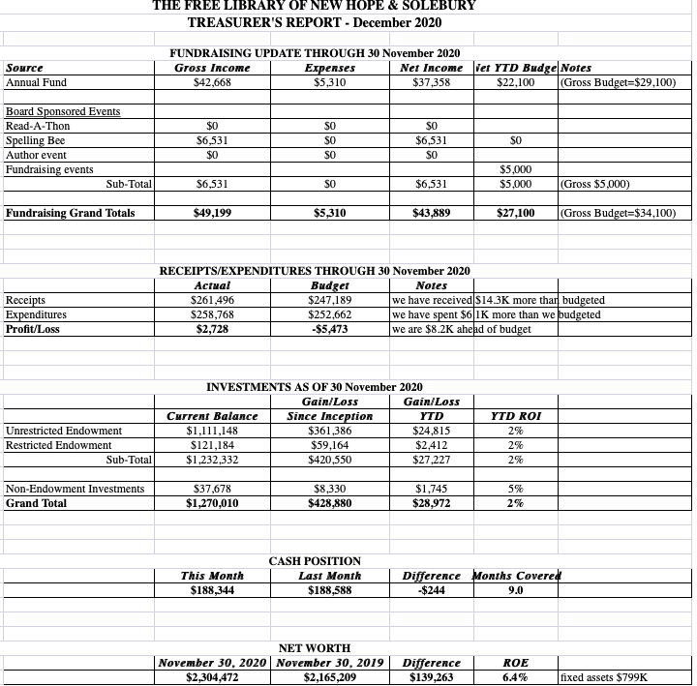

The Finance Committee asked for approval of the November Finance Report. APPROVED by all.

Larry also asked for a motion to continue the Library’s relationship with the audit firm Bee, Bergvall & Co. They will review our financials and complete IRS Form 990. The review will cost approximately $4,500. Colin made a motion and Christopher seconded. APPROVED by all.

- DIRECTOR’S REPORT – Connie Hillman

District & State News
- The Library received confirmation that it will be fully funded by the State in 2021. The balance of funds should be received soon.
- The new computers have been installed. Connie is still waiting for her laptop.
- Information for the PA Cares Grant will be submitted on December 17. The Library should receive a $795 reimbursement for any PPE purchased from April 2020 on. There is a possibility for additional reimbursement through September 1, 2021.
- The Library will migrate to a new ILS system in 2021. The system (WISE) is from OCLC, an online worldwide library cooperative. It should provide patrons with better library service options. The framework for the migration is currently being laid.
- In response to the recent spike in Covid-19 cases, eight libraries in the Bucks County system have elected to return to curbside delivery service only. Doylestown and the branch libraries are reducing the number of people permitted into the building and the amount of time individuals are permitted to browse the collection. Public seating has been removed. Overall, our patrons have been supportive. A complaint from a regular user has been forwarded to the Board.
Programming
Plans are in the works for a Winter Reading Challenge from January 17–31. The entire community will be challenged to read at least an hour a day and record their time on BeanStack. Those who finish the challenge will receive a small prize and be entered into a drawing for a Kindle Fire. The Staff is planning a number of virtual programs to coincide with the two-week Challenge, similar to the Buzzathon. The free program is a way to keep the community engaged this winter. Information will be sent to the schools and the community over the next weeks.
Volunteers
Paul Spencer has kindly mounted the plaque in memory of volunteer Marilyn Lanctot by the front desk, where Marilyn enjoyed working. Invitations to a Zoom dedication will be sent after input from Marilyn’s husband.
- PROPERTY – Larry Davis

Doug reported that the Historic Architecture Review Board (HARB) has asked for an updated estimate for the front door replacement.

- GOVERNANCE – Colin Jenei & Christopher Whitney

- Colin made a motion and Liz seconded that a public meeting be scheduled for Tuesday, December 22, 2021 at 5:30 p.m. The sole purpose of this short meeting is to vote for Deborah Heffernan as a new Board member, starting in 2021 to replace for Colin Jenei. APPROVED by all.
- A motion was made by Larry and seconded by Colin for Doug Brindley and Liz Jordan to serve a second three-year term. An amendment to the motion was made for Julia Klossner to serve a three-year term starting in 2021. All have accepted. APPROVED by all.
- A motion was made by Colin and seconded by Christopher to renew the current slate of officers for 2021: Doug Brindley, President; Joanne Reszka, Vice President; Lawrence Davis, Treasurer; and Liz Jordan, Secretary. APPROVED by all.

- DEVELOPMENT – Julia Klossner, Deidre Alderfer, Mike

No report, but Deidre suggested holding a Covid-friendly porch fundraiser in the spring.

- MARKETING – Liz Jordan

The November Operating Fund Appeal (NOFA) is printed but still out for delivery with the USPS, which is experiencing gridlock due to mail-in ballots and the volume of holiday mail. The mail house has stated that it should deliver no later than December 24. Extra copies of the mailer are being sent to the Library. Follow-up emails and Facebook posts are scheduled through mid-January.

Liz asked the Board for their opinion on renewing annual membership with the Delaware River Towns Chamber of Commerce at a cost of $100.

VIII. FRIENDS REPORT – No report.

- OTHER ITEMS – Doug Brindley

- Doug offered the date of Saturday, January 9 for a virtual board retreat.
- Doug also thanked Colin Jenei for his service on the Board.

Doug adjourned the meeting at 7:06 p.m.

Next meeting: January 20, 2021

Respectfully submitted,

Liz Jordan, Secretary

ADDENDUM:

