THE FREE LIBRARY OF NEW HOPE SOLEBURY
Board of Trustees Meeting Minutes – Approved Copy
January 20, 2021

The Board met via Zoom due to COVID-19. Attending: Doug Brindley, President; Larry Davis, Treasurer; Liz Jordan, Secretary; Deidre Alderfer, Connie Hillman, Julia Klossner, Mike McKenna, Christopher Whitney. Also attending: Eric Jacobson, Patricia Lynch, Carol Spencer. Excused: Joanne Reszka, Vice President.

- CALL TO ORDER – Doug Brindley

The meeting was called to order by Doug at 5:33 p.m. MOTION by Larry to accept the Minutes of the December 16, 2020 Meeting. SECONDED by Julia. APPROVED by all.

- FINANCE REPORT – Larry Davis

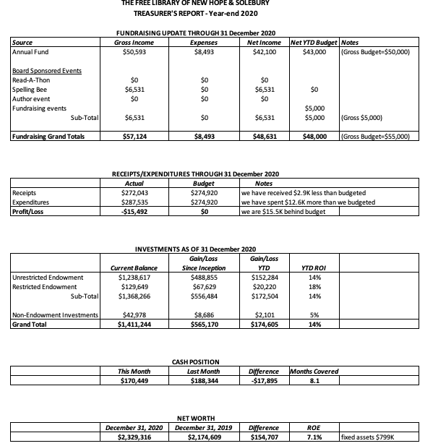

Financial Narrative Highlights

- New Hope provided $844 in December ended $9,000 below their target of $42,900 for the year. Solebury provided no contribution in December, ending the year $5,000 below their commitment of $120,000. Update: Solebury contributed $5,000 on January 21, 2021.
- The Paycheck Protection Plan continues to be unresolved.
- Larry completed the Workers Compensation audit with the insurance company.
- Gross Annual Fund contributions slightly exceeded the $50,000 budget expectation, even with a delayed year-end fund appeal.
- During 2020 the library carried the $20,000 expense for the children’s library bookcases, while the offsetting income for these was recorded in 2019.
- Receipts from operations for 2020 were $272,043 ($2,900 less than what was budgeted), and total expenses were $287,535 (over budget by $12,600). Considering the children’s room bookcase expense ($20,000, income was recorded in 2019) and the up-front printing costs, held against the unrealized potential of the fall Annual Fund drive, the negative year-end result is not as bad as it may appear.

The Finance Committee asked for approval of the December Finance Report. APPROVED by all.

- DIRECTOR’S REPORT – Connie Hillman
- Connie has submitted a mid-cycle update to the Raab Foundation. She has contacted the IT department in Doylestown about purchasing a booster for the Library’s wireless. She is still waiting for her new laptop.
- All employee annual evaluations have been completed.
- The Plan for Use of State Aid Part 2 has been submitted.
- The Friends of the Library have generously given $5,000 to split equally toward adult programming and the Summer Reading Program in 2021.
- The Library’s migration to the new ILS system is slated to begin in the fall.
- If the cases of COVID-19 continue decline, Connie will look into opening the building to the public in the coming week.
- There are 94 registered (including several classes of NH-S students registered under a single name) for the Winter Reading Challenge (January 17-31). This is more than signed up for the 2020 summer reading program.
- The dedication of the plaque in honor of volunteer Marilyn Lanctot is scheduled for Tuesday, January 26 at 4pm via Zoom.
- PROPERTY – Larry Davis – No Report

- GOVERNANCE – Christopher Whitney

Christopher has provided the framework for the Library Director’s annual performance review. He recommends that the Bylaws be reviewed to ensure that performance reviews are consistently scheduled. Doug also mentioned that they will revisit the Director goals and objectives mid-year.

- DEVELOPMENT – Julia Klossner, Deidre Alderfer, Mike McKenna

- Connie has distributed the current strategic plan, as well as a webinar on developing a strategic plan, to the Development Committee. A meeting is scheduled for February 1 to further discuss and brainstorm a new strategic plan.
- Julia updated the Board on a potential new development initiative to replace an in-person event this year. The book Inspiring Library Stories would be sent with a letter to top donors to show the importance of libraries in the community and to encourage support for our Library. The Board gave the go-ahead on fleshing out this project with the recommendation of sending the book to municipality leadership as well.

- MARKETING – Liz Jordan

- Liz shared an update from Lawler Direct Mail (mail house) regarding the non-delivery of the November Operating Fund Appeal (NOFA). On December 31, the mailers were scanned at the NDC in Trenton. The Mailing Standard Specialist stated that mail delivery delays are due to package delivery and limited staffing.
- On a positive note, donations in December through January 15, 2021 stand at $16,460 (97 donors). This does not include a $4,000 donation in November.

- FRIENDS REPORT – Carol Spencer

The Friends of the Library delivered a check for $5,000 to be divided equally between adult and children programming. The Friends have also sent out their membership renewals.

- OTHER ITEMS – Doug Brindley

Doug noted that there will be a primary to fill vacated seat(s) on the Solebury Township Supervisors in May. The librarian from the Solebury School is a candidate.

Larry made the motion to adjourn the meeting at 6:22 and Julia seconded. APPROVED by all.

Next meeting: February 17, 2021

Respectfully submitted,

Liz Jordan, Secretary

ADDENDUM:
