THE FREE LIBRARY OF NEW HOPE SOLEBURY
Board of Trustees Meeting Minutes – APPROVED
February 17, 2021

The Board met via Zoom due to COVID-19. Attending: Doug Brindley, President; Joanne Reszka, Vice President; Larry Davis, Treasurer; Liz Jordan, Secretary; Deidre Alderfer, Connie Hillman, Julia Klossner, Mike McKenna. Also attending: Eric Jacobson. Excused: Christopher Whitney

- CALL TO ORDER – Doug Brindley

The meeting was called to order by Doug at 5:32 p.m. MOTION by Larry to accept the Minutes of the January 20, 2021 Meeting. SECONDED by Mike. APPROVED by all.

- FINANCE REPORT – Larry Davis

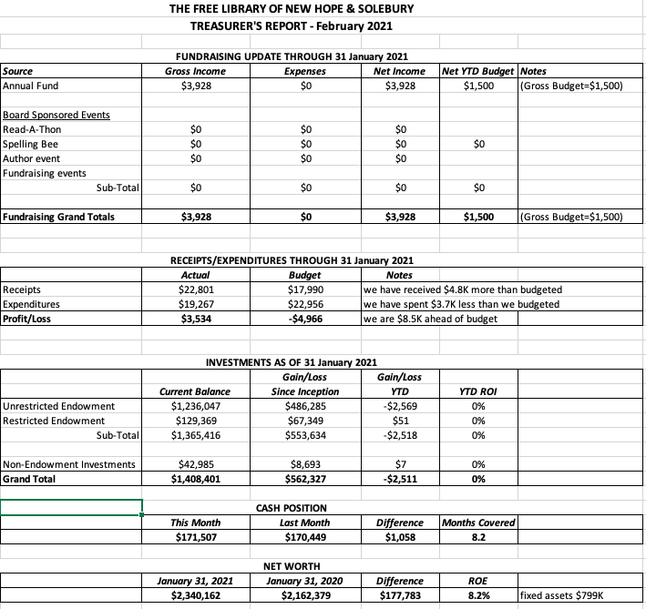

Financial Narrative Highlights
- In January 2021, the Library continued to receive light early-stage fund drive contributions (the mailer was not received until late January/early February).
- Receipts are well ahead of budget for the month, and expenses are well below budget. Part of the reason expenses are below budget was that there no purchases for the collection booked during the month.
- While there were no new contributions from the municipalities in January, the Library did receive $13,748 from the State.
- There have been no new communications regarding the PPP loan from 2020.
- The cash position remains strong, providing overing eight months of coverage.
- The unrestricted endowment balance at the end of January was $1,236,047 and investment performance across all funds was essentially flat.

The Finance Committee asked for approval of the Finance Report. APPROVED by all.

- DIRECTOR’S REPORT – Connie Hillman

- On February 9, 2021, thanks to dropping numbers of Covid-19 in our area, the Library building reopened for limited public access. It is now open to the public from 12pm-5pm daily; 12pm-3pm Saturdays. Curbside pick-up and home delivery services continue for those who request it. Virtual programming is also ongoing. The staff is following guidelines from the state and CDC for sanitizing the building and occupancy.
- The annual report is due the end of February. Connie is still waiting on 2020 financial statements to complete the report and hopes to receive by the end of the week.
- Connie has met with the head of IT of the Bucks County Library System and filed the application for e-rate, which is due at the end of the month.
- The first-ever Winter Reading Challenge was a success, attracting 105 participants. This number is significantly higher than the summer, leading the staff to believe that patrons are acclimatizing to remote programming. Congratulations to Walker Brindley, who won the grand prize of a Kindle Fire in a completely random drawing.
- Connie praised the staff for creating so many virtual programs over the past year.
- In honor of Black History Month, the Library is hosting a presentation from the Museum of the American Revolution entitled: The Same Principle Lives in Us: People of African Descent and the American Revolution on Tuesday, February 23 at 7pm on Zoom.
- PROPERTY – Larry Davis
There has been no communication from HARB (Historical Architectural Review Board) regarding the front door replacement.
- GOVERNANCE – No report.

- DEVELOPMENT – Julia Klossner, Deidre Alderfer, Mike McKenna

- The Development Committee continues to work with Connie on the Library’s strategic plan, which is in its early stages.
- The Development Committee will meet with the Marketing Committee on March 4 to discuss joint efforts on the potential use of the book Inspiring Library Stories.

- MARKETING – Liz Jordan

- NOFA 20 (November Operating Fund Appeal) delivered between January 28-February 4.
  - NOFA 20 Pre-Mailer Arrival: 107 donors gave $21,287.50
  - NOFA 20 Post-Mailer Arrival: 70 donors gave $5,873.50
  - Total NOFA 20 20 so far: $27,161.00. We are about $2,500 away from NOFA 19 total. Notably, there are 30 new donors (eight from the voter list).
  - Thanks to Eric for providing detailed and informative reports on fundraising.
  - One more “thank you” email and social post will be planned as donations wind down in early March.
- Timing of SOFA (Spring Operating Appeal) will most likely be mid- to late May. The theme will play off the “Inspiring Library Stories” book that many Board members are reading. Liz and Connie have spoken about finding our own inspiring stories from the staff.
- Liz and Julia are planning a joint Marketing/Development meeting on March 4th.
- Liz attended her first meeting of the Bucks County Non-Profit Group on February 12 via Zoom. Topics: how to invest non-profit funds, reporting on restricted funds, applying for 2nd PPP and the importance of follow-up to major donors from Board members. The “drive-by raffle basket” event idea was shared with Kris Reilly of FOL.

- FRIENDS REPORT – No report.

- OTHER ITEMS – Doug Brindley

The Board discussed outcomes of the February 16th Solebury Supervisor work session. Next steps: (1) develop a service agreement with Solebury Township that sets out what the Library does (hours, staffing, services, etc.) and (2) work with Supervisors Robert McEwan and Kevin Morrissey on defining a process for naming Solebury Township’s representative Board members in the future. Christopher will be asked to work on this initiative. Doug will contact New Hope Borough Council to invite them to join in the process.

Larry made the motion to adjourn the meeting at 6:24 and Liz seconded. APPROVED by all.

Next meeting: March 17, 2021

Respectfully submitted,

Liz Jordan, Secretary

ADDENDUM:

