THE FREE LIBRARY OF NEW HOPE SOLEBURY
Board of Trustees Meeting Minutes – Draft Copy
March 17, 2021

The Board met via Zoom. Attending: Doug Brindley, President; Joanne Reszka, Vice President; Liz Jordan, Secretary; Deidre Alderfer, Connie Hillman, Julia Klossner, Mike McKenna, Christopher Whitney. Also attending: Eric Jacobson, Patricia Lynch, John Schuster. Excused: Larry Davis.

- CALL TO ORDER – Doug Brindley

The meeting was called to order by Doug at 5:33 p.m. MOTION by Christopher to accept the Minutes of the February 17, 2021 Meeting. SECONDED by Julia. APPROVED by all. Doug then took a few minutes to introduce John Schuster to the Board. John shared a little bit about himself and his experience.

- FINANCE REPORT (Preliminary) – Sent in advance from Larry Davis

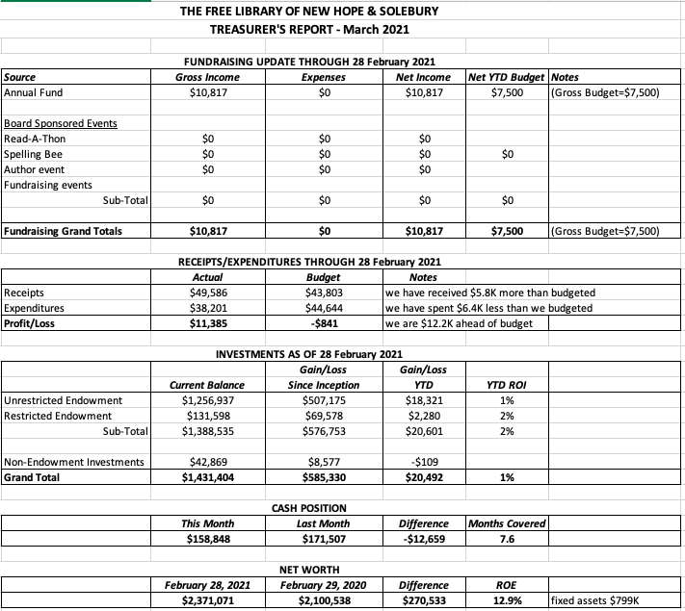
Other Financial News

Connie has advised the Board that the Library received its PPP loan forgiveness letter from First National Bank & Trust of Newtown.

Doug asked for approval of the Finance Report. APPROVED by all.

- DIRECTOR’S REPORT – Connie Hillman

- The annual report was submitted on February 27. Connie thanks everyone who helped obtain the needed financial statements.
- The E-rate application has been filed and approved. A rebate of approximately $700 will be coming to the Library in June.

District Updates

- A new District consultant, Hannah Miller, has been hired and will start in April.
- The County received a grant for Diversity Training. All staff members are invited to take the training sessions, which will be conducted by the Peace Center and are expected to begin in April. Christopher asked if the training could also be available for Board Trustees, and Connie will investigate.
- The Free Library should be receiving a reimbursement of approximately $750 for PPE purchased in 2020.
- The District holds some leftover funds in its budget. Suggested uses are to hire a fundraising consultant to work with each library or to pay for a strategic planning consultant. A majority of County libraries are working on their strategic plans this year.
- District libraries discussed operations under Covid-19 guidance and what changes could be made as State restrictions ease and more people are vaccinated. Before adjusting operations, The Free Library will continue to monitor Covid statistics in our area and follow guidance from the CDC and the State. Getting all staff members vaccinated will also help in making operational decisions. Four of five staff members have now had their first vaccine.
- PROPERTY – No report

- GOVERNANCE – Christopher Whitney

Christopher has met with a sub-committee of two Solebury Township Supervisors and a Solebury resident to define and draft a procedure for filling the two Trustee positions that are allotted for Township approval. A first draft is ready to be sent, after Board review. This document will ultimately need to be approved by both the Library Board and the Supervisors.

- DEVELOPMENT – Julia Klossner, Deidre Alderfer, Mike McKenna

Julia updated the Board on the short-term and long-term Development asks. The long-term ask will come out of the strategic plan. It has been determined that strategic plan should focus on goals and future-oriented services and how to best deliver them the community, rather than the physical building.

- MARKETING – Liz Jordan

- The Marketing Committee and Development Committees met on March 4 to discuss SOFA and Development initiatives, as well as reactions to the book Inspiring Library Stories.
- NOFA 2020 wrapped with a St. Patrick’s Day thank-you message (email, Facebook, Twitter). Final results: 231 donors gave $31,546.00. (107 donors pre-mailer arrival and 124 post-mailer arrival). There were 41 new donors, including 15 new donors who did not come from the eTapestry list. They are presumably from the voter list purchased.
- As a point of comparison: NOFA 2019 had 215 donors contributing $29,640.00.
- Anticipated mail date of SOFA 2021 is mid-May with an “Inspiring Library Stories” theme.

- FRIENDS REPORT – No report.

- OTHER ITEMS – Doug Brindley

Connie informed the Board that an article about The Free Library has been sent to New Hope Borough to be inserted in its April newsletter.

Doug made the motion to adjourn the meeting at 6:40 and Julia seconded. APPROVED by all.

Next meeting: April 21, 2021

Respectfully submitted,

Liz Jordan, Secretary

ADDENDUM:

