THE FREE LIBRARY OF NEW HOPE SOLEBURY
Board of Trustees Meeting Minutes – Approved
April 21, 2021

The Board met via Zoom. Attending: Doug Brindley, President; Joanne Reszka, Vice President; Larry Davis, Treasurer; Liz Jordan, Secretary; Deirdre Alderfer, Connie Hillman, Julia Klossner, Mike McKenna, John Schuster, Christopher Whitney. Also attending: Eric Jacobson, Patricia Lynch, Carol Spencer.

- CALL TO ORDER – Doug Brindley

The meeting was called to order by Doug at 5:32 p.m. MOTION by Christopher to accept the Minutes of the March 17, 2021 Meeting. SECONDED by Julia. APPROVED by all.

- FINANCE REPORT – Larry Davis

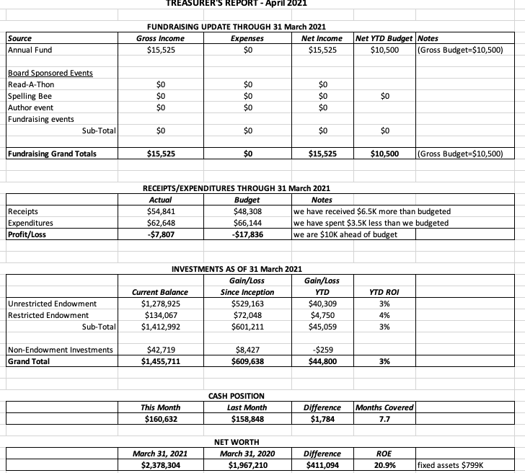

Other Financial Updates

The Library has received the full $31,915 contribution expected from the State for 2021. Overall receipts of $54,841 for the first three months (excluding investment gains) continue to be ahead of budget, and expenses continue to be well below budget.

Larry asked for approval of the Finance Report. APPROVED by all.

- DIRECTOR’S REPORT – Connie Hillman
- While COVID-19 numbers remain high, there is reason to be optimistic. By the end of April, the majority of the staff and volunteers will be fully vaccinated, and many regular patrons have been vaccinated as well. Thus, the Library will open to public access at 10:30 a.m. instead of 12 noon, beginning Monday, May 3. Curbside and home delivery service will still be available. Programming will continue virtually.
- The Library received a reimbursement for Beanstack, our online summer reading program, in the amount of $752.
- Doylestown submitted the paperwork necessary for the PA Cares Grant reimbursement, and it is currently under review by the State. We hope to receive the reimbursement from this grant within the next quarter.
- A new wireless booster has been installed. Connie also received a new laptop.
- Holicong Security replaced the smoke detector batteries in all of the smoke detectors.
- The special needs teen volunteers will be returning Tuesday and Thursday mornings to clean DVDs and audiobooks. This will be one teacher and one student at a time for about an hour. Teachers and students have been vaccinated. We’ve missed seeing them and are happy to have them back.
- While Darcy is on medical leave, a temporary circulation assistant has been hired for Saturday afternoons. Rebecca Rude has been a volunteer for the past three years and started on April 17.
- The first strategic planning meeting will be held Tuesday April 27 at 7 p.m. via Zoom.
- PROPERTY – Larry Davis & Doug Brindley
Doug will resubmit the proposal on the front door replacement to HARB (Historical Architectural Review Board) with New Hope Borough. There were no other property issues.
- GOVERNANCE – Christopher Whitney

Christopher shared the procedural contract for filling the two Trustee positions allotted for Solebury Township approval that has been written by the joint committee.

- DEVELOPMENT – Julia Klossner, Deirdre Alderfer, Mike McKenna

Doug reported that the Raab Foundation has invited the Library to resubmit for additional grant funding.

- MARKETING – Liz Jordan & Joanne Reszka

SOFA 2021 (spring operating fund appeal) is at the printer. The printer anticipates it will go to the mail shop the week of April 26. It will be sent to our eTapestry list and the voter registration list, a quantity of approximately 7,600.

Joanne updated the Board on the Spelling Bee, which is tentatively scheduled for Friday, October 1. The Board discussed potential post-COVID changes to the event, including location and ticket sales. Joanne will form a committee to further examine the details of holding an in-person event.

- FRIENDS REPORT – No report.

Connie noted that the Friends are unable to take book donations at this time.

- OTHER ITEMS – Doug Brindley

Deirdre has initiated contact with New Hope Borough Council. She and Doug met with Council Member Tina Rettig via Zoom and shared updates about the Library. Meetings will continue quarterly.

Doug adjourned the meeting at 7:10 p.m.

Next meeting: May 19, 2021

Respectfully submitted,

Liz Jordan, Secretary

Addendum:

