THE FREE LIBRARY OF NEW HOPE SOLEBURY
Board of Trustees Meeting Minutes – Approved
May 27, 2021

The Board met via Zoom. Attending: Doug Brindley, President; Joanne Reszka, Vice President; Larry Davis, Treasurer; Liz Jordan, Secretary; Connie Hillman, Julia Klossner, Mike McKenna, John Schuster, Christopher Whitney. Also attending: Eric Jacobson, Patricia Lynch, Carol Spencer. Excused: Deirdre Alderfer.

- CALL TO ORDER – Doug Brindley

The meeting was called to order by Doug at 5:31 p.m. MOTION by Christopher to accept the minutes of the April 21, 2021, meeting. SECONDED by Joanne. APPROVED by all.

- FINANCE REPORT – Larry Davis

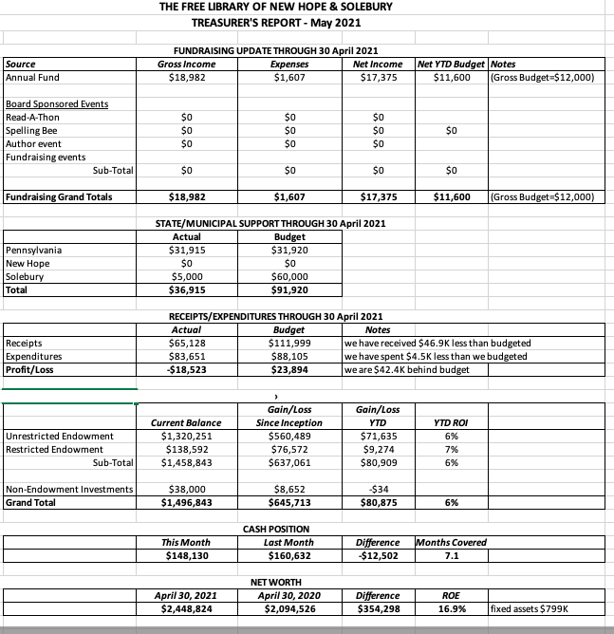
Larry updated the Board that, in mid-May, municipal funding came in of approximately $29,000 came in from New Hope Borough.

Larry asked for approval of the Finance Report. APPROVED by all.

- DIRECTOR’S REPORT – Connie Hillman
- Building operations starting June 1:
  - More chairs will be added to the public spaces.
  - The restroom will reopen for the public.
  - Books will no longer be quarantined, but patrons will be asked to continue to place returns in the book drop. This helps front desk operations run more efficiently.
  - Evening hours will resume once the staff is in place.
  - While programming will continue virtually, two in-person events are scheduled for later in the summer.
  - Curbside pickup will continue for those who request it.
  - Connie will monitor the health conditions and be prepared to resume restrictions if needed.
- Connie is in the process of getting estimates to upgrade the computer outlets on the first floor of the library to finish the first Raab Foundation grant received in 2020. The library was invited to submit another application for a project-based second Raab grant. If awarded, this grant would help install a story walk at the Bucks County Audubon Society.
- A reminder that the board training with the fundraising consultant will be Tuesday, June 29 at 7 p.m. The training will be recorded for those who cannot attend.
- Statewide Library Training has been announced for May-September. Some of these virtual sessions are geared for board members, and the library board is invited to register.
- Robert Huxley has kindly offered to sponsor the Summer Reading Program again in 2021. Program details will be announced shortly.
- The library partnered with Toastmasters and Girl Scouts USA for a second Women in History program, this time focusing on adventurous women, such as British naturalist Isabella Bird and WWII spy Virginia Hall. The program aired virtually on May 24.
- PROPERTY – Larry Davis
Connie reported that the recessed light fixture above her desk is being replaced. It is part of a grid system, so there is a possibility that other replacements will follow.
- GOVERNANCE – Christopher Whitney

Christopher has delivered the Board’s questions regarding the procedural contract for filling the two Trustee positions representing Solebury Township to the working group. Christopher anticipates one final meeting of the group with Doug and the Township’s solicitor in attendance to, hopefully, wrap up the procedure.

- DEVELOPMENT – Julia Klossner, Mike McKenna

Julia asked the Board to revisit the strategic planning spreadsheet she had sent, so that we can move the strategic planning process forward. Deadline for Trustees to respond will be June 3.

- MARKETING – Liz Jordan

We are in week 2 of SOFA (spring operating fund appeal) 2021 follow-up communications.

Liz asked for approval to investigate creating a printed “evergreen” postcard that could be given/mailed to newcomers in the community. The Board gave the go ahead to pursue this project after submitting an estimate.

- SPELLING BEE – Joanne Reszka & Christopher Whitney

After reviewing alternate venues, co-chairs Joanne and Christopher recommend that the Bee continue to be held at the auditorium at the New Hope-Solebury High School. The date for the Bee will be Friday, October 1, pending approval from facilities. In the meantime, Joanne is identifying potential corporate sponsors. Christopher will lead efforts to secure teams and sell tickets. He requested that every Board Trustee commit to bringing one team on board and to selling tickets. Christopher and Joanne raised the idea of increasing ticket prices. Joanne also suggested sponsorships of each letter of the alphabet, rather than trying to organize a basket raffle when many of the raffle donors may have experienced a tough year business-wise.

- FRIENDS OF THE LIBRARY (FOL) REPORT – Carol Spencer
Carol reported that the FOL will have their first in-person meeting since the beginning of the pandemic in June. Additionally, on June 4, the FOL will reorganize, re-box and shelf the book donations in the storage unit. This will make it easier for book dealers to come in and purchase from the collection. Volunteers for this project were requested.

- OTHER ITEMS – Doug Brindley

With no other items for discussion, Doug asked for a motion to adjourn the meeting at 6:44 p.m. Christopher made the motion and Julia seconded. APPROVED by all.

Next meeting: June 16, 2021

Respectfully submitted,

Liz Jordan, Secretary

Addendum:

