THE FREE LIBRARY OF NEW HOPE SOLEBURY
Board of Trustees Meeting Minutes – Draft Copy
June 16, 2021

The Board met via Zoom. Attending: Doug Brindley, President; Joanne Reszka, Vice President; Larry Davis, Treasurer; Liz Jordan, Secretary; Deirdre Alderfer, Connie Hillman, Julia Klossner, John Schuster, Christopher Whitney. Also attending: Eric Jacobson, Patricia Lynch, Carol Spencer. Excused: Mike McKenna

- CALL TO ORDER – Doug Brindley

The meeting was called to order by Doug at 5:33 p.m. MOTION by Christopher to accept the minutes of the May 27, 2021, meeting. SECONDED by Joanne. APPROVED by all.

- FINANCE REPORT (Preliminary) – Larry Davis

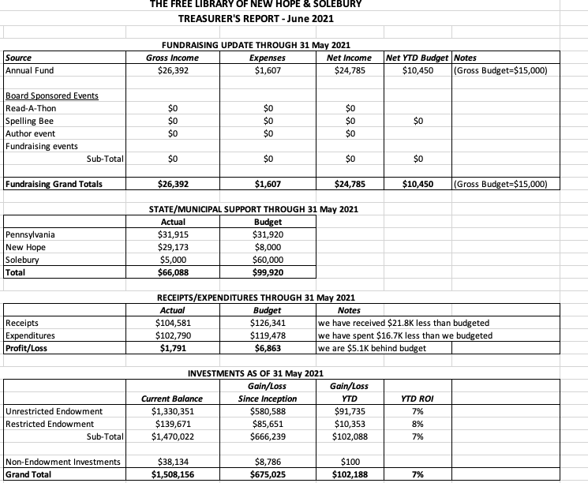

The library’s investments have been rebalanced. Larry asked for approval of the Finance Report. APPROVED by all.

- DIRECTOR’S REPORT – Connie Hillman
- The library resumed evening hours Monday, June 14. There is limited seating, and masks are still required. This will most likely change as soon as the Governor eliminates the mask mandate later in June.
- Connie will file a BEAR form for the past year’s e-rate reimbursement by June 25.
- Registration for the Summer Reading program (Tails & Tales) begins Saturday, June 19. All ages are welcome to register. It will largely be virtual this year with some in-house “passive” programs, like a virtual pet show and a name-the-library-pet contest.
Property
- The recessed lighting above Connie’s desk has been fixed.
- The library received its annual fire inspection on June 16, and Garamond also came out for a yearly lift inspection.
- PROPERTY – See Director’s Report
- GOVERNANCE – Christopher Whitney
Doug and Christopher met with Mark Freed (Solebury Township’s lawyer) to iron out details for the agreement about the procedure for appointing Solebury’s representatives on the Library Board of Trustees. Julia suggested that we include a list of all Library Board members with the agreement rather than include names to ensure the document is evergreen. Doug stated that writing a “service agreement” will be the next task with Solebury Supervisors. We will write the first draft of this agreement.

Doug brought up the offer of a one-time $5,000 from Solebury Township to use toward health insurance reimbursement for full-time employees. Doug will draft a plan that includes a financial commitment from the Board to review at a future executive session.

- DEVELOPMENT – Julia Klossner

Julia will touch base with the Breen’s about the possibility of rescheduling the April event cancelled in 2020. In the continuing work of developing a new Strategic Plan, Julia is compiling a list of local individuals to invite to be part of focus groups.

- MARKETING – Liz Jordan

We are in week 5 of SOFA (spring operating fund appeal) 2021 follow-up communications.

A general library postcard to community newcomers has been printed, and Liz requested that the Board and Library staff distribute these with personal notes.

- SPELLING BEE – Joanne Reszka & Christopher Whitney

Facilities at New Hope-Solebury High School have asked for a form about holding the Bee. As we await a School Board vote on outside groups holding events at the schools, the Board agreed to publicize the Bee without mentioning the location until we get confirmation.

- FRIENDS OF THE LIBRARY (FOL) REPORT – Carol Spencer

Carol reported that the FOL had their first meeting. FOL volunteers have reorganized book donations and have heard that they may be able to use a front porch on Main Street for a book sale.

- OTHER ITEMS – Doug Brindley

With no other items on the agenda, Larry made the motion to adjourn at 7:01 p.m. APPROVED by all.

Next meeting: July 21, 2021

Respectfully submitted,

Liz Jordan, Secretary

Addendum:

