THE FREE LIBRARY OF NEW HOPE SOLEBURY
Board of Trustees Meeting Minutes – Approved
July 21, 2021

The Board met via Zoom. Attending: Doug Brindley, President; Joanne Reszka, Vice President; Larry Davis, Treasurer; Liz Jordan, Secretary; Deirdre Alderfer, Connie Hillman, Julia Klossner, Mike McKenna, John Schuster, Christopher Whitney. Also attending: Eric Jacobson, Patricia Lynch, Carol Spencer.

- CALL TO ORDER – Doug Brindley

The meeting was called to order by Doug at 5:34 p.m. MOTION by Christopher to accept the minutes of the June 16, 2021, meeting. SECONDED by Joanne. APPROVED by all.

- FINANCE REPORT – Larry Davis

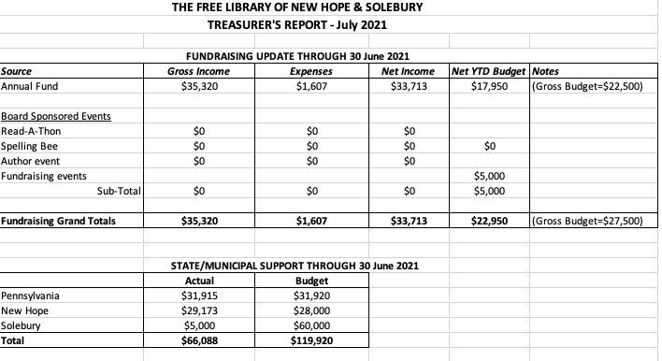
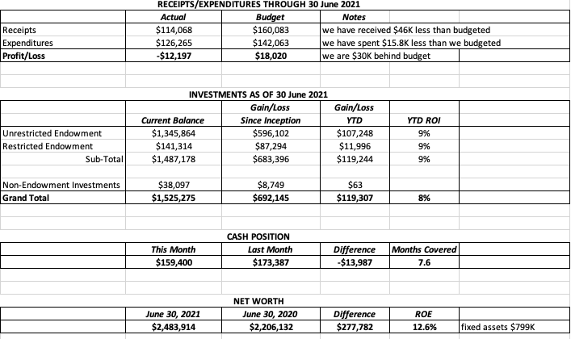

Other Updates:
- Larry noted that a significant contribution from Solebury Township came in July that is not reflected in the June report.
- The Auditor’s report is nearly completed.

With no questions from the Board, Doug asked for approval of the Finance Report. APPROVED by all.

- DIRECTOR’S REPORT – Connie Hillman
- Masks are no longer required for fully vaccinated patrons, but strongly recommended for patrons not fully vaccinated. Connie will continue to monitor the latest health conditions. Foot traffic has picked up, and circulation is back to pre-COVID days. It is a pleasure to see patrons and families again.
- The PA state budget passed at the end of June, and libraries will be flat funded again. However, as part of the American Rescue Plan federal legislation, additional funds for libraries are available through the Institute of Museum and Library Services (IMLS). For Pennsylvania, this amount is $4.79 million. The PA General Assembly passed legislation that authorizes the distribution of $4.7 million to libraries in two parts: (1) an equal share of $890,000 to eligible state-aided libraries; and (2) a proportional amount based on the library’s share of the public library subsidy. It is important to note that these are one-time funds and are not part of the state budget. Timing is not known yet, but The Free Library could expect approximately $2,000-$3,000.
- The Free Library has been selected as a location for a ballot box for the fall election by the Bucks County Board of Elections. It will be located inside and be available during the library’s regular hours of operation. The ballot box will not be bolted to the floor, but it will be monitored by a security camera provided by the County. A lease agreement between the County and The Free Library is forthcoming.
- The Free Library was awarded a STEM Tinkering grant from the Office of Commonwealth Libraries. The kit (Building, Paths and Circuits) will be a great addition to the library’s circulating STEM collection and STEM programming.
- Connie reminded the Board to view the fundraising workshop in anticipation of a one-on-one session with Chad Barger. He has instructed us to select a bullet point from the fundraising plan to focus on.
- PROPERTY – No report
- SPELLING BEE – Joanne Reszka
- The Bee is scheduled for October 1, based on final facilities approval from NH-S High School
- Joanne thanked Connie and Liz for getting the emails and social media about the Bee going.
- Christopher asked the Board to identify potential Bee team members.
- Joanne and Christopher will meet with Julia regarding outreach to top donors.
- DEVELOPMENT – Julia Klossner
- Julia will spearhead a campaign to write personal thank-you notes to top donors. Invitations to the Spelling Bee will also be extended to these donors as another touch point.
- Julia, Joanne and Connie met regarding on strategic planning and have ideas on how to go forward.

- MARKETING – Liz Jordan
- The evergreen postcard to community newcomers is available for distribution.
- Bee marketing and publicity is in full swing. The forms have been updated and are on the website. Emails and social posts are going out now with refreshed Bee branding. Twitter and Instagram have been added to Facebook for social posts. Liz has sent out a list of potential businesses for Bee program ads to the Trustees.

- GOVERNANCE – Christopher Whitney

Doug reported that he attended the Solebury Township meeting on July 20, where the agreement between Solebury Township and The Free Library regarding the process for future appointments of Solebury representative Trustees was approved and signed.

John updated the Board and Library staff on his research into QSEHRA (Qualified Small Employer Health Reimbursement Arrangement) and recommended HealthEquity as a third-party QSEHRA provider for its efficiency and flexibility, rather than a self-administered program. There will be a one-time set-up fee and a yearly fee. John answered staff questions about how the reimbursement would work.

MOTION by Doug to allow John to proceed with QSEHRA within costs previously determined and to engage HealthEquity as the third-party provider with the intent of operationalizing the reimbursement arrangement as soon as possible. Joanne seconded. APPROVED BY ALL.

- FRIENDS OF THE LIBRARY (FOL) REPORT – Carol Spencer

The FOL has been holding weekend porch book sales on North Main Street in New Hope, and it has been doing well, making about $200 each day it has been open.

- OTHER ITEMS – Doug Brindley

With no other items on the agenda, Christopher made the motion to adjourn at 6:50 p.m. Joanne seconded. APPROVED by all.

Next meeting: August 18, 2021

Respectfully submitted,
Liz Jordan, Secretary
ADDENDUM:
