THE FREE LIBRARY OF NEW HOPE SOLEBURY
Board of Trustees Meeting Minutes – Approved
August 18, 2021

The Board met via Zoom. Attending: Doug Brindley, President; Joanne Reszka, Vice President; Larry Davis, Treasurer; Connie Hillman, Julia Klossner, Mike McKenna, John Schuster, Christopher Whitney. Also attending: Eric Jacobson, Patricia Lynch, Carol Spencer. Excused: Liz Jordan, Deirdre Alderfer

- CALL TO ORDER – Doug Brindley

The meeting was called to order by Doug at 5:33 p.m. MOTION by Christopher to accept the minutes of the July 21, 2021, meeting. SECONDED by John. APPROVED by all.

- FINANCE REPORT – Larry Davis

- The auditors have sent an amended copy of last year’s audit, which they had withdrew for minor edits. Larry and Doug will review the updated audit report.
- Larry and John have discussed changing the format of monthly financial reports to the Board. Detailed reports from Linda Landis would still be available on Dropbox.

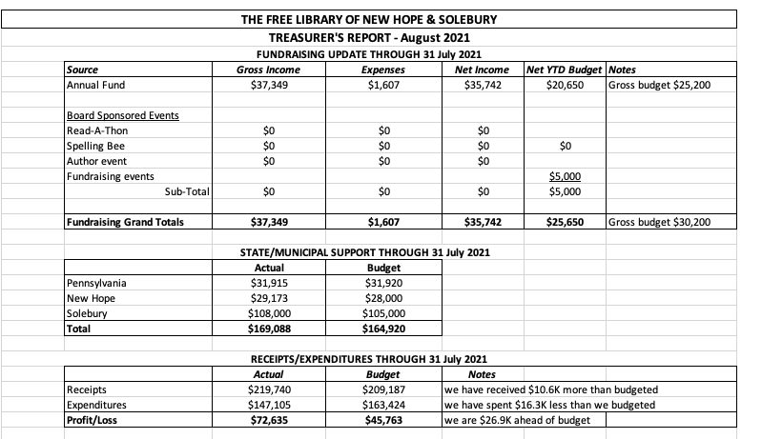
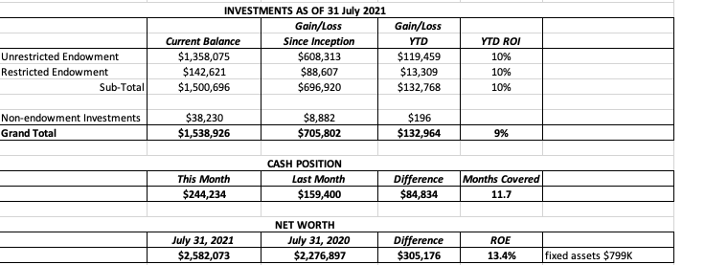
Larry asked for approval of the Finance Report. APPROVED by all.

- DIRECTOR’S REPORT – Connie Hillman

- The recent surge of the Delta strain of the Covid -19 virus has moved Bucks County to a substantial risk of infection. The CDC recommends that masks be worn indoors, regardless of vaccination status, in substantial or high-risk areas. On Monday, August 9, Bucks County required the wearing of masks in county buildings. While the library is not a county building, it has followed the lead of other Bucks libraries and required masks again. As of now, there are no plans to limit hours, remove furniture or other measures. In-person programming will be determined case by case in the fall as Connie continues to monitor the situation.
- The contract for the ballot box was received. John has reviewed the contract and has raised questions with the County Solicitor. Overall, this looks to be a positive opportunity for the library. Cameras will be installed to monitor the box and a representative from the Board of Elections will sit in the library to monitor the box. Hours of operation for the ballot box are still to be determined; John affirmed to the County that we will not be responsible for payment of Library employees, should the box hours vary outside of the library’s regular hours. The County has assured the library that should the library’s physical property be affected through placement of the ballot box, the facilities will be returned to their original condition. John also asked the County to follow the library’s policies, specifically around mask-wearing. Board members stated their support for this requirement. It was suggested that we notify the New Hope police of the presence of the box, to request their help in case of any behavioral problems.
- On August 2, Del Guerico’s, the library’s trash removal company, sent notification that it would no longer be able to provide service due to Covid-19 related issues. Connie has signed up with Whitetail Disposal Inc., which offers a comparable price. All seems to be working well.
- The library’s newspaper carrier has also terminated service. Patricia is following up with the newspapers to resume the service of all four papers.
- The meeting with fundraising expert Chad Barger is scheduled for Tuesday, August 24 at 1 p.m. Everyone is welcome to attend. Future coaching sessions will be available. The Bristol library has had one and said it was very helpful.
- Circulation stats have improved significantly from 2020.
- The summer reading program’s finale event (The Andrew Show) was held at Pat Livezey Park August 5, thanks to the cooperation of Solebury Township.
- Connie has been assisting the Spelling Bee committee with marketing the Bee on social media and the library’s website.
- John has been keeping the full-time staff informed about the status of the health reimbursement arrangement in anticipation of signing on.

- SPELLING BEE – Joanne Reszka & Christopher Whitney, Co-Chairs

- The Spelling Bee has been approved to use the auditorium by New Hope-Solebury School District.
- Christopher updated the Board on the number of teams that have registered thus far (2) and asked for information on teams in the works from other Board members, as well as providing information on teams that he knows to be forming. He reiterated the need for Board members to be working on recruitment of teams.
- Board members stated concerns about the health and safety of a snack table; it was noted that the snack table does not raise much money. Christopher and Joanne will review the implications of this discussion.
- Joanne requested Board members’ input and help concerning sponsorships, program advertisements, and alphabet letters. While alphabet letters are proving popular, there are still program ads to sell. Julia noted that we need to be conscious of contacting our sponsors/donors/teams in case of postponement or cancellation due to the rise in the Covid variant. Larry recommended holding program ad checks for a couple of weeks while we monitor the situation.
- PROPERTY – Larry Davis
No report.
- DEVELOPMENT – Julia Klossner
The strategic planning sub-committee is moving forward with two phases:
      - A brief two- or three-question survey will be sent to as many people in the community as possible.
      - This will be followed by two community focus groups, probably on Zoom, in the fall.
Julia will keep the Board updated.

- MARKETING – Liz Jordan (submitted in advance)
- Evergreen postcards are available in Connie’s office for Trustees to hand out to newcomers in the community and neighbors. This is an easy way to invite people to obtain library cards.
- The committee is working on a full slate of communications (email, press releases, social posts, etc.) to publicize the Community Spelling Bee.
- Selecting a theme and planning photos are in the works for NOFA (November Operating Fund Appeal. The appeal will follow the same format as SOFA 2021 (Spring Operating Fund Appeal). Anticipated mail date is November 15.

- GOVERNANCE – Christopher Whitney

No report from Christopher.

John offered an update on QSEHRA (Qualified Small Employer Health Reimbursement Arrangement): the plan is effective as of August 1, 2021, and employees are being enrolled. Doug noted that he was asked by the Solebury Township Manager to draft a letter as a notice to them that the library is implementing a specific plan. Solebury Township will then be able to release the $5000. Doug will be asked to present a financial report to the Supervisors in August and will ask for their support for the health insurance plan going forward.

- FRIENDS OF THE LIBRARY (FOL) REPORT – Carol Spencer

The FOL’s book sale has been running for seven weeks and has accrued $2,341.00. The Borough asked for a certificate of occupancy fee, which has not yet been refunded. The Friends of the Library anticipate accepting book donations.

- OTHER ITEMS – Doug Brindley.

With no other items on the agenda, Christopher made the motion to adjourn at 6:53 p.m. Julia seconded. APPROVED by all.

Next meeting: September 15, 2021

Respectfully submitted,

Joanne Reszka, Vice President

ADDENDUM:
