THE FREE LIBRARY OF NEW HOPE SOLEBURY
Board of Trustees Meeting Minutes – Draft Copy
September 15, 2021

The Board met via Zoom. Attending: Doug Brindley, President; Joanne Reszka, Vice President; Liz Jordan, Secretary; Larry Davis, Treasurer; Deirdre Alderfer, Connie Hillman, Julia Klossner, Mike McKenna, John Schuster, Christopher Whitney. Also attending: Eric Jacobson, Patricia Lynch, Elizabeth Varnai

- CALL TO ORDER – Doug Brindley

The meeting was called to order by Doug at 5:31 p.m. MOTION by Christopher to accept the minutes of the August 18, 2021, meeting. SECONDED by Larry. APPROVED by all.

- FINANCE REPORT (Preliminary) – Larry Davis
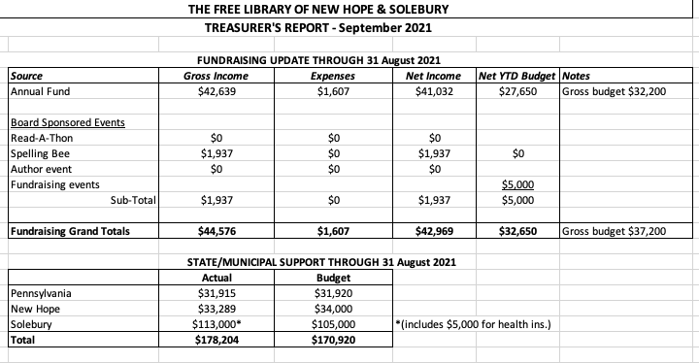
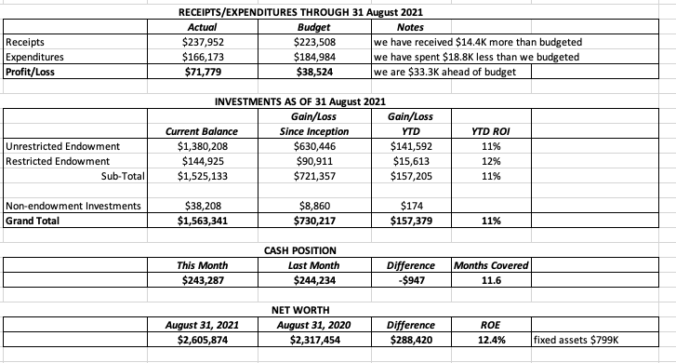
Additional Financial Notes:
- Fund drive contributions in August were $5,290, bringing the total for the year to $42,639.
- New Hope Borough contributed $4,116, and Solebury Township contributed $5,000 toward health care expenses.
- The unrestricted endowment reflected an overall 11.0% return on investment for the first eight months of 2021.
- Larry plans on rebalancing the portfolio at the end of the year.

Larry asked for approval of the Finance Report. APPROVED by all.

Larry has shared the IRS Form 990 with the Board. He saw no issues with it and is prepared to file the form. Christopher moved that we approve the form and John seconded. APPROVED by all.

Larry also noted that the library is due for a full audit in 2022. The current accounting firm is raising the price from $7,000 to $10,000. The Board will offer suggestions of new accounting firms as soon as possible for a change by year end.
- DIRECTOR’S REPORT – Connie Hillman

- Covid-19 Update: There are no changes to report at present. Masks are required in the building, and services have not been altered. There has been a small uptick in curbside requests.
- Newspaper Delivery Update: The delivery problem is still being resolved.
- Tropical Storm Ida impact: The Library closed at 5 p.m. on September 1 to allow the staff to get home safely. A small amount of flooding in the furnace room and by the back door in the children’s area was cleaned up quickly.
- Session with Chad Barger, Fundraising Expert: Members of the Board and the library staff had the first coaching call with Chad Barger on August 24 and received good information and suggestions. A second call will be scheduled this fall once a date is selected. Connie will send a synopsis of the first call for those unable to make the meeting. This opportunity was made possible through the Bucks County library system.
- Pennsylvania Humanities Council (PHC) Grant Opportunity: The Library received a Cares grant in the amount of $4,500 in spring of 2021 to maintain operations during Covid. A similar opportunity is now available and is being offered to other agencies that would normally be outside of the PHC scope. While the library may not receive a second grant (be eligible?), Connie has been working with PHC, taking part in a grant listening session and in an advocacy call with Senator Mike Fitzpatrick. She plans to send the application later this month.
- American Rescue Plan Funds for Library Recovery: The application for this one-time grant will be submitted for Bucks County libraries in October for an end-of-year payment. The Free Library of New Hope & Solebury’s allotment could be approximately $5,00.-$7,000.
- Health Equity: Thanks to John’s help with set-up, the health equity accounts for full-time employee are working well. Doug added that the Solebury Supervisors have been notified that the money was used according to their intent.
- Strategic Planning Survey: The survey was sent via email on August 23 and has been advertised in various outlets in the community. As of now, there are 130 responses. Connie has given Julia and the Strategic Planning committee a mid-point synopsis and will share a more complete version of the survey with the rest of the Board when it closes on September 23.
- Migration to OCLC Wise: The migration to the new interlibrary circulation/catalog system is slated to begin in December. All trainings will be virtual. Directors and managers will receive training in October, and the staff trainings will be in November. The staff is hoping for a more intuitive and user-friendly system.

- SPELLING BEE – Joanne Reszka & Christopher Whitney, Co-Chairs

The Community Spelling Bee fundraiser on October 1 has been postponed due to the rise of the Covid delta variant and the community’s growing nervousness about attending indoor events. Overall, the reaction to postponement has been supportive. Teams, sponsors, volunteers, judges, program ad buyers and other parties have been contacted, and a public announcement will go out on September 16. Joanne has asked to schedule a post-Bee meeting to plan for the future.

- PROPERTY – Larry Davis
No report.
- DEVELOPMENT – Julia Klossner
Julia reported on the status of the strategic plan. Once the strategic plan survey, two community focus groups will be organized to gain further input.
- MARKETING – Liz Jordan
- First draft of NOFA (November Operating Fund Appeal) is complete. The theme is “Having fun isn’t hard when you have a library card.” This is a reference to a song on the PBS show Arthur, which is based on the popular children’s book series by Marc Brown. Liz asked the Board and Staff for help getting brief testimonials for the appeal. It will go to the printer November 3 for a mid-November mailing.
- A joint marketing/development meeting will be planned this fall to coordinate outreach for NOFA.
- Liz suggested that the Board’s annual retreat in January include time to work on fundraising and development.

- GOVERNANCE – Christopher Whitney
Christopher noted that Joanne’s next term will begin in January and that the Solebury Supervisors should be notified per the agreement.

John noted that contributions to QSEHRA (Qualified Small Employer Health Reimbursement Arrangement) will be quarterly for ease in management.

- FRIENDS OF THE LIBRARY (FOL) REPORT – Elizabeth Varnai

The FOL’s weekend book sale on Main Street in New Hope has been successful, bringing in about $3,000 to date. The Friends will continue the sale, weather permitting, through the fall.

- OTHER ITEMS – Doug Brindley

John and Joanne gave a recap about a seminar they attended about running more efficient board meetings. Takeaways included: draft of minutes received earlier; committee reports summarized in advance; all materials sent in a packet; and vision/mission statements included on the agenda. John will survey other libraries about posting the agenda, per Sunshine Laws.

With no other items on the agenda, Christopher made the motion to adjourn at 6:34 p.m. Larry seconded. APPROVED by all.

Next meeting: October 20, 2021

Respectfully submitted,

Liz Jordan, Secretary

ADDENDUM:
